Theory of Relativity: A Critical Analysis

Roberto A. Monti

__________________________________________________________Abstract
Einstein’s theory of relativity is shown to be a physical theory of limited experimental validity. Twelve different experiments seem to disprove its two postulates.
__________________________________________________________
Key words: theory of relativity, cosmology, electric conductivity of the ether, background radiation, extragalactic redshifts, elecromagnetic measurements of the speed of light, one-way measurements of the speed of light, kinematic measurements of the speed of light, interferometric experiments.

1. THE PREMISES
Insufficiencies and gaps in Einstein’s premise to his 1905 paper, “On the Electrodynamics of Moving Bodies,” ⁽¹⁾ have been pointed out by several authors. ⁽²⁾ A case in which Maxwell’s electrodynamics give different results, which can be experimentally tested as such has recently been pointed out by Bartocci and Mamone Capria.⁽³⁾
Moreover, background radiation anisotropy measurements today allow one to detect by electromagnetic means the Earth’s motion relative to the background radiation,⁽⁴⁾ which can be considered at least quasistationary within the “blackbody” constituted by the ether, “certainly the most extended and probably the most homogeneous known body.”^{(5,6)}
It is, however, exactly at the basic level of the postulates that experimental evidence seems to disprove Einstein’s theory of relativity.

- THE FIRST POSTULATE

Einstein’s first postulate of relativity states that: The same laws of Electrodynamics and Optics should also apply to all systems of coordinates that the equations of mechanics are valid for… . We wish to elevate this presumption (the contents of which will be known as the Principle of Relativity) to the fundamental assumption (of our Theory)… . The introduction of a luminiferous ether will prove to be superfluous…as will the introduction of a Space absolutely at rest endowed with special properties.⁽¹⁾
As a consequence of this first postulate, the electromagnetic wave equation “in the vacuum” was written as follows ⁽¹⁾:

(1/c²)(δ²F/δt²) = Δ²F; F ≡ E,H,

where Δ² is the Laplace operator, E is the electric field intensity in volts per meter, H is the magnetic field intensity in amperes per meter, c is the speed of light in the ether (vacuum) in meters per second, and t is time in seconds.
Yet according to Maxwell, “… all these theories lead to the conception of a medium in which the propagation takes place with negligible dispersion of energy.”^{(5,6)} Thus in the electromagnetic wave equation

ε₀μ₀(δ²F/δt²) + σ₀μ₀(δF/δt) = Δ²F, (1)

where ε₀ is the electric permittivity of the ether in farads per meter; μ₀ is the magnetic permeability of the ether in henrys per meter; σ₀ is the electric conductivity of the ether in (ohm meter)⁻¹; the term σ₀μ₀ (δF/ δt) may be considered to be negligible, and the wave equation becomes^{(5,7)} ε₀ μ₀ ( δ²F/ δt²) = Δ²F. Consequently, the Einstein postulate is characterized by two precise assumptions which are in contradiction with Maxwell’s electrodynamics:

- While, according to Maxwell’s theory, the velocity of propagation of electromagnetic waves is a function of two defined, measurable properties of the medium in which the propagation takes place, namely, electric permittivity ε₀, and magnetic permeability μ₀, and we have therefore⁽⁵⁾ c = 1/(ε₀μ₀)^{1/2}, according to Einsteinian theory the medium “does not exit” and therefore cannot “be endowed with special properties.”⁽¹⁾ As a consequence, the velocity of electromagnetic waves is defined as follows⁽¹⁾: c = the path length of light/duration of time.

- While, according to Maxwell’s theory, “propagation takes place with negligible dispersion of energy,”⁽⁶⁾ at least for distances of the order of those of our solar system, so that the term σ₀μ₀ ( δF / δt ) may be considered to be negligible, Einsteinian theory does not consider at all the hypothesis of the existence of an electric conductivity of the ether: σ₀≠ 0. Consequently, the numerical value of this “nonexistent physical property” in Einstein’s theory is σ₀ = 0, and correspondingly the dielectric rigidity of the ether R_{D} – the maximum potential gradient that can exist in a dielectric without the creation of a discharge⁽⁸⁾- is infinite: R_{D} = ∞.

Now, the contradiction between the fact that the electromagnetic speed of light c = 1/(ε₀μ₀)^{1/2}, which was the object of about fifty years of experimental measurements before 1905,⁽⁹⁾ is obtained from the measurements of two definite physical properties of the ether,ε₀ and μ₀, and Einstein’s statement that “the ether does not exist and consequently it cannot be endowed with special properties,”⁽¹⁾ was avoided purely and simply by omitting to define c in terms of ε₀ μ₀.
Both the hypotheses implied in the second assumption, instead, prove experimentally groundless.

- ELECTRIC CONDUCTIVITY AND DIELECTRIC RIGIDITY OF THE ETHER
The terms of the problem are the following: the basic physical meaning of the third principle of mechanics (principle of action and reaction) can be summarized as follows. In the universe, as we know it, there are no isolated systems; in other words, each physical system always interacts with some other system according to the principle of action and reaction.
The effect of the interaction of the electromagnetic wave with the medium in which it propagates is represented, in the wave equation, by the “damping term” σ₀ μ₀(δF/δt). Note that a damping term is always introduced in any propagation equation or force field equation consequently to the recognition of the fact that in nature there are not isolated systems and to avoid Olbers’ paradoxes (the divergence of Gauss’s integral for a force flux, as well as for the luminosity flux).^{(10,11)}
For example, the analogous Olbers paradox for the gravitational field had already been solved by Laplace by introducing a damping coefficient in Newton’s gravitational potential.⁽¹¹⁾ The idea of Laplace has been taken again by Nernst^{(12,13)} and has been extended by Yukawa to strong interactions.⁽¹⁴⁾
To assume that σ₀ = 0, R_{D} = ∞, means instead to advance the hypothesis that every electromagnetic wave is an isolated system and that it can endlessly propagate without losing energy, thus being, in this respect, an example of “perpetual motion”.
The problem of the existence of an electric conductivity of the ether had been faced in an unforgivably superficial way by Thomson⁽¹⁵⁾ in 1888. On the basis of experimental results that proved little more than preliminary and certainly insufficient, Thomson came to the conclusion that:

These experiments show that after a certain exhaustion has been passed, the difficulty of getting a discharge to pass through a highly exhausted tube increases as the exhaustion is increased. This result is in direct opposition to a theory which has found favor with some physicists, viz. That a vacuum is a conductor of electricity… . Numerous other experiments of very different kinds point to the conclusion that a vacuum is not a conductor… . Again, if we accept Maxwell’s Electromagnetic theory of light, a vacuum cannot be a conductor or it would be opaque and we should not receive any light from the sun or stars.⁽¹⁶⁾

Thomson does not consider that according to the experimental evidence pointed out by Maxwell,⁽⁵⁾ “the true electric current on which the electromagnetic phenomena depend is not the same thing as the current of conduction, but the variation of the electric displacement must be taken into account in estimating the total movement of electricity.”
In fact, it is well known that “something” much faster than a flux of electrons (much faster than the “current of conduction”) goes from one pole of an electric circuit to the other.
The migration speed of charge bearers in a copper wire, for example, is about 100 cm/s. Measurements of the electric current velocity made by Pouillet⁽¹⁷⁾ in 1837 showed that this velocity is much faster than the speed of light, a result recently confirmed by Milnes.⁽¹⁸⁾
Again, for example, in my opinion the current of conduction is not present in a superconductor because the supercurrent can freely move in it for a hundred thousand years, and electrons can avoid energy dissipation by the Joule effect only if they do not move through the circuit (this may be the reason why good high temperature superconductors are poor conductors of conduction current).
The current of conduction, in this hypothesis, is a possible parasitic effect of the passage of a displacement current in any medium. In other words, a supercurrent is somewhat like a spring breeze making leaves rustle, whereas a “normal” (conduction) electric current resembles a storm depriving the atomic tree of its electrons and carrying them in its trail. Intensity apart, however, the wind is always the displacement current.⁽¹⁹⁾
This is certainly not a “complete theory” of high temperature superconductivity, but these hypotheses are not contradicted by any experimental fact.
Since 1911⁽²⁰⁾ it has been known that under peculiar conditions this parasitic effect can stop. Under these conditions the displacement current does not quickly change into heat (Joule effect) setting electrons in motion, but can freely run for a very long time through the superconducting circuit.
The displacement current is transmitted by the superconducting lattice and loses its initial energy very slowly, with a relaxation time similar to that of an electromagnetic wave through the ether⁽¹⁹⁾.
The density of the electric current of an electromagnetic wave in the ether is given by⁽²¹⁾

J = ε₀(δE/δt) + δP/δt,

Were ε₀(δE/δt) is the density of the displacement current, and δP/δt is the density of the polarization current of the ether.
Both these currents, in conformity with the principle of action and reaction, cause energy damping - very small, but not-null, because in nature a “perfect elastic medium” does not exit. This means that the continuous series of actions and reactions between ether and electromagnetic fields (waves) causes a damping of the energy of the electromagnetic (EM) waves (the motion of the EM waves is not a perpetual motion). Olbers’ paradox is a paradox no more, because it can be explained by introducing the electric conductivity of the ether.
But there is still an effect that I like to call the “Olbers effect”, constituted by the fact that at night “the sky is illuminated at 2.7 K,” that is, not illuminated at the frequencies supposed by Olbers, but still illuminated.

4. MEASUREMENT OF THE DIELECTRIC RIGIDITY OF THE ETHER
Experimental evidence shows that the ether is certainly a conductor of displacement currents of electricity, that is, σ₀ is very small but is different from zero, and R_{D} is not infinite.
The problem relating to the measurement of the dielectric rigidity of the ether had been taken again into consideration in 1897 by Trowbridge, who found an experimental answer in conformity with the third principle of dynamics:

I have studies the resistance of highly rarefied media under disruptive discharges, and I am led to the conclusion that with a sufficiently powerful electrical stress, what we term a vacuum can be broken down, and that the disruptive discharge during its oscillations encounters very little resistance… .
My experiments lead me to conclude that under very high electrical stress the ether breaks down and becomes a good conductor… ,⁽²²⁾

and, consequently, as Olbers emphasized in 1823, “at night the sky is dark”.⁽²³⁾
Trowbridge was not able to come to these conclusions as a reply to Thomson’s objections about the conductivity of the ether and “the light from the sun or stars”. However, he has certainly shown that R_{D} is not infinite, while Olbers had already pointed out the correct experimental evidence of the electric conductivity of the ether.
The Olbers effect was calculated by Eddington in 1926⁽²⁴⁾ and measured by Regener in 1933.⁽²⁵⁾ Their results were pointed out by Nernst in 1938,⁽¹³⁾ and the temperature of the background radiation was measured again in 1965 by Penzias and Wilson, who confirmed Eddington’s and Regener’s experimental results.⁽²⁶⁾
Trowbridge’s experiment was never repeated, but “vacuum decay effect” is today currently verified.^{(10, 27-31)} I suggest that Trowbridge’s experiment should be repeated.

5. SOLUTION OF THE “COMPLETE” WAVE EQUATION AND EVALUATION OF σ₀
It is well known⁽³²⁾ that if σ₀ is so small that σ₀² can be neglected, which is our case, then Eq. (1) admits solutions of the type

φ = e^{-δr} g(r – c₀t), (2)

where δ = σ₀/2ε₀c₀ = R₀σ₀/2, r is the distance between the electromagnetic source and the observer, and R₀ = (μ₀/ε₀)^{1/2} = the wave resistance of the ether ≅ 376.74 Ω.
We have, therefore,

E = exp(-R₀σ₀r/2) E₀ (r – c₀t) ;

H = exp(-R₀σ₀r/2) H₀ (r – c₀t) .

The solution (3) describe, in a completely general way, the damped oscillations of the electric and magnetic fields of an electromagnetic wave in the ether.
As is known, 1) the damped oscillations are not periodic, and 2) the pseudo period of a damped oscillation depends upon the amplitude. However, the way in which the frequency varies in time is not deducible a priori. Further information, which only experiment can yield, is necessary in order to deduce the frequency damping laws.
This information is provided by the law of the photoelectrical effect, which shows that the energy of an electromagnetic wave is directly proportional to its frequency. This allows us to relate the energy density of the electromagnetic fields of an electromagnetic wave to its frequency ν under any hypothesis about its composition (whether or not it is considered composed by an ensemble of photons of energy hν).
Let W₀ = Kν₀ be the initial energy of an EM wave (of a single photon) and W₁ = Kν₁ residual energy after a path r. We have

W₁/W₀ = exp(-R₀σ₀r) = ν₁/ν₀; ν₁ = ν₀ exp(-R₀σ₀r);

λ₁ = λ₀ exp(R₀σ₀r);

z = Δλ/λ₀ = (λ₁ - λ₀)/λ₀ ₌ [exp(R₀σ₀r) - 1]

⇒ z + 1 = exp(R₀σ₀r) ⇒ r = (1/ R₀σ₀) ln(z + 1). (4)

Now, the galactic redshifts could, obviously, be attributed to the damping of the electromagnetic waves emitted from the various galaxies in random motion within a stationary universe in which a velocity of the gravitational interaction v_{g} >> c₀, according to Laplace,⁽³³⁾ allows locally coordinated motions of clusters and superclusters of galaxies. And the measurement of the redshifts and galactic distances allows us to determine the quantity σ₀. From these measurements we get⁽¹⁰⁾

σ₀ = (2.85 ± 0.15) × 10⁻²⁹ (Ω ⋅ m)⁻¹
(5)
(R₀σ₀/2)² ≅ 3 × 10⁻⁵³.

Equation (4) links distance r and redshift z of the radiation sent forth by galaxies.
Comparison between Hubble relativistic linear law and the logarithmic law which comes out from Maxwell’s electromagnetic wave equation^{(5,10)} shows that, in any case, the logarithmic law fits experimental data much better than the linear law^{(12, 34-37)} ; moreover, it has no problems with the age of the universe.
The comparison has to be made calculating the absolute flux F_{b} – or the absolute magnitude M, defined as the magnitude the source should have if placed at⁽³⁸⁾ 10 pc – of any extragalactic source, from its apparent bolometric flux f_{b} (apparent magnitude m)⁽³⁸⁾ by the relations

f_{b} = F_{b}/[4πr²(1 + z)],

M = m + 5 – 5 log r, r = (1/R₀σ₀) ln(1 + z),

and comparing the results consequent to these relations with the results from the “standard model” of cosmology.⁽³⁹⁾
For z > ½, for example (see Figs. 1 and 2), the difference will be unmistakable. All the extragalactic sources will show an “extraordinary absolute flux F_{b} “ (an extraordinary absolute magnitude M) if not placed at the “right distance”, r = (1/R₀σ₀) ln (1 + z), which is much smaller than Hubble’s distance in any of its versions according to relativistic cosmologies⁽¹⁰⁾.
The “energy effect” hν₀/hν = 1 + z is considered due to the existence of the electric conductivity of the ether σ₀, which decreases the energy of photons without affecting their rate of arrival (Hubble and Tolman, 1935).^{(34, 39)} The existence of this “energy effect” shows that, in addition to
ε₀ and μ₀, a third “special property” of the ether exists: the electric conductivity σ_{0.}
Note, moreover, that the existence of the term σ₀μ₀(δF/δt) causes the “question” of Lorentz invariance to vanish.⁽¹⁰⁾ The hypothesis of an expansion of the universe was consequently adopted by Einstein and his followers just “to save relativity”. But:

1) A Doppler effect due to expansion gives another factor 1 + z in Eq. (6) owing to the “number effect” (the increased path length of the photons causes a consequent decrease in the energy density), which further increases the “extraordinary” absolute flux F_{b} (and absolute magnitudes M), which correspond to the linear law.^{(34-36, 39)}
2) The existence of a Doppler effect is in contradiction to the postulates of relativity: the Doppler effect for sound waves exists because the speed of sound is a constant depending only on some specific physical properties of the medium. Without a medium, no sound waves and no sound Doppler effect.⁽²¹⁾ By analogy, the Doppler effect for light depends on the fact that the speed of light is a constant depending only on some physical properties of the ether: ε₀ and μ₀. Without the ether, no EM waves and no Doppler effect for EM waves. Relativity can reproduce well-known formulas obtained by classical electromagnetism (it is sufficient to state “c is constant”). But the real constant of the Doppler effect for light is
c₀ = 1 / (ε₀μ₀)^{1/2}, not c_{M} = λν. Relativity states that c_{M} ≡ c₀ without experimental proof and omits to note that c₀ is defined in terms of ε₀ and μ₀, two “special properties” of the ether.

Note: Observations of the apparent magnitudes and redshifts of quasar and galaxies clearly show that an “extraordinary luminosity” is associated to these “celestial objects” if a linear law is adopted.⁽⁴⁰⁾
Figure 2, for example, shows that quasar, whose mean absolute magnitude at z = 0.14 is of the order of magnitude of a galaxy⁽³⁸⁾ (M = - 20.64) reach the “extraordinary magnitude” M = - 28 at z = 4 (they also reach the “extraordinary recession velocity” v = 0.923c₀).
The Galaxy⁽⁴¹⁾ 4C 41.17 (z = 3.8), if the linear law is followed, is given the “extraordinary absolute magnitude” M = - 27 (q₀ = 0.5, H = 50, M ≅ - 23.86, correction factor = + 0.98) and the “extraordinary recession velocity” v = 0.917c₀.
New experimental data about more than 60 galaxies with z > 2 will soon be available.⁽⁴²⁾
Note that the absolute magnitude of the Galaxy 4C 41.17 is very near to that of a quasar at z = 4.
In my opinion, these “extraordinary luminosities” (and velocities) are due only to the “extraordinary distance” that is attributed to these object according to the relativistic linear law and the hypothesis of the expanding universe.^{(12,13,34)}

- FIRST POSTULATE: CONCLUSIONS
Thus three experimental tests seem to be in contradiction to the first postulate of Einsteinian relativity:

- The experiment made by Trowbridge, which proves that the dielectric rigidity of the ether is not infinite ⁽²²⁾ (“vacuum decay effect”). ^{(10, 27-31)}
- The reality of Olbers effect, which is a paradox no more, and the existence of the background radiation corresponding to the electric conductivity of the ether ^{(4, 10, 12, 13, 23, 25, 26)}
σ₀ = (2.85 ± 0.15) × 10⁻²⁹ (Ω m)⁻¹
- Comparison between relativistic linear law and logarithmic law. ^{(12, 34-37, 39)} See Figs. 1 and 2.

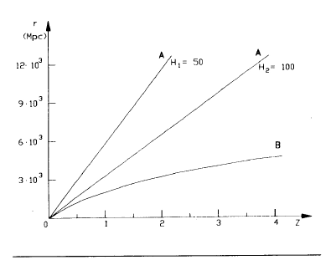

Figure 1. Comparison between calculated distances (luminosity distances) according to Hubble law and the logarithmic law deducible from the solution of the “complete” electromagnetic wave equation.
(A) r = c₀z/h (q₀ = 1, smallest Hubble distance)⁽¹⁰⁾
(B) r = (1/R₀σ₀) 1n ( 1 + z ) .
H₁ = 50 km/(s Mpc); H₂ = 100 km/(s Mpc) ; R₀ = 376.74 Ω⁽⁷⁾
σ₀ = (2.85 ± 0.15) x 10⁻²⁹ (Ω ⋅ m )⁻¹ ;
1/(R₀σ₀) ≅ 3 x 10³ Mpc, 1 Mpc = 3.86 x 10²¹ m.⁽¹⁰⁾

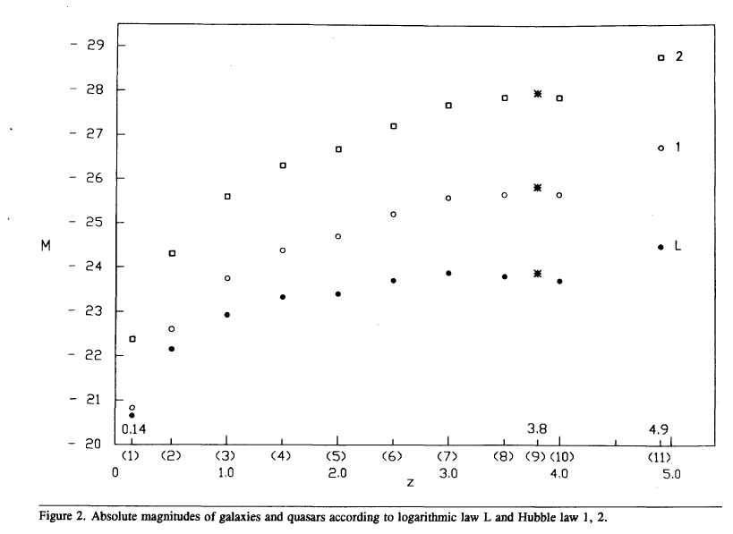

(1)$\overline{z}=0\text{.}\text{14}±0\text{.}\text{03}$; $\overline{m}=\text{17}\text{.}\text{33}$; number of objects (quasar) : 135
M = m + 5 - 5 log r = - 20.64 ; r= ( 1/R₀ σ₀ ) 1n ( 1 + z )
M₁( 100 ; 1 ) = m + 5 - 5 log D₁ ; D₁ = ( c₀z )/ 100
M₂ ( 50 ; 0.5 ) = m + 5 - 5 log D₂ ; D₂ = ( 2c₀/50 ) [ 1 + z - ( 1 + z )^{1/2}]
M₁ = - 20.83 ; M₂ = - 22.41 .

(2)$\overline{z}=0\text{.}5±0\text{.}\text{02}$; $\overline{m}$= 18.28 ; number ( quasar ) : 89
M = - 22.14 ; M₁ = - 22.6 ; M₂ = - 24.31 .

(3)$\overline{z}=1\text{.}0±0\text{.}\text{03};\overline{m}=$18.63 ; number ( quasar ) : 140
M = - 22.96; M₁ = - 23.75 ; M₂ ₌ -25.6 .

(4)$\overline{z}$ = 1.5 ± 0.05 ; $\overline{m}$ = 18.88 ; number (quasar) : 346
M = - 23.31 ; M₁ = - 24.39 ; M₂ = - 26.33 .

(5)$\overline{z}$ = 2.0 ± 0.08 ; $\overline{m}$ = 19.22 ; number (quasar) : 539
M = - 23.37 ; M₁ = - 24.67 ; M₂ = - 26.69 .

(6) $\overline{z}$ = 2.5 ± 0.1 ; $\overline{m}$ = 19.19 ; number (quasar) : 308
M = - 23.68 ; M₁ = - 25.18 ; M₂ = - 27.26 .

(7) $\overline{z}$ = 3.0 ± 0.1 ; $\overline{m}$ = 19.21 ; number (quasar) : 132
M = - 23.88 ; M₁ = -25.56 ; M₂ = -27.69 .

(8) $\overline{z}$ = 3.5 ± 0.1 ; $\overline{m}$ = 19.45 ; number (quasar) : 14
M = - 23.82 ; M₁ = - 25.66 ; M₂ = - 27.83 .

(9)Galaxy : 4C 41.17
z = 3.8 ; m = 19.5 ; number : 1
M = - 23.86 ; M₁ = - 25.78 ; M₂ = - 27.98 .

(10) $\overline{z}$ = 4.0 ± 0.2 ; $\overline{m}$ = 19.73 ; number (quasar) : 13
M = - 23.69 ; M₁ = - 25.67 ; M₂ = - 27.87 .

(11) Quasar PC 1247 + 3406 (Ref. 43)
z = 4.897 ; m = 19.3 ; number : 1
M = - 24.33 ; M₁ = - 26.53 ; M₂ = - 28.59 .

Recession velocity :

$v=\frac{{\left(1+z\right)}^{2}−1}{{\left(1+z\right)}^{2}+1}=0\text{.}\text{944}c_{0}$

- The second postulate
The second postulate of Einsteinian relativity states that

…light propagates in vacuum with a fixed velocity c, independent of the velocity of the emitting body… . By definition… the time light employs to go from a point A to a point B is equal to the time employed by light to go from B to A … . Let us establish … that the quantity : 2AB/ (t′_{A} – t_{A}) = c is a universal constant, the velocity of light in vacuum… . In our Theory … the velocity of light plays physically the role of an infinite velocity.⁽¹⁾

Now, as we have seen above, according to Maxwell, light propagates through the ether at an “electromagnetic speed” c₀ = 1/(ε₀μ₀)^{1/2} that only depends on the properties ε₀ (electric permittivity) and μ₀ (magnetic permittivity) of the ether and thus does not obviously depend on the state of motion of the emitting body.⁽⁵⁾ Consequently, the Einsteinian postulate is characterized by three precise assumptions, which are in contradiction to Maxwell’s electrodynamics :

- While, the “universal constant” of Maxwell’s theory is the “electromagnetic speed” c₀ = 1/(ε₀μ₀)^{1/2}, according to Einstein’s second postulate, the “universal constant” is the kinematic speed of light c_{M} = 2L/ΔT, where L = AB and ΔT = (t′_{A} – t_{A}). Consequently, Einstein is formulating the hypothesis according to which c₀ ≡ c_{M} .
- While, according to Maxwell’s theory, the two finite velocities c₀ and c_{M} physically play the role of two finite velocities, according to Einstein’s the two velocities, ”identical by definition” physically play “the role of an infinite velocity.”⁽¹⁾
- While, according to Maxwell’s theory, the kinematic speed of light is not a constant but depends on motions through ether, according to Einstein’s second postulate the kinematic speed of light is a “universal constant” and does not depend on motions through the ether.

With regard to the first assumption, Einstein definitely ignores the basic distinction between the kinematic and the electromagnetic speed of light, which had, however, been a research field for physicists during half a century.^{(9,44)}
In 1905 the state of experimental data was the following⁽⁹⁾ :

c₀ = (3.001 ± 0.003 ) × 10⁸ m/s ;

c_{M} = (2.998 ± 0.003 ) × 10⁸ m/s

Therefore, there could be room for demanding new measurements, but certainly not for establishing the identity c₀ ≡ c_{M} on an experimental basis.
With regard to the second assumption, assuming “by definition” that “the time light employs to go from a point A to a point B is equal to the time employed by light to go from B to A” without distinguishing between c₀ and c_{M} led to the Einsteinian paradox c + v = c, c – v = c, from which c = c (1 - β²), (β = v/c), which obviously means that “c physically plays the role of an infinite speed.”^{(1,2)}
With regard to the third assumption, in 1904 Michelson had already published his experimental project relating to the detection and measurement of the effects on the kinematic speed of light due to the motions of rotation and revolution of the Earth through the ether, by means of what is today known as the Michelson-Sagnac effect.⁽⁴⁵⁻⁴⁹⁾ But Michelson could not manage to find the funds that were necessary to conduct the experiment (he conducted it in 1925).⁽⁵⁰⁾
The effect was tested in 1913 by Sagnac,⁽⁴⁶⁾ and Sagnac’s experimental results disproved the second postulate of special relativity. Moreover, in 1887 the Michelson-Morley experiment⁽⁵¹⁾ “was sufficient to show clearly that the effect did no have the anticipated magnitude. However, and this fact must be emphasized, the indicated effect was not zero, as requested by the Theory of Relativity.”⁽⁵²⁾ This result was confirmed in 1926 by Miller (“indicated effect”^{(52,53)}: v = 10 ± 0.33 km/s).
In 1929 Michelson, Pease, and Pearson⁽⁵⁴⁾ again confirmed that "no displacement of the order anticipated was obtained," but that the indicated effect" was not zero. ("Indicated effect": v ≈ 20 km/s. Uncertainty not indicated but at least of the same order of magnitude of the uncertainty of Miller's experiment.)
In 1932 Kennedy and Thorndike⁽⁵⁵⁾ could show once more ,using a different geometry (unequal arms),that the kinematic speed of light is not constant during the day, thus disproving for the third time the second postulate of relativity. And in this case no "temperature effects on the interferometer" could be called for.⁽⁵⁶⁾
Finally, in 1938 Ives and Stilwell⁽⁵⁷⁾ showed experimental evidence of the relations

λν = λ₀ν₀(1 - β²) / (1 - β² sin² θ)^{1/2}, ν = ν₀ (1 - β² )^{1/2} ,

λ = λ₀(1 - β² )^{1/2} / (1 - β² sin² θ)^{1/2},

disproving with a direct, positive test the second postulate of relativity.
The terms of the whole matter, which is elementary if properly set out, follow.

- ELECTROMAGNETIC MEASUREMENTS OF THE SPEED OF LIGHT
As it is known, starting from Coulomb's laws F = QQ' / kr², F = mm' / μr², which describe quantitatively the electrostatic and magnetostatic interactions, two different units of measurements,called, respectively, electrostatic and electromagnetic, were defined.^{(5, 58)}
In both of these systems of units the dimensions of the quantity 1/(kμ)^{1/2} are [LT ⁻¹], that is, that of a velocity which turns out to be a function of the properties k and μ of the medium that occupies the space between the bodies which interact electrically and magnetically.

The medium that occupies the "empty space" was called ether, the velocity 1/( kμ)^{1/2} was called velocity v , and the "properties" k and μ , respectively, elasticity and density of the ether .

In 1856 Weber and Kohlrausch⁽⁵⁹⁾ carried out the first measurement of this velocity with the following result : v = 3.1074 x 10⁸ m/s (uncertainty not indicated) .

From 1864 Maxwell⁽⁶⁰⁾ was able to deduce from his equations the existence of "electromagnetic waves" with velocity of propagation v =1/( kμ)^{1/2} . Maxwell compared the values of the velocity v with those available of the kinematic velocity of light, and, since they involved methodologically distinct measurements, he felt confident, on the basis of the substantial agreement of their order of magnitude, to advance his "electromagnetic theory of light" :

It is manifest that the velocity of light and the ratio of the units are quantities of the same order of magnitude. Neither of them can be said to be determined as yet with such a degree of accuracy as to enable us to assert that the one is greater or less than the other . It is to be hoped that, by further experiment, the relation between the magnitudes of the two quantities may be more accurately determined .
In the meantime our theory, which asserts that these two quantities are equal and assigns a physical reason for this equality, is certainly not contradicted by the comparison of these results such as they are.⁽⁵⁾

In the following forty years numerous other electromagnetic measurements of the velocity v were carried out, together with numerous kinematic measurements.
In 1905, as already said, the situation was the following :

c₀ = (3.001 ± 0.003) x 10⁸ m/s,

c_{M} = (2.998 ± 0.003) x 10⁸ m/s.

Therefore, there could be room for demanding new measurements, but certainly not for establishing the identity c₀ ≡ c_{M} on an experimental basis . But after 1905 no new experimental measurement of the electromagnetic speed of light was made, and in 1932 these measurements were abandoned :

At the beginning of the century it seemed improbable that one should find them [ c₀ and c_{M} ] identical… . Michelson stated this clearly :… a difference might almost certainly be predicted… . This attitude was completely general… . But this attitude [ towards c₀ and c_{M} ] changed little by little, in large part thanks to the influence of the Einstein and the Theories of Relativity, to the point where today [1932] many physicists - probably the large majority - consider these velocities necessarily identical … . This change is not due to the influence of experimental results, since these, far from being negligible, were completely left aside, but due to considerations of a philosophical nature .⁽⁶¹⁾

The invention of calculable condensers by Lampard and Thompson in 1964^{(44,62)} removed one of the principal difficulties that prevented, until a few years ago, new electromagnetic measurements with decidedly smaller uncertainties than those obtainable at the turn of the century ( 10⁻³) .

At this moment the main problem regarding this measurement lies in the fact that the inductance measurements permit uncertainties of the order 10⁻⁵ . As a consequence, in a direct measurement of c₀, present technologies allow uncertainties of the order⁽⁴⁴⁾ 10⁻⁵ . The fact that this uncertainty is larger than that associated with current kinematic measurements (which is of the order 10⁻⁹) has induced the experimenters to put aside the idea of new measurements of the velocity v .

Nevertheless, taking into account that a new electromagnetic measurement does not just have a numerical significance, since for uncertainties of the order 10⁻⁵ it can give useful, if not decisive, information, and for uncertainties of the order 10⁻⁶ it is a crucial test of special relativity's second postulate, it is necessary, in my opinion, to proceed with new experimental determinations of the electromagnetic speed of light,⁽⁶²⁾ c₀ .

9 . THE TWO GROUPS OF EXPERIMENTAL TESTS OF EINSTEIN'S SECOND POSTULATE OF RELATIVITY

In 1905 the crucial point of Einstein's relativity was the statement : "The time light employs to go from a point A to a point B (forward time Δt_{F}) is equal to the time employed by light to go from B to A (return time Δt_{R})," ⁽¹⁾ because extragalactic redshifts were not known .⁽¹²⁾

Now, if Δt_{F} ≠ Δt_{R} , we have two different groups of experimental tests of relativity's second postulate : 1) we can search for effects due to the difference Δt_{F} − Δt_{R} , and 2) we can search for effects due to the sum Δt_{F} + Δt_{R} .

Following Michelson (1904),⁽⁴⁵⁾ Sagnac (1913) , ⁽⁴⁶⁾ and Ives (1938), ⁽⁶³⁾ consider Fig. 3,

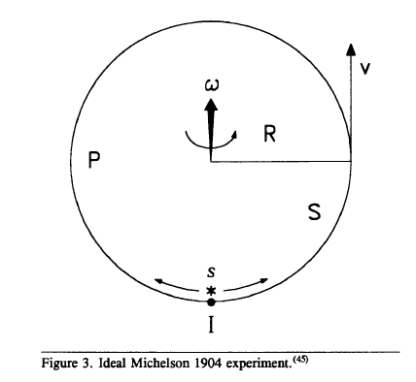

where P is a rotating platform ; S is the surface of the platform ; R is the radius of the platform ; v = ωR = the rotational velocity ; s is the light source ; I is the interference point ; and L = 2πR .

Consider now two light pencils, one traveling counterclockwise (Δt_{F}) and the other clockwise (Δt_{R}) . We have Δt_{F} = L/ (c₀ - v ) ; Δt_{R} = L/ (c₀ + v ) . The difference is

Δt_{F} − Δt_{R} = 2Lv/c₀²(1-β²) = 2Lβ/c₀(1-β²) ,

and neglecting only terms in β³ and higher order, ΔT = Δt_{F} − Δt_{R} = 2Lβ/c₀ .

The corresponding phase shift is Δ_{L} = (c₀ΔT) /λ =( 2Lβ) /λ .
The sum is Δt_{F} + Δt_{R =} 2L/c₀(1-β²) , and neglecting only terms in β³ and higher order, ΔT = Δt_{F} + Δt_{R} = 2L/c₀ + 2Lβ²/c₀ .

1) Working with the difference we consequently have the possibility (taking as a reference the velocity relative to the cosmic background radiation)^{(4, 44)} of searching for effects in β = v/c₀ ≅ 400/300 000 ≅ 1.3 x 10⁻³ .

2) Working with the sum we have the possibility of searching for the much smaller effects in β² ≅ 1.7 x 10⁻⁶ .

A skilled experimental physicist, I think, could have no doubts : it is better to work with the difference .

In the case of Fig. 3 , for example , we have Δ_{L} = 2 ( 2πR) v /λ c₀ = 4ωS/c₀λ . This relation is completely general, that is, 1) it does not depend on the shape of the surface S, and 2) it does not depend on the location of the center of rotation .⁽⁴⁸⁾
Unfortunately, the first test was made by Michelson, working with the sum, and the result of the experiment (1987) did not have the theoretical magnitude anticipated by the ether theory .
Only in 1904 did Michelson have the good idea to work with the difference, but he was unable to fund the experiment, which, as we know, has a positive result, in agreement with the ether theory .
Let us now follow these various different experiments .

10. KINEMATIC MEASUREMENTS OF THE SPEED OF LIGHT

Let U (XOY) be a reference frame whereby the electromagnetic speed of light c₀ = 1/ (ε₀μ₀ )^{1/2} results in being equal to the kinematic speed of light c_{M} = 2L /ΔT . This reference frame is "absolutely at rest" relative to the ether.
Let E (xoy) be a moving frame of reference with speed V = (ωR + v ) (ωR is the rotational velocity, and v is the "linear" velocity) .
Consider in E the interferometer I of Fig. 4.

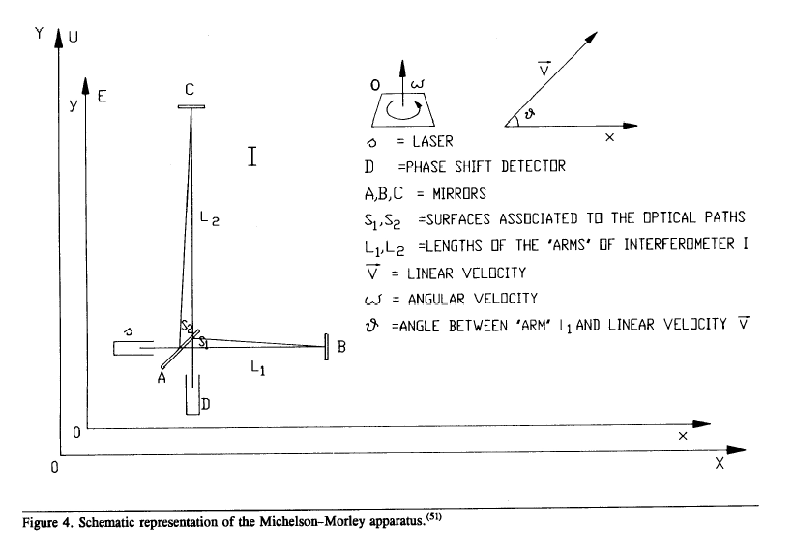

Consider then the following case : ω = 0 ; v ≠ 0,v = const ; S₁ ≠ S₂ ≠ 0 .
Following Kennedy and Thorndike, ⁽⁵⁵⁾ the time taken by light to run along the optical path AB + BA ( arm L₁, Fig. 5 ) is given by the sum of the forward time,

Δt_{F}¹ = L₁ /c₀(1 - β²) [(1 - β² sin² θ)^{1/2} + β cos θ ]

(β = v / c₀) ,
and the return time,

Δt_{R}¹ = L₁ /c₀(1 - β²) [(1 - β² sin² θ)^{1/2} - β cos θ ] .

We have then

ΔT¹ = Δt_{F}¹ + Δt_{R}¹ = 2L₁ /c₀(1 - β²) [(1 - β² sin² θ)^{1/2}] .

Now,

ΔT¹ = 2L₁ / c_{M} = 2L₁ / c₀(1 - β²) [(1 - β² sin² θ)^{1/2}]

⇒ c_{M} = c₀(1 - β²) / (1 - β² sin² θ)^{1/2} ;

and c_{M} = c₀ only if v = 0 .

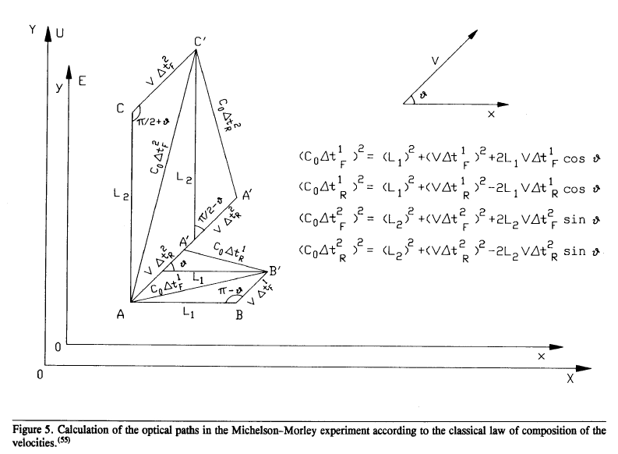

Obviously, if one does not distinguish between c₀ and c_{M} , the physical relation
c_{M =} c₀(1 - β²) / (1 - β² sin² θ)^{1/2} becomes the "relativistic paradox" ⁽²⁾

c = c(1 - β²) / (1 - β² sin² θ)^{1/2} .

Of course, the physical evidence of the Earth's motions (rotation, revolution, rotation around the galactic center, velocity relative to background radiation) and the physical evidence that c₀ and c_{M} are both finite ( they can be measured) are experimental evidence that Δt_{F}¹ ≠ Δt_{R}¹, contrary to Einstein's definition .
For example, in the case of a "linear" velocity v ≠ 0, the optical path AB is different from the optical path BA (AB > BA ) and light takes a time

dT¹ = Δt_{F}¹ - Δt_{R}¹ = [2L₁ /c₀(1 - β²)] β cos θ ≠ 0

to travel the optical path AB - BA ≠ 0 at the finite speed c₀ . ( If v ≠ 0 ; θ ≠π/2, Δt_{F}¹ ≡ Δt_{R}¹ only if c₀ = ∝ . But in this case Δt_{F}¹ = Δt_{R}¹ = 0 and we could not measure the speed of light .)
The "linear shift" corresponding to the difference Δt_{F}¹ - Δt_{R}¹ is Δ_{L} = [2L₁/λ(1 -β²)] β cos θ and, neglecting only terms in β³ and higher order, Δ_{L} = (2L₁/λ) β cos θ .
The two physical quantities c₀ and c_{M} cannot be considered "identical by theoretical definition."⁽¹⁾ They can, and must, be measured, and they obviously physically play the role of two finite velocities .
Assuming the hypothesis that the state of motion of the system E(xoy) does not alter the values of electric permittivity ε₀ and of magnetic permeability μ₀ of the ether as they result from the measurements of an observer first at rest and then in motion at a speed v , then it comes out that the same observer E(xoy) can determine its own state of motion by comparing the results of the electromagnetic and kinematic measurements of the speed of light made in its own frame of reference because c₀ > c_{M} ; c₀ = c_{M} only if v = 0 .

For example, an observer in 1905 could certainly have considered the possibility that the Earth "is in motion at a high speed," since ⎢v ⎪ = c₀(1 - c_{M}/ c₀)^{1/2}, c₀ = (3.001 ± 0.003) x 10⁸ m/s > c_{M} = (2.998 ± 0.003) x 10⁸ m/s .⁽⁴⁴⁾ The electromagnetic measurement of the speed of light made by Rosa and Dorsey during 1905 to 1907 was the last one.⁽⁹⁾
I suggest once again that new measurements of the electromagnetic speed of light should be made,^{(9,44,62)} but I want to emphasize that the experimental evidence of the measurability of the two speeds of light is experimental evidence that they "have physically the role of two finite velocities", and that if v ≠ 0, θ ≠ π/2 a "forward time" is different from a "return time" : Δt${}_{F}^{1}$≠ Δt${}_{R}^{1}$ .
The two relations c_{M} = c₀(1 - β²)/ (1 - β² sin²θ)^{1/2} and Δ_{L} = (2L₁/λ)β cos θ show that c_{M} and the "linear shift" are not only a function of v, but also a function of θ .
Consequently, the measurements of the kinematic speed of light and of the photoelectric effects associated to "linear" shifts⁽⁶⁴⁻⁶⁹⁾ should show, for example, daily and "long period" effects due to the Earth's motions.
With regard to c_{M}, optical gyroscope have shown that the standing waves that originate inside them can lock onto the ring of the gyroscope.⁽⁷⁰⁾
Taking into account the fact that today c_{M} results from measuring the wavelength and frequency of standing waves along optical paths associated to nearly null, or null, surfaces in system with null rotational speed relative to the Earth, locking of the standing waves does account for the "stability" of the present precision kinematic measurements of the speed of light,⁽⁷¹⁾ which should otherwise be a function of the overall rototranslatory motion of the Earth .
In other words, while until a few years ago measurements of the kinematic speed of light were made using various methods, today metrologists make measurements with the only method that gives constant values; they have dismissed all the methods that did not give constant values for c_{M} .
To make a historical comparison, we can say that physicists today do not decline to look into "Galileo's telescope", but from the various different telescopes they choose the "wrong one" which gives "null results" .

- THE MICHELSON - MORLEY EXPERIMENT.

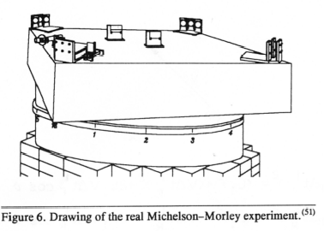

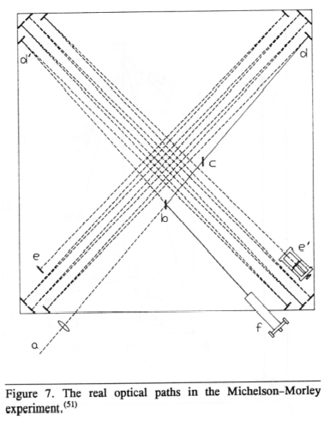
Many different precision measurements are required to test the "stability" of Einstein's "universal constant" c_{M} with a "single arm". But with "two arms" it is possible to make a comparison between kinematic velocities in different directions without making measurements of c_{M}. This is the physical meaning of the Michelson-Morley experiment .
In 1887 Michelson wanted to test the orbital motion of the Earth relative to the ether - a rotational velocity, considered as a "nearly linear velocity" - by means of its effects on the kinematic speed of light due to slow rotation of the interferometer around this "linear velocity", that is, the Michelson-Morley apparatus had to work as an optical gyroscope .
Today, background radiation anisotropy measurements allow one to detect by electromagnetic means the Earth's motion relative to the background radiation; "nevertheless it moves,"⁽⁴⁾ and optical gyroscopes show the optical effects due to slow rotation around a fixed velocity.⁽⁷⁰⁾
Consequently, the fact that the experimental results of the Michelson-Morley experiment did not have the anticipated magnitude⁽⁵²⁾ does not obviously mean that it is impossible to detect the motion of the Earth relative to the ether. It only means that something is wrong with the Michelson-Morley apparatus.
In my opinion, there are two possibilities: (1) locking of the standing waves in the interferometer, and (2) the choice of an erroneous "theoretical solution" and the corresponding adoption of a "wrong" apparatus. The real experimental apparatus is shown in Fig.6 and was diagrammatically represented as in Fig.7 . Because of the difficulty in calculating the optical paths, Lorentz suggested representing it as in Fig.8 .^{(49,51)}

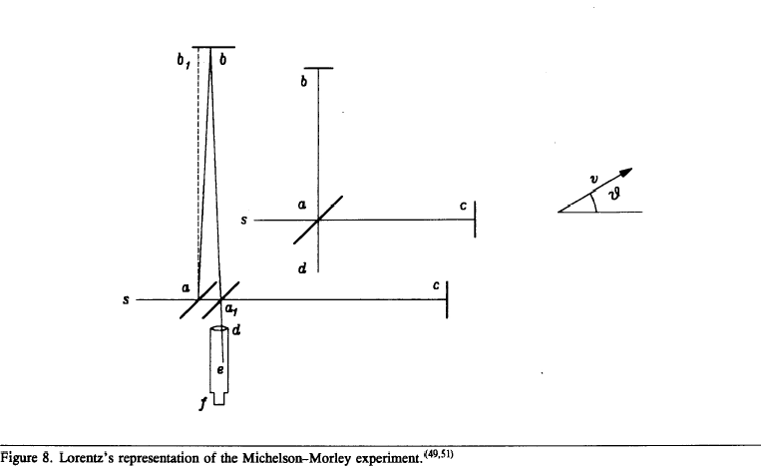

Today we know that the standing waves in the interferometer "prefer" to have a node on the surface of the reflecting mirror, so that they "lock" onto the mirror.⁽⁷⁰⁾ And we can see that in the real Michelson-Morley apparatus we have 16 reflecting mirrors. The "locking probability" is consequently very high.
The experimental result of the Michelson-Morley experiment did not have the anticipated magnitude, but it was not null, as supposed by Lorentz and postulated by the theory of relativity.⁽⁵²⁾ Lorentz's theoretical solution for the fringe shift, adopted by Michelson, was (ΔT${}_{θ}^{1}=$Δt${}_{F}^{1}$+ Δt${}_{R}^{1}$; ΔT${}_{θ}^{2}$= Δt${}_{F}^{2}$ + Δt${}_{R}^{2}$ )

Δ₀ = $\frac{c_{M}}{λ}$[( ΔT${}_{0}^{1}$ - ΔT${}_{0}^{2}$ ) - (ΔT${}_{θ}^{1}$ - ΔT${}_{θ}^{2}$)]

=$\frac{c_{M}}{λ}$$[(\frac{2L_{1}}{c_{M_{0}}}−\frac{2L_{2}}{c_{M_{{}_{π/2}}}})−(\frac{2L_{1}}{c_{M_{π/2}}}−\frac{2L_{2}}{c_{M_{{}_{π}}}})]$

L₁ + L₂
= ⎯⎯⎯⎯ β² sin² θ .
λ

From Lorentz's point of view the problem was that

c_{M}${}_{0/π}$ = c( 1 - β² ) ≠ c_{M}${}_{π/2}$ = c (1 - β² )^{1/2} .

But supposing, as he did, a "contraction" of the longitudinal rod by a coefficient

(1 - β² )^{1/2} ⇒ c_{M}${}_{0/π}$= c_{M}${}_{π/2}$ and Δ_{θ} = 0 ,

that is, the Michelson-Morley apparatus could not work as an optical gyroscope . But if we consider the possibility that the fringe shift depends on the total variation of the optical path - defined as the algebraic sum of the variations in each single arm - we have

Δ_{θ} = ( c₀/λ )$[({ΔT}_{θ^{1}}−{ΔT}_{0^{1}})+({ΔT}_{θ^{2}}−{ΔT}_{0^{2}})]$

= [( L₂ - L₁) /λ ] β² sin² θ .

In the case of the Michelson-Morley experiment L₁ ≅ L₂ and of course Δ_{θ} ≅ 0 , whereas, as we shall see, in the case of the Kennedy-Thorndike experiment L₁ ≠ L₂, and a "daily effect" corresponding to the daily rotation of the interferometer (fixed relative to the Earth) could be clearly observed.⁽⁵⁵⁾
An experimental solution to overcome both these problems (locking and equal arms) could be the optical circuit of Fig. 9,⁽⁷²⁾ with the addition of a device to "unlock" the standing waves.⁽⁷⁰⁾ This optical circuit, which is a "Sagnac circuit" with disjoint surfaces,⁽⁴⁶⁾ has never been tested .

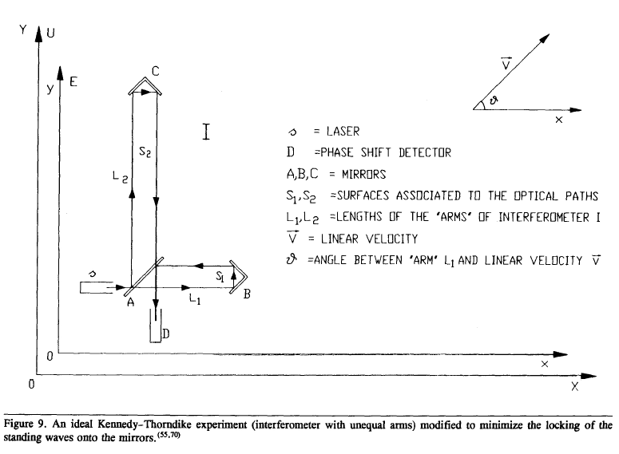

- THE MORLEY-MILLER EXPERIMENTS (1902 TO 1905)

Morley and Miller pointed out that the result of the Michelson-Morley experiment did not have the anticipated magnitude, but the indicated effect was not zero. Moreover, Michelson and Morley made only one series of observations, in July 1887, and never repeated the ether drift experiment at any other time, notwithstanding many printed statements to the contrary.⁽⁵²⁾
Consequently, at the International Congress for Physics held in Paris in connection with the International Exposition of 1900, Lord Kelvin strongly urged the repetition of the ether drift experiment with a more powerful apparatus. Morley and Miller decided to repeat the experiment from 1902 to 1905 . The conclusion, at the end of 1905, was the following:
The observations showed a very definite positive effect slightly larger than previously obtained, but still too small to be reconciled with the expectation, The velocity of relative motion of the Earth and ether obtained from the observations made in 1905 is 8.7 ± 0.6 km/s … . Since the Theory of Relativity postulates an exact null effect from the ether drift experiment which had never been obtained in fact, the writer [ Miller ] felt impelled to repeat the experiment in order to secure a definitive result.⁽⁵²⁾

As we shall see, Miller repeated the experiment from 1921 to 1926 .

- ROMER'S AND BRADLEY'S EXPERIMENTS ( 1676, 1728 )

The difference Δt_{F} - Δt_{R} was used for the first time to measure the one-way speed of light ( c₀ ) by Romer ( 1676 ) and later by Bradley ( 1728 ).⁽⁶⁶⁾ From the classical composition of the velocities, in the case of Jupiter's satellites ( Romer ), we have ( Fig. 10 ) : in A and C ( θ = π/2 ; θ = 3/2 π ) we observe the "true" period T = T₀ . In B and D (θ = π; θ = 0 ) we have

B : Δt_{F} = T_{max} = ( T₀ + vT₀/c₀ ) ⇔ T₀( c₀ + v ) = T_{max}c₀

D : Δt_{R} = T_{min} = ( T₀ - vT₀/c₀ ) ⇔ T₀( c₀ - v ) = T_{min}c₀ ,

from which

ΔT = T_{max} - T_{min} = ( 2v/c₀ ) T₀⇒ c₀ = ( 2v/ΔT )T₀ .

In the case of aberration ( Bradley ) we have ( Fig. 11 )

C₀T/sin φ = vT/sin α ⇒ sin α ≅ α = ( v/c₀ ) sin φ .

Romer's result was c₀ = 301 000 km/s . A recent result from aberration ( 1976 ) is ⁽⁶⁶⁾ c₀ = 299 900 km/s . Note that is both cases we have ( c_{M} = 299 792.5 km/s ) c₀ > c_{M} .

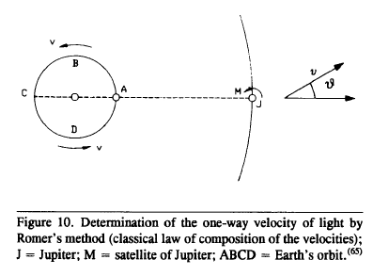

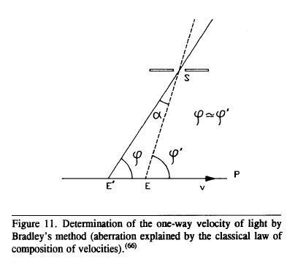

- SAGNAC'S EXPERIMENT (1913 )
Adding one mirror to the ideal Michelson-Morley experiment we have Sagnac's experiment ( Figs. 12 and 13 ) .

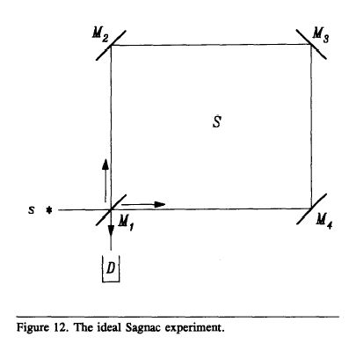

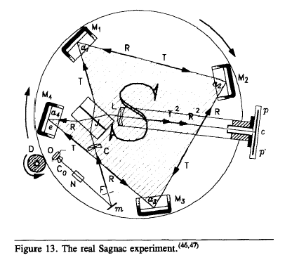

Working with the difference Δt_{F} - Δt_{R} , in 1913 Sagnac proved the formula Δ_{L} = ( 4ω S )/ c₀λ and disproved the theory of relativity . Moreover, Sagnac suggested that a large "Sagnac circuit" fixed to a carrier ( a ship in his example ) could be sensitive to slow and small deviations around a fixed velocity, so that it could work as an optical gyroscope.⁽⁴⁷⁾ If the mechanical vibrations of Sagnac's apparatus could not allow the "unlocking" of the standing waves, Sagnac's experiment would certainly have been considered further proof of special relativity .
In the 1960s the problem of the locking was discovered and solved technically because it was already known that a "Sagnac circuit" had to work ( a null result could not be accepted ) . The first optical gyroscope was built in 1963 by Macek and Davis. Today, a sensitive ring laser gyroscope can fit in the palm of one's hand . Passenger carriers such as Boeing's 757/ 767 series and a number of Airbus Industry's A 310s rely on ring laser gyroscopes rather than mechanical ones.⁽⁷⁰⁾

- GENERAL RELATIVITY ( 1914 TO 1918 )
Two years after Sagnac's experimental result Einstein produced the general Theory ( 1916 ).⁽⁷³⁾ The result of the experimental tests of general relativity are very uncertain or in contradiction with experimental evidence.
The "relativistic explanation" of the well-known secular advance of Mercury's perihelion does not consider that 1916 experimental value of the unexplained advance of 43" was corrected in 1930⁽⁷⁴⁾ to 50.9", and today we know that a new evaluation is necessary.⁽⁷⁵⁾ Moreover, Einstein's explanation was based on the hypothesis that the speed of gravitational interaction was equal to the speed of light, contrary to experimental evidence pointed out by Laplace⁽³³⁾ and Tisserand.⁽⁷⁶⁾
Finally, today we know that the Sun's solid inner core rotates faster than the surface, which can explain the precessions of all the planets.⁽⁷⁷⁾
Coming now to the "difference" between the Newtonian and Einsteinian deflection of a beam of light, this difference was not confirmed after the results of the expedition of 1919, in which Dyson and Eddington put forth the hypothesis that the refraction index of solar atmosphere n had a constant value n< 1.000 002 12 and neglected the results from the astrographic plates of Sobral's expedition.⁽⁷⁸⁾
Further measurements have shown large differences in value among these deflections⁽⁷⁹⁾ which can be easily understood taking into account that the refraction index of the solar atmosphere depends upon solar activity .⁽⁸⁰⁾ Moreover, the experiment by Pound and Rebka⁽⁸¹⁾ in 1960 clearly showed that the energy or mass of light is subject to gravitation in the same way as ordinary matter, hΔν = mgz, where m = hν/c${}_{0^{2}}$, g is the Earth's gravitational acceleration, and z is the vertical path length ( the frequency must change because c₀ and h are constants ).⁽⁸²⁾
Finally, the "natural necessity of covariance" was experimentally justified by the "equivalence of inertial and gravitational masses."⁽⁷³⁾

Now, an inertial mass is associated to any charge. Writing gravitational charge instead of gravitational mass, the "equivalence" means only that microscopic gravitational charges are equally accelerated by a macroscopic gravitational field.⁽⁸³⁾
Consequently, general relativity, which is a generalization of special relativity,⁽⁷³⁾ cannot give any validation to special relativity.

- LANGEVIN'S "EXPLANATION" OF SAGNAC'S EXPERIMENT (1921)

Sagnac's experiment cannot be explained by special relativity, because according to special relativity,⁽¹⁾ c + v = c - v ; Δt_{F} ≡ Δt_{R} .
After the "success" of the 1919 expeditions, Langevin tried to "save" special relativity by means of general relativity.⁽⁸⁴⁾ Langevin starts saying that the Michelson-Morley experiment and Sagnac's experiment are "not comparable" . But he only shows that he has not understood that the difference consists in one mirror .
Then he makes the hypothesis that the rotation of the platform (with a frequency of two rotations per second) causes, within the reference frame connected with the rotating platform, exactly the space-time variations that can explain the experimental result Δ_{L} = 4ω S / c₀λ if general relativity is true. But

- There are no direct experimental tests of the space-time variations called for by Langevin .

- Ives pointed out that the behavior of moving clocks supposed by Langevin ends with another "clock paradox" that has no experimental proof.⁽⁶³⁾

- The platform of Sagnac's experiment can also work fixed to the Earth - the same reference frame of the Michelson-Morley experiment, that is, without additional rotations.⁽⁵⁰⁾

- Finally, in 1941 Dufour and Prunier showed that Langevin's argumentation was disproved if part of optical circuit was fixed to the laboratory.⁽⁸⁵⁾

As a consequence, Langevin's argumentation is experimentally groundless, and Sagnac's experiment disproves relativity .

- THE MILLER EXPERIMENTS ( 1921 TO 1925 )
From 1921 to 1925 Miller had the opportunity to repeat the Michelson-Morley experiment at Mount Wilson .⁽⁵²⁾ The result was the following :
These observations all show a positive periodic displacement of the interference fringes, as of an ether drift, of the same magnitude, about 10 ± 0.33 km/s, as had been obtained in previous trials… . Under the conditions of actual observations, the periodic displacements could not possibility be produced by temperature effects… . These experiments had given conclusive evidence of a real effect which was systematic but which was small in magnitude and was unexplainable as to his azimuth… . The average of the curve on sidereal times, showed conclusively that the observed effect is a cosmical phenomenon.⁽⁵²⁾

Finally (1933), commenting on the other ether drift experiments by Kennedy, Joos, Michelson, Pease, and Pearson, Miller⁽⁵²⁾ pointed out that "In none of these experiments have the observations been of such extent and of such continuity as to determine the exact nature of the diurnal and seasonal variations."
After Miller's experiments, in fact, the general attitude "do not search for daily effects in interferometric observations" seems to have been adopted by relativists. Shankland, for example, made - 30 years later - a critical analysis of Miller's experiments without repeating the experiments and "without embarking on a sound recomputation of the cosmic solution data."⁽⁵⁶⁾

- THE MICHELSON - GALE EXPERIMENT ( 1925 )
The Michelson-Gale apparatus, owing to its dimensions, was sensitive to the Earth's rotation.⁽⁵⁰⁾ It consisted of two coupled interferometric experiments, fixed in Clearing, IL (rotating with the Earth), of which one gives a "null Michelson-Sagnac Effect" owing to insufficient surface, and worked as a "fiducial mark", whereas the second gives a "positive" Michelson-Sagnac effect owing to the large enough surface enclosed by the optical path of the two pencil of light (Fig. 14 ).

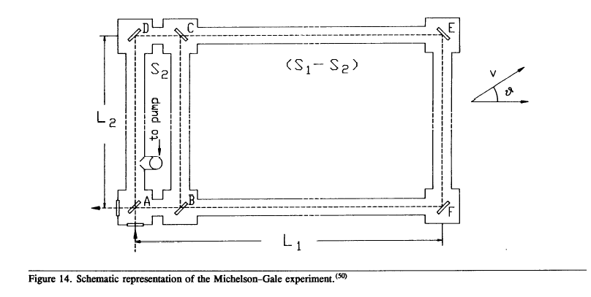

Michelson only considered the case ω ≠ 0, v = 0. But owing to the existing linear velocity
v = ( 390 ± 30 ) km/s relative to the background radiation⁽⁴⁾ the approximations used to obtain the formula Δ_{L} = ( 4ω/c₀λ ) ( S₁ - S₂ ) sin φ ( where φ = 41°46' is the latitude of experiment ) are questionable. We can suppose, for example, that the effect due to rotation of the interferometers around the linear velocity v could be of the form f ( v, sin θ, L₁, L₂ ) . In this case the Michelson-Gale experimental shift should show daily effects corresponding to the Earth's rotation:

Δ_{L} = ( 4ω/c₀λ ) ( S₁ - S₂ ) sin φ + f( v, sin θ, L₁, L₂ ).

As a matter of fact, the distribution of experimental data in the Michelson-Gale experiment shows large oscillations around the "constant value"

( 4ω/c₀λ ) ( S₁ - S₂ ) sin φ = 0.23

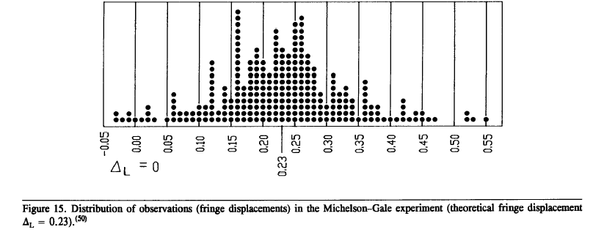

(Fig. 15 ). But Michelson, after Miller's results, omitted to give his experimental data in time sequence.
Today we know that the Michelson-Gale experiment works exactly like an optical gyroscope showing, in addition to the "constant effect" due to the rotation of the Earth around its axis, the effect due to the deviations of the Earth around the "linear" fixed velocity relative to the background radiation. In my opinion, a repetition of the experiment will show exactly this behavior, because the Michelson-Gale experiment is the optical gyroscope suggested by Sagnac in 1914.

- THE MICHELSON-PEASE-PEARSON EXPERIMENT (1929 )
After Miller's results Michelson could not avoid a repetition of his experiment ( Fig. 16 ).

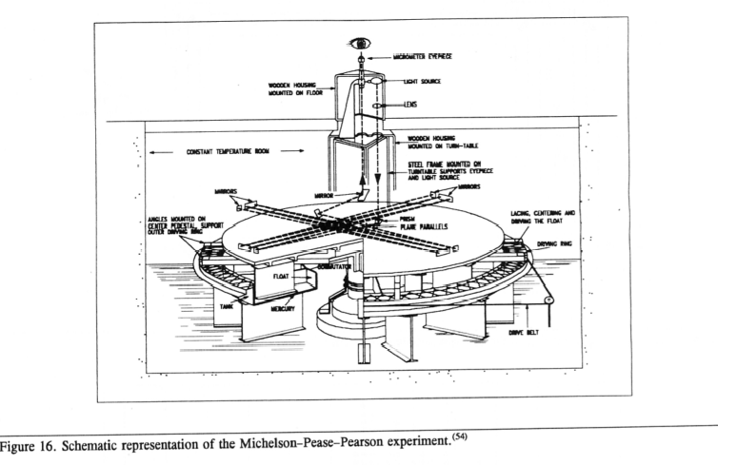

Michelson gave a first announcement of his result at the "Michelson Meeting" of 31 October - 3 November 1928 :

The results gave no displacements as great as one fiftieth ( 1/ 50 ) of that to be expected on the supposition of an effect due to a motion of the solar system of 300 km/s . These results are differences between the displacements observed at maximum and minimum at sidereal times.
These directions correspond to Dr. Stromberg's calculations of the supposed velocity of the solar system.⁽⁸⁶⁾

But later ( January 1929 ) he corrected the previous announcement:

…No displacement of the order anticipated was obtained …
The result gave no displacement as great as one fifteenth ( 1 /15) of that to be expected on the supposition of an effect due to a motion of the solar system of 300 km/s,⁽⁵⁴⁾
that is, 20 km/s, the double of Miller's result. Michelson stopped the experiment and did not publish the experimental data.

- THE KENNEDY-THORNDIKE EXPERIMENT (1929)
In 1929 Kennedy and Thorndike supposed that, according to their theoretical calculations, a Michelson-Morley interferometer with unequal arms ( L₁ ≠ L₂ ) could show experimental evidence not only of the longitudinal contraction L = L₀(1 - β²)^{1/2}, but also of the time dilation⁽⁵⁵⁾ ΔT = ΔT₀/(1- β²)^{1/2}. Consequently, they built an interferometer with unequal arms (Fig. 17).

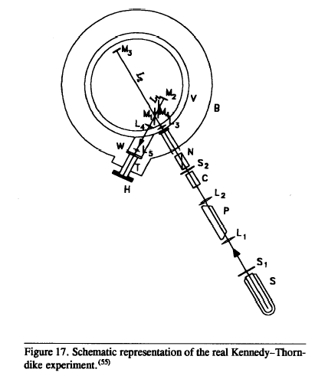

But they had an astonishing surprise: the interferometer worked as an optical gyroscope, showing a "daily effect" due to the rotation of the Earth around some kind of fixed velocity . The daily effect was a real effect; it could be clearly observed in the photographic plates.⁽⁵⁵⁾ Again they tried to "save relativity" saying that "the effect had not the anticipated magnitude according to ether theories."⁽⁵⁵⁾
But, as a matter of fact, the daily effect of the Kennedy-Thorndike experiment definitely disproves relativity, because a daily effect in itself means that the kinematic speed of light is not constant during the day, while the "anticipated theoretical magnitude" according to relativity is no daily effects. The Kennedy-Thorndike experiment was never repeated. I suggest that it should be repeated using the experimental apparatus of Fig. 9.

- THE IVES-STILWELL EXPERIMENT (1938)
In 1937 Ives and Stilwell⁽⁵⁷⁾ wanted to give a direct experimental proof of the relations

(c₀ = λ₀ν₀)

c_{M} = λν = λ₀ν₀(1 - β²)/ (1 - β² sin² θ)^{1/2}

ν = ν₀(1- β²)^{1/2}; λ = λ₀(1- β²)^{1/2}/(1 - β² sin² θ)^{1/2}

obtained calculating the Doppler effect via the classical formula for the composition of the velocities. To obtain these relations, note that the source and the receiver of the interferometer in the reference frame E (Fig. 4 ) are comoving and that the frequency ν of the source is constant in E.^{(87,88)} Taking either leg of the Michelson interferometer, the following relation holds: c(θ) = c_{M}/(1+β cos θ). Consequently, for the horizontal leg (θ = 0,π) we have

(L/νλ₁) + (L/νλ₂) = 2L/λν c₁(θ = 0) = νλ₁ = c₀(1- β)

c₁/c₂ = νλ₁/νλ₂ c₂(θ = π) = νλ₂ = c₀(1+β).

When solved these give the following solutions:

λ₁ = λ/(1 + β)

- λ_{B} = (λ₁ + λ₂)/2 = λ/(1- β²)

λ₂ = λ/(1- β)

Now, because ν = const in E ⇒ ν = kν₀ ; λ = ƒ (θ)λ₀

ƒ(θ) = α/(1 - β² sin² θ)^{1/2}; k,α, = φ( v ) = const if v = const.

For θ = 0 :

λν = λ₀ν₀(1- β²) = kαλ₀ν₀ ⇒ kα = (1- β²).

For θ = π/2 :

λν = λ₀ν₀(1- β²)^{1/2} = [kα/(1- β²)^{1/2} ] λ₀ν₀

⇒ kα = [(1- β²)^{1/2}]².

We have, consequently, various possible solutions for k and α .

Ives and Stilwell^{(57,89)} could test that the solution that gives the correct experimental value for the shift Δλ = λ_{B} - λ₀ is the solution k = α = (1- β²)^{1/2} from which

ν = ν₀(1- β²)^{1/2}; λ = λ₀(1- β²)^{1/2}/(1 - β² sin² θ)^{1/2}

λ_{B} = λ(1- β²) = λ₀(1- β²)^{1/2} (θ = 0,π)

Δλ = λ_{B} - λ₀ = λ₀{[1/(1- β²)^{1/2}] - 1} ≅ (1/2) λ₀β².

Ives pointed out correctly that his real ,positive, non-null effect disproved the theory of relativity.⁽⁵⁷⁾ But he did not stress the difference between c₀ and c_{M} and could not clearly explain his experimental result.
In his paper⁽⁵⁷⁾ Ives writes the two relations λ = λ₀(1- β²)^{1/2} and ν = ν₀(1- β²)^{1/2} separately and does not combine them, probably because without distinguishing between c₀ and c_{M} he would have found Einstein's paradox c = c (1- β²).
On the contrary, distinguishing between c₀ and c_{M} and noting that the kinematic velocity of light on the Earth $c_{M_{E}}$ = λ_{E}ν_{E} is very near to the electromagnetic velocity λ_{E}ν_{E} ≅ λ₀ν₀ = c₀ because⁽⁴⁾ v_{E} ≅ 10⁵ m/s, which is much smaller than the velocity of the ions in his tube⁽⁵⁷⁾ (v₁ ≅ 10⁶ m/s), Ives could have definitely proved that c_{M} ≠ c₀ ; c_{M} ≅ λ₀ν₀(1- β²) = c₀(1- β²), which is the right solution of Einstein's paradox c = c(1- β²).

- MARINOV'S EXPERIMENTS (1979 TO 1986)
For two beams of light running is opposite directions we have the "linear shift" (c₀/λ)(Δt_{F} -Δt_{R}) = (2L/λ)β cos θ (Fig. 18).
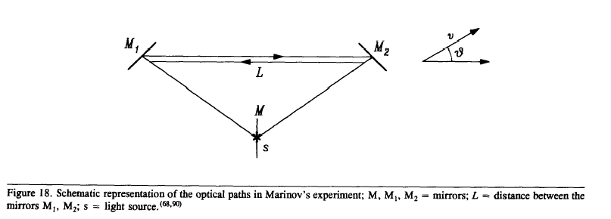

Modern technology allows us to measure the photoelectric effects caused by the electric fields of the two beams of light which have different wavelengths λ₁ = λ/(1 + β); λ₂ = λ/(1 - β).
The result is a sinusoidal daily effect.
Marinov was not aware of the distinction between c₀ and c_{M}. Consequently, some of the mathematical relations in his paper are wrong . But he successfully conducted this kind of experiment from 1979 to 1986.^{(68, 90)} His experimental results have been published in scientific reviews of "secondary importance", and the experiment was never repeated.

- SILVERTOOTH'S EXPERIMENT (1987)
In 1983 Silvertooth built a "standing wave sensor", which, again, could allow the measurements of the photoelectric effects due to the electric fields of two opposite beams of light, giving the usual "linear shift" (c₀/λ)(Δt_{F} -Δt_{R}) = (2L/λ)β cos θ .
Silvertooth, like Marinov, had only a theoretical flaw: he was not aware of the distinction between c₀ and c_{M}. Consequently, some of the mathematical relations in his papers are wrong, but the experiment works well.^{(87, 88)} Silvertooth offered freely to anybody his standing wave sensor, but again, the experiment was never repeated. Marinov's and Silvertooth's experiments are both different version of the optical gyroscope.

24. RADAR TESTING OF THE VELOCITY OF LIGHT [WALLACE (1969),
TOLCHEL'NIKOVA (1991) ]
These kinds of measurements are similar, in principle, to Romer's experiment: differences in time caused by the "classical" composition of the velocity of light with the velocity of the planets (in this case Earth and Venus). Wallace noticed that published interplanetary radar data presented evidence for the relations⁽⁹¹⁾ c + v ≠ c - v ≠ c .
The relativist I. I. Shapiro stopped the access to the experimental data. Wallace tried to impeach Shapiro with no results.⁽⁹²⁾ But similar results were obtained in Russia in 1991; at an International Conference in St. Petersburg, Tolchel'nikova confirmed Wallace's observations.⁽⁹³⁾

25. NEVERTHELESS IT MOVES

Today it is well known that anisotropy measurements of background radiation not only enable evaluation of the modulus, but also of the direction of the Earth's translation motion:

…the microwave sky should appear hottest in the direction of motion and coolest in the opposite direction with a dipole variation of the form δT/T = (v/c₀)cos θ .
Observations of δT/T can therefore be used to find the velocity of the observer v … . Because of the rotation of the Earth, such an isotropy should appear in a fixed radiometer as a signal variation with a period of one sidereal day (which is just the time taken for the telescope to return to point toward a direction in the sky fixed relative to the stars, not to the sun). This enables the required signal to be extracted from both the noise and any other real effects in the data. Recent results … yield a velocity of (390 ± 30) km/s in the direction RA = 11^{h} , δ = + 6° . Figure 19 shows that a large peculiar velocity of the Galaxy is required to produce the observed result … . The frame of reference in which the microwave background appears isotropic can be regarded as providing a standard of absolute rest.⁽⁴⁾

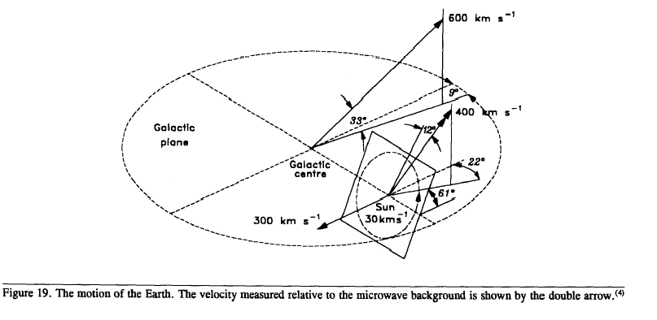

Then Raine tries to save relativity: "This anisotropy measurement sometimes seems to lead to concern that there might be a conflict with the Special Theory of Relativity, since this is held to assert the impossibility of establishing a privileged rest frame, even by using experiments involving electromagnetic radiation ..." But, according to Raine, "What Relativity in fact forbids is the determination of motion by local experiments, that is, like the Michelson Morley experiment, which can be performed (at least in principle) in laboratories shielded from external influences, for example by drawing the curtains."⁽⁴⁾
Raine seems unaware that measurements of the microwave background are usually performed by carefully wrapping the fixed radiometer in polystyrene curtains, thus confirming the possibility of demonstrating the Earth's translation velocity with the most scrupulous regard to relativistic experimental conditions.
According to Zeldovich and Novikov,

At every point of the Universe there is an observer in relation to which microwave radiation appears to be isotropic … .
The presence in every point of the isolated reference frame reminds us of the physicists' hypotheses during the process of the creation of the Theory of Relativity, when it was supposed that light was the oscillation of a certain material, ether , which filled the entire Universe. It was also supposed that the system of coordinates connected to ether was a main isolated system and experiments were carried out to discover the Earth's movement in relation to ether.
We know that these experiments (performed by Michelson and other) had negative results: ether bearing light does not exist.
Yet evolution of the Universe has lead to the phenomenon that in observations of microwave cosmic radiation (but only in astronomical observations) the isolated system has appeared which is sometimes called "new ether". The aforementioned observations have enabled definition of the Earth's, the Solar System's and also of the Galaxy's velocities in relation to the new ether, these being 390 and 600 km/s respectively.⁽⁹⁴⁾

It would thus appear that after "the process of the creation of the Theory of Relativity" someone went to the trouble of creating the "new ether" in relation to which it was possible to define and measure the Earth's, the solar system's , and the galaxy's velocities. This ether is "new" because "the negative results of Michelson and others" had shown that the "old ether" did not exit. In reality, this "new," opportune "post-1905 creation" seems to be just as unlikely, while the "new" and the "old" ethers are much more likely to be the same old Maxwell ether.

26. E = mc²₀

The famous relation E = mc²₀, which is usually attributed to Einstein, has been part of the heritage of classical physics since its Newtonian foundation. See, for example,

- Newton (Optics, 1717): "Are not gross bodies and light convertible into another, and may not bodies receive much of their activity from the particles of light which enter their composition?
The changing of bodies into light and light into bodies is very conformable to the course of Nature, which seems delighted with transmutations."

- De Laplace (Celestial Mechanics, 1845):"… but if light is an emanation of the Sun, the mass of this star must relentlessly decrease and, due to the motion of the Earth, it must come out of it a secular equation in opposition to that which produces light pressure."⁽⁹⁵⁾

- Lewis⁽⁹⁶⁾: "The important equation P = E/c₀ from which E = mc²₀ comes out, was obtained by Maxwell as consequence of his Electromagnetic Theory and by Boltzmann through the direct application of the laws of Thermodynamics.
Poynting has emphasized it again and recently (1903) it has been verified with remarkable precision in the beautiful experiments of Nichols and Hull."

(4) De Pretto (1903)⁽⁹⁷⁾: "Given then E = mc²₀ , m = 1 kg and c₀ = 3 x 10⁵ km/s, anyone can see that
the quantity of calories obtained is represented by 10 794 followed by 9 zeros, that is more
than ten thousand billions .
To what terrible result has our reasoning brought us?
Nobody will easily admit that an amount of energy equal to the quantity that can be derived
from millions and millions kilograms of coal is concealed and stored at a latent state in one
kilogram of matter of any kind; this idea will be undoubtedly considered foolish …
However, be the result of our calculus conveniently reduced, it should be nevertheless
admitted that inside matter there must be stored so much energy as to strike anyone's
imagination.
What is, in comparison to it, the force that can be derived from the richest combustible and
from the most powerful chemical reactions?"

It is worth noting that direct connections existed between the family of Besso, Einstein's friend,⁽¹⁾ and the family of De Pretto.⁽⁹⁸⁾
According to Born,⁽¹⁴⁾ Einstein's "merit" is that of having made a "generalization" of the theorem of the inertia of energy, applying it to energies and interactions different from the electromagnetic ones. However, this generalization has limited experimental foundations and seems to be disproved by recent results in low-energy transmutations.^{(83, 99-103)}

- VARIATION OF FORCE WITH VELOCITY
The supposed "variation of the mass with the velocity" can be obtained from the relation E = mc²₀ , as shown by Lewis.⁽⁹⁶⁾ But, in my opinion, a real "variation of the mass with the velocity" is in contradiction with the conservation of the charges. Consequently, in 1986⁽⁸³⁾ I advanced the hypothesis that any force depends on the velocity as, for example, Weber's force. This suggestion was developed by Assis who, in 1989, showed that, in fact, Weber's law gives Bucherer's results.⁽¹⁰⁴⁾

- SECOND POSTULATE: CONCLUSIONS
Einstein's second relativity postulate seems to be disproved by the following experimental tests:

- Measurability of kinematic and electromagnetic velocities of light. Romer and Bradley could measure the one-way speed of light (c₀) just because c₀ + v ≠ c₀ - v ≠ c₀. New electromagnetic measurements of the speed of light can further underline the groundlessness of the second postulate.^{(9, 62)}
- "Equal arms" interferometric experiments, which prove that the kinematic speed of light is not a constant (Michelson-Morley, Michelson-Pease-Pearson^{(51, 52, 54)}).
- Michelson-Sagnac effect (the optical gyroscope).^{(47, 50)}
- The Kennedy-Thorndike experiment (the interferometer "with unequal arms").⁽⁵⁵⁾
- The Ives-Stilwell experiment (existence and measurement of longitudinal and "transverse" Doppler effects).⁽⁵⁷⁾
- Marinov's "coupled shutters" experiment.^{(68, 90)}
- Silvertooth's experiment.^{(87, 88)}
- Radar observations of Venus.^{(91, 93)}
- Detection by electromagnetic means of the Earth's motion through the background radiation ("Nevertheless it moves").⁽⁴⁾

- GENERAL CONCLUSIONS
Einsteinian relativity seems to be a physical theory of limited experimental validity on the basis of at least 12 different experimental tests, which seem to disprove its two postulates. Further tests that may disprove the theory of relativity are conceivable (new electromagnetic measurements of the speed of light, a modified Kennedy-Thorndike experiment).
The difficulty in dealing with the scientific matter of "the coming of relativity" is not due to a lack of scientific argumentation or experiment. These, in my opinion, already indicate that the theory is in trouble. The real difficulty seems to be that relativity is not a scientific question, but an academic subject. Many scientists work in research programs concerned with relativistic astronomy and astrophysics, relativistic cosmology, relativistic gravitational antennas, relativistic scientific, and popular literature. And many scientists work in elementary particle physics to study the 10⁻³⁷s after an event (the big bang) that might never have occurred. Against this background the most sound scientific argumentations do not have much of an impact. But notwithstanding the present difficulties the scientific should prevail.

Received 24 March 1994.

_______________________________________________________
Résumé
A la suite de douse différents tests expérimentaux qui semblent réfuter les deux postulats de base de la théorie de la relativité
restreinte d'Einstein, nous monstrons que cette théorie physique
semble avoir une validité expérimentale limitée.
_______________________________________________________

References
- A. Einstein, Ann. Phys. 17, 891 (1905).
- L. Essen, The Special Theory of Relativity. A Critical Analysis (Clarendon Press, Oxford, 1971).
- U. Bartocci and M. Mamone Capria, Found. Phys. 21 (7), 787 (1991); Am. J. Phys. 59 (11), 1030 (1991).
- D. J. Raine, The Isotropic Universe (Adam Hilgher, Bristol).
- J. C. Maxwell, A Treatise on Electricity and Magnetism (Dover, 1954), Vol. II .
- Idem, On Action at a Distance: Ether, scientific papers (1890) .
- A. Sommerfeld, Elektrodynamik (Italian translation) (Sansoni, Firenze, 1961).
- D. Halliday and R. Resnick, Physics (John Wiley and Sons, NY, 1966), Part II.
- R. A. Monti, "Some Aspects of the History of Electromagnetic Measurements of the Speed of Light," in Proceedings of the VIII National Congress of History of Physics (Milano, 1988), p. 353.
- Idem, "The Electric Conductivity of Background Space," in Problems in Quantum Physics, Gdansk '87 (World Scientific, Singapore, 1988), p. 640.
- J. Chazy, La Théorie de la Relativité et la Mécanique Celeste (Gauthier-Villars, Paris, 1930), Vol. II, p. 204.
- R. A. Monti, "Albert Einstein and Walther Nernst: Comparative Cosmology," in Proceedings of the VIII National Congress of History of Physics (Milano, 1988), p. 331.
- W. Nernst, Z. Phys. Bd. 106, 633 (1938).
- M. Born, Atomic Physics (Boringhieri, Torino, 1976).
- J. J. Thomson, R. Soc. Proc. XIV, 290 (1888).
- Idem, Recent Researches in Electricity and Magnetism (Clarendon Press, Oxford, 1893), p. 96.
- M. Pouillet, Eléments de Physique Expérimentale et de Météorologie (Hachette, Paris, 1853), Vol. I, p. 801.
- H. W. Milnes, Toth-Maat. Rev. 2 (4) (1984); Radio Electron. 54 (January 1983).
- R. A. Monti, The Green (Tesla) Lightning Repeller (Andromeda, Bologna, 1983).
- H. Kamerling, Onnes. Konink. Akad. Wetensch. Amsterdam., Proc. 13, p. 1274, 26 May 1911, communication 120b; Konink. Akad. Wetensch. Amsterdam, Proc. 14, p. 113, 23 June 1911, communication 122b.
- B. M. Javorskij and A. A. Detlaf, Handbook of Physics (Mir, Moscow, 1977).
- J. Trowbridge, Philos. Mag. S5, 43 (264), 378 (1897).
- H. W. M. Olbers, Gesammelte Werke (Berlin, 1894), p. 135.
- A. S. Eddington, The Internal Constitution of the Stars (Cambridge University Press, 1926).
- E. Regener, Z. Phys. Bd. 80, 668 (1933).
- A. A. Penzias and R. W. Wilson, Astrophys. J. 142, 419 (1965).
- J. Rafelsky, L.P. Fulcher, and W. Greiner, Phys. Rev. Lett. 27, 958 (1971).
- H. Backe et al., Phys. Rev. Lett. 40, 1443 (1978).
- C. Kozuharov et al., Phys. Rev. Lett. 42, 376 (1979).
- W. Greiner and W. Scheid, Heavy Ion Collision (North Holland Publishing, Amsterdam, 1982), Vol. 3.
- U. Mueller, GSI preprint, August 1985.
- C. A. Coulson, Waves (Oliver and Boyd, 1965), p. 18.
- P. S. De Laplace, Works (Royal Printing House, Paris, 1845), Vol. IV, Book X, Chap. VII, p. 364.
- E. Hubble, Mon. Not. R. Astron. Soc. 113 (6), 658 (1953).
- R. A. Monti, Progress in Cosmology According to Walther Nernst and Edwin Hubble (Andromeda, Bologna, 1988).
- P. A. La Violette, Astrophys. J. 301, 544 (1986).
- I. E. Segal, Proc. Natl. Acad. Sci. U.S.A. 83, 7129 (1986).
- P. Bakulin, E. Kononovic, and M. Moroz, General Astronomy (Mir, Moscow, 1984), p. 483.
- A. Sandage, Ann. Rev. Astron. Astrophys. 26, 561 (1988).
- A. Hewitt and G. Burbidge, Astrophys. J. Suppl. Ser. 87, 451 (August 1993).
41. K. C. Chambers, G. K. Miley, and W. J. M. Van Breugel, Astrophys. J. 363, 21 (November
1990).
42. Ibid. 401, L69 (December 1992).
- D. P. Schneider, M. Schmidt, and J. E. Gunn, Astron. J. 102, 837 (1991).
- R. A. Monti, "The Speed of Light," in Problems in Quantum Physics, Gdansk '87 (World Scientific, Singapore, 1988), p. 659.
- A. A. Michelson, Philos. Mag. 8 (6), 48 (December 1904), p. 716.
- M.G. Sagnac, C.R. 157, 708 (October 1913); 157, 1410 (December 1913).
47. Idem, J. Phys. 5 Ser. T.IV, 177 (March 1914).
- E.J. Post, Rev. Mod. Phys. 39, NC2, 475 (April 1967).
- R.A. Monti , "The Michelson Morley, Sagnac and Michelson Gale Experiments," in Proceedings of the VIII National Congress of History of Physics (Milano, 1988), p. 307.
- A. A. Michelson and H.G. Gale, Astrophys. J. LXI (3), 140 (April 1925).
- A. A. Michelson and E.W. Morley, Am. J. Sci. 334, 333 (1887).
- D. C. Miller, Rev. Mod. Phys. 5, 203 (1933).
- Idem, Science LXIII, 433 (April 1926).
- A. A. Michelson, F.G. Pease, and F. Pearson, Nature 123 (3090), 88 (January 1929).
55. R. J. Kennedy and E.M. Thorndike, Phys. Rev. 42, 400 (1932).
56. R. S. Shankland, S. W. McCuskey, F. C. Leobe, and G. Kuerti, Rev. Mod. Phys. 27, 167 (1955).
57. H. E. Ives and G. R. Stilwell, J. Opt. Soc. Am. 27, 389 (1937); 28, 215 (1938).
- M. Hurmuzescu, Ann. Chim. Phys. 7 serie, T.X, 433 (April 1897).
- W. E. Weber and R. Kohlrausch, Uber die Elektricitatsmenge, welche bei galvanischen Stromen durch den Querschnitt der Kette fiesst (1856) (Werke, Berlin, 1893), p. 597.
- J. C. Maxwell, Trans, R. Soc. CLV. Received: 27 October, read 8 December 1864.
- N. E. Dorsey, La mesure de c. Reports of the International Congress on Electricity (Paris, 1932), Sec. 2, Report 10, p. 189.
- R. A. Monti, Electromagnetic Measurements of the Velocity of Light," communication to the 1988 Conference on Precision Electromagnetic Measurements, edited by Y. Suematsu (Tsukuba, 1988), CPEM '88 Digest, p. 298.
- H. E. Ives, J. Opt. Soc. Am. 28, 296 (1938).
- O. Wiener, Ann. Phys. Handbook XL, 203 (1890).
- A. Sommerfeld, Optics (Academic, NY, 1964).
66. G. S. Landsberg, Optica (Mir, Moscow, 1976).
- H. E. Ives and T. C. Fry, J Opt. Soc. Am. 23, 73 (1933).
- S. Marinov, Spec. Sci. Tech. 3, 57 (1980).
- E. W. Silvertooth and S.F. Jacobs, Appl. Optics 22 (9), 1274 (1893) .
- D. Z. Anderson, Sci. Am. (254), 86 (April 1986).
- J. F. Mulligan, Am J. Phys. 44 (10), 960 (1976).
- H. Aspden, Phys. Essays 3, 39 (1990).
- A. Einstein, Ann. Phys. 49 (4), 769 (1916).
- H. R. Morgan, J. Opt. Soc. Am. 20, 225 (April 1930).
- I. I. Shapiro, in Centenario di Einstein , edited by G. Barbera (Firenze, Italy), p. 221.
- F. Tisserand, Mécanique Celeste (Gauthier-Villars, Paris, 1896), Vol. IV, p. 494.
- P. Burgatti, Accad. Lincei. Atti 19 , 199 (4 Febbraio 1934); see also Sky Tel., 584 (June 1898); P.A. Sturrock, Physics of the Sun (Reidel, 1986), Vol. I, p. 1.
- F. W. Dyson, A. S. Eddington, and C. Davidson, R. Soc. Philos. Trans. 220, 291 (27 April 1920).
- R. Adler, M. Bazin, and M. Schiffer, Introduction to General Relativity (McGraw-Hill, NY, 1965), p. 193.
- G. Godoli, Il Sole (Enaudi, Torino, Italy, 1982), p. 137.
- R. V. Pound and G. A. Rebka, Jr., Phys. Rev. Lett. 4 , 337 (1960).
- R. T. Weidner, Am. J. Phys. 35, 443 (1967).
- R. A. Monti, Theoretical and Experimental Foundations of General Relativity (Seagreen N° 3, Andromeda, Bologna, Italy, 1986), p. 88.
84. P. Langevin, C. R. 173 , 831 (November 1921).
85.A. Dufour and F. Prunier, J. Phys. Radium T. III (9), 153 (September 1942).
86. A. A. Michelson, F. G. Pease, and F. Pearson, J. Opt. Soc. Am. 18, 181 (1929).
87. E. W. Silvertooth, Spec. Sci. Tech. 10, 3 (1987).
88. R. A. Monti, "Note on Silvertooth's Experiment", in Proceedings of the International
Conference "Galileo Back in Italy" (Andromeda, Bologna, 1990), p. 135.
89. H. I. Mandelberg and L. Witten, J. Opt. Soc. Am. 52 (5), 259 (1962).
90. S. Marinov, The Thorny Way of Truth, Part II (East-West, Graz, 1986), p. 68.
91. B. G. Wallace, Spectrosc. Lett. 2 (12), 361 (1969).
92. Idem, Sci. Ethics, Forum, I (1) (February 1985).
93. S. A. Tolchel'nikova, Proceedings of the II International Congress "Space and Time" (St.
Petersburg, 1991).
94. J. B. Zeldovich and I. D. Novikov, Structure and Evolution of the Universe (Mir, Moscow,
1982), Vol. I, p. 402. (Italian edition by Editori Riuniti.)
95. P. S. De Laplace, Collected Papers (Royal Press, Paris, 1845), Vol. VI, Book X, Chap. VII, p.
360.
96. G. N. Lewis, Philos. Mag. S6, 16 (95), 705 (1908).
97. O. De Pretto, Proceedings of the Veneto Royal Institute of Science, Letters and Arts. A.A.1903-
1904, Vol. LXIII, Part 2, p. 459.
98. U. Bartocci, B. M. Bonicelli, M. M. Capria, O. Speri, and P. Zorzi, Proceedings of the LXXXVI
National Congress of the Italian Physical Society (Trento, 1990), p. 49.
99. R. A. Monti, "A Brief History of the Atom, Cold Fusion and Cold Fission," in Proceedings of
the International Congress "What Physics for the next Century?" (Andromeda, Bologna, 1992).
100.Idem, "Cold Fusion and Cold Fission: Experimental Evidence for the Alpha-Extended Model of
the Atom," communication to the Second International Conference on Cold Fusion (Como,
Italy, 1991).
101.Idem, "Experiments in Cold Fusion and Cold Fission," communication to the IV International
Conference on Cold Fusion (Maui, Hawaii, 1993).
102. Idem, private communication to J. O.'M. Bockris, 1993.
103. J. O.'M. Bockris, R.T. Bush , G.H. Lin, and R.A. Monti, "Lattice Assisted Nuclear
Transformation (LANT)," submitted to Fusion Tech.
104. A.K.T. Assis, in Proceedings of the Conference Foundations of Mathematics and Physics
(Wesley, Blumberg, 1990), p. 8; Phys. Lett. A 136, 227 (1989).

Roberto A. Monti
Consiglio Nazionale delle Ricerche
Istituto TESRE
Via Gobetti 101
40129 Bologna, Italy

