ICCF-5

Montecarlo, France, April 12, 1995

In 1994 I had the possibility to work with Burns Developments (Vancouver, Canada). I decided to concentrate my attention on the disposal of the nuclear waste, and I prepared a Communication for the ICCF-5: "Variations of the Half Lives of Radioactive Elements and associated Cold Fusion and Cold Fission reactions". My paper was presented "in time" and was of the "appropriate length", but, after the Poster Session it "disappeared" like the others. I wish to thank Hal Fox for publishing it now.

Dr. R. A. Monti
research associate

April 12, 1995

To the Attendees
Fifth International Conference on Cold Fusion

VARIATIONS OF THE HALF-LIVES OF RADIOACTIVE ELEMENTS AND ASSOCIATED COLD FUSION AND COLD FISSION REACTIONS

INTRODUCTION
According to the Alpha-Extended model of the atom (1), heavier elements are made from lighter elements by Low Energy Transmutations (Cold Fusions). Conversely, lighter elements can be produced by Cold Fission of heavier elements.
Cold Fusion and Cold Fission are complementary and reversible processes (2),(3).
Some ordinary chemical reactions can cause Cold Fusion and Cold Fission of stable nuclei (4), (5). This led me to test the effects of similar chemical reactions on unstable (radioactive) nuclei during early 1993 and a new series in March 1995 which is detailed herein.

OBJECTIVE
To achieve and observe Cold Fusion/Fission in radioactive elements by using a variety of proprietary formula Fusion/Fission Mixtures (FM's) and Collecting Elements (E's) and noting changes to radioactivity or evidence of significant changes to quantity of elements.

METHODOLOGY
It was decided to repeat the experiments conducted in 1993 which showed that a quick decay of radioactivity in Thorium (a few days) occurred within a metal bead resulting from the chemical reaction of Th with the FM's and E's.
The purpose was not only to simply repeat the experiments but also to test different FM’s and E's in order to optimize radioactive decay.
The radioactive element tested was ${}_{\text{90}}^{\text{232}}{}\text{Th}$ (half life : 1.41 10¹⁰ years) which was readily available to us. The product was Thorium Ash.
Three different proprietary formula FM's were prepared initially in a quantity sufficient for the experiments devised (FM 1, FM 2, FM 3). These were then discarded in favour of a variant of FM 2 identified as FM 2N which was used for all the remaining experiments commencing with experiment 6.
Five different E's (E 1, E 2, E 3, E 4, E 5) were used in the experiments.
I. C. P. tests ranging over 66 elements were made on the E's and the Thorium Ash to define their atomic composition and to establish experimental base lines.
I. C. P. tests ranging over 66 elements were made to all metal beads collected after the ignitions and analysed for significant changes in elemental composition.

A specified quantity of Thorium ash was mixed thoroughly with different FM's and E's, with total weights ranging between 500g and 1200g. This mixture was then placed into a steel container and ignited.
Observations and measurements for each experiment were noted in detail and are reproduced in summary form with this report.

OBSERVATIONS
The principal components of the Thorium ash were as follows:
Th >20000 ppm, the test equipment was not calibrated to read greater
concentrations.
Pb 10100 ppm
Mg 9300 ppm
Ce 6300 ppm
Al 2880 ppm
Fe 411 ppm
Au 5.41 ppm
The ignition resulted in smoke, orange-yellow flame, and a magma like mass which on cooling became two components; being a collected metal bead at the bottom of the container and slag above it.
A Geiger counter held into the proximity of the smoke detected no radiation, a verification of tests of the smoke conducted during 1993 at the Southwest Research Institute in San Antonio, Tx., and elsewhere.
After separation, both the collected metal bead and the slag were radio-active, the bead reading approximately twice as much as the slag.
Radioactivity and radioactive decay was monitored on both the bead and the slag and in each case the radioactivity in the collected metal bead declined rapidly in a very short time, while the slag remained constant.
No effort was made during this sequence of tests to remove the remaining Th and other metals from the slag.
There were changes in the level of the base line metals. Changes considered to be significant had to be at least double the base line quantity or 10 ppm whichever was the lower amount. These changes are noted on the attached summaries of the experiments.

CONCLUSIONS
The experiments revealed that I could devise a new Fusion/Fission Mix which gives fairly reproducible results and that I could make a selection among various different Collecting Elements.
The experiments have shown that
a) it is possible to cause accelerated decay (cold fission) of Thorium in metal surrounds, and
b) it is possible to cause a variety of different Cold Fusion and Cold
Fission reactions by means of "ordinary" chemical reactions, and
c) it is possible to reduce radioactivity of slag by removing trace metals from the slag; more experiments are necessary.

The research field is now wide open.

Roberto A. Monti

number 1 2 3 4 5 6 7 8

radioactive
materials used:
Th ash (grams) 20 20 20 10 10 10 10 10

Fusion slag(grams) 0 0 0 0 0 0 0 0

concentration

- ppm >20000 >20000 >20000 >20000 >20000 >20000>20000>20000
- cpm >10000 >10000 >10000 >10000 >10000 >10000>10000>10000

collecting elements

E 1 x x x x x x x

E 2 x x x x x x x

E 3 x x x x x

E 4 x x x

E 5 x
fusion/fission mixes

FM 1 x
FM 2 x x
FM 3 x x

FM 2N x x x

Th post ignition
radio-activity (note 1)

start - cpm 900 1000 756 740 1091 947 1455 638
end - cpm 65 144 91 64 93 62 59 66

Th in metal 0.30 <0.10 0.42 0.10 0.10 <0.04 0.58 0.07
bead - ppm

changes to other
elements(note 2)

Ni x x x x

Tl x

Bi x x x x x x x

Au (x) (x) (x) (x) (x) x (x) x

Rh x x x x x x

Pt (x) (x) x

Be x

Sc x x

Cu x

Sb x

Al
Zn
Mg
Br

note 1: The background level of radioactivity was 60 cpm +/-10

note 2: For changes to be reflected it had to be the lesser of 10 ppm or
double.
Parentheses indicate a decrease in ppm' s.

note 3: Experiments summarized herein were conducted during March
1995.

Test number 9 10 11 12 13 14 15
radioactive
material used:

Th ash (grams) 10 10 10
Fusion slag (grams) 0 0 0 100 100 100 100

concentration
- ppm >20000 >20000 >20000 42.5 42.5 42.5 42.5
- cpm >10000 >10000 >10000 750 750 750 750

collecting elements

E 1 x x x x x x

E 2 x x

E 3

E 4 x x x x x x

E 5 x x x x x

fusion/fission mixes
FM 1

FM 2

FM 3

FM 2N x x x x x x x

Th post ignition radio-
activity (note 1)
start – cpm 713 586 1410 483 470 521 586
end - cpm 67 57 60 66 54 63 53

Th in metal 0.07 <0.07 0.07 <0.03 <0.20 <0.09 <0.07
bead – ppm

changes to other
elements (note 2)
Ni x x x x x x

Tl x x x x x

Bi x x x x x

Au x x (x) x x x x

Rh x

Pt

Be x x x

Sc x x x x x x x

Cu

Sb x x x x x

Al x x x x

Zn x

Mg x

Br x

note1: The background level of radioactivity was 60 cpm +/- 10

note 2: For changes to be reflected it had to be lesser of 10 ppm or
double. Parentheses indicate a decrease in ppm's.

note 3: Experiments summarized herein were conducted during March
1995.

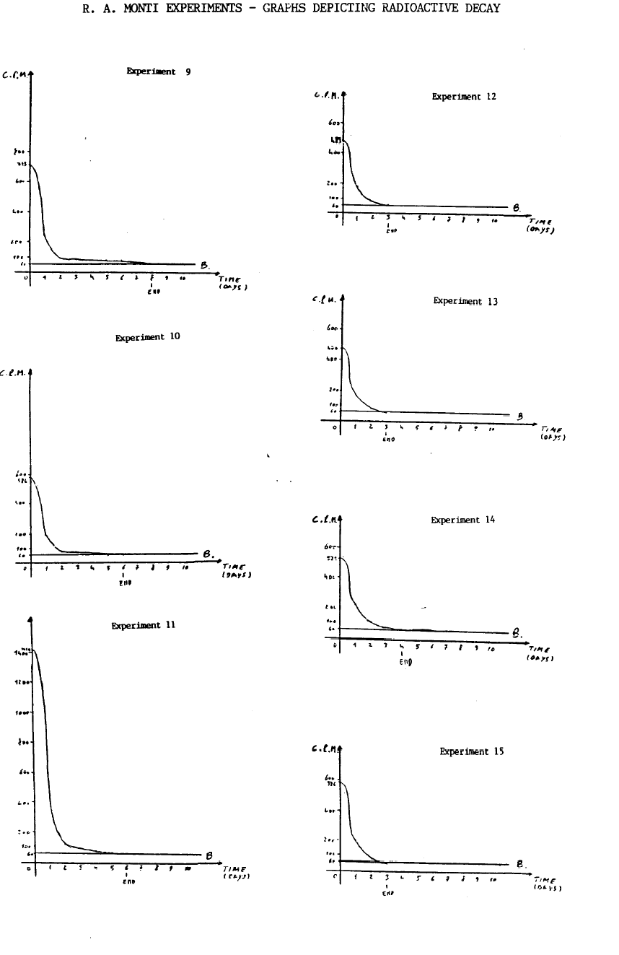
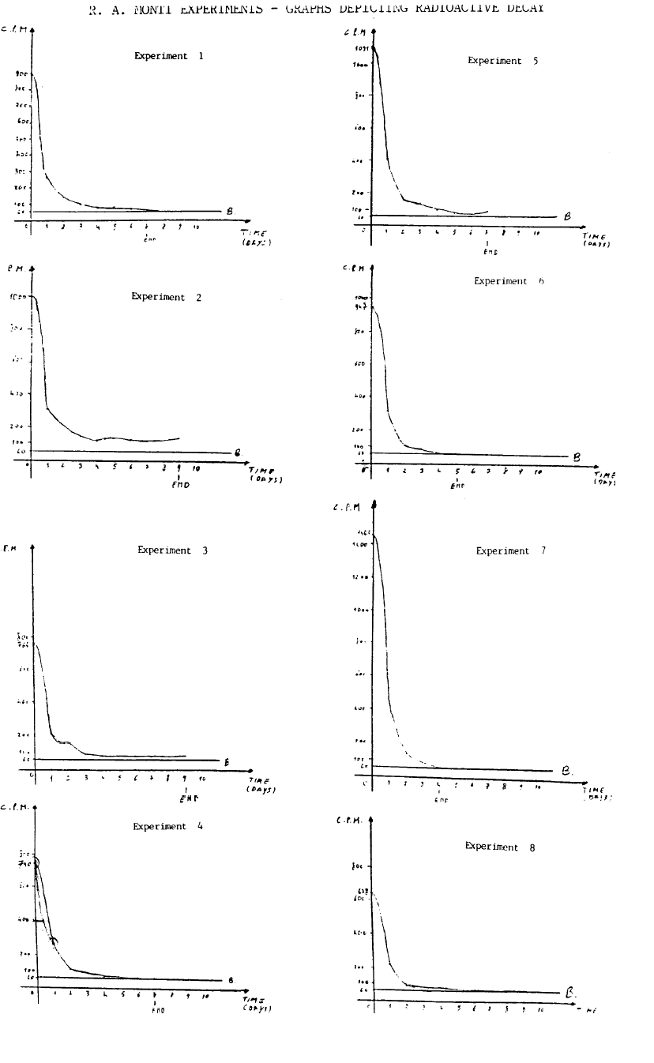

REFERENCES.

(1) R. A. Monti. Cold Fusion and Cold Fission : experimental evidence for the Alpha-Extended Model of the Atom. Communication to ICCF 2. Como,Italy,1991.
(2) R. A. Monti. Low Energy Transmutations. Communication to ICCF 3. Nagoya, Japan 1992.
(3) R. A. Monti. Experiments in Cold Fusion and Cold Fission. Communication to ICCF 4. Maui. Hawaii 1993.
(4) R. A. Monti. Transmutation of radioactive elements by Atomic chemistry. Private communication to J.O'M. Bockris.
(5) J.O'M. Bockris, R. T. Bush, G. H. Lin, R. A. Monti. Lattice Assisted Nuclear Transformations (LANT). Submitted to Fusion Technology.

