Health reasons prevented R. A. Monti to present the paper to ICCF-9.
We wish to thank Hal Fox for publishing it now in J. N. E.

Roberto A. Monti
Researcher. IASF-CNR
Research Director. Monti America Corporation
E-mail: monti@bo.iasf.cnr.it

Gerardina A. Cesarano Monti
Research Assistant
Monti America Corporation
E-mail: cesarano.monti@lowenergytransmutations.org

Metallic Transmutations induced by Acetic Acid.

Abstract

A simple test can show the transmutation of Mercury into Gold, proving that Lavoisier's Principle is experimentally groundless and that Alchemy is an Experimental Science.

The "Principle" of Lavoisier.

In his Traite Elementaire de Chimie, Lavoisier gives "the key and the rules of the new system of Chemistry". (1)
On vol. IV, p.176, we can read: "New (term): Gold. Old (Alchemic) correspondent: Sun".
The description of Gold is then followed by the statement: "It seems impossible that for centuries Sects of Alchemists tried to change less precious elements into Gold".
From the point of view of Lavoisier: "In all Chemical Reactions the same quantity of matter is present before and after the reactions". (1)
Lavoisier consequently hypothesizes that in a Chemical Reaction transmutations from one element to another do not occur ("Principle" of Lavoisier).
One cannot, for example, make Gold from Mercury by means of a Chemical Reaction.
Lavoisier was a very talented and well-educated man. The fact that he was trying to
"translate" the "old" Alchemic terminology into the "new system of Chemistry" shows that he was aware of Alchemy.
We can certainly suppose, for example, that he had within his grasp the famous Biblioteque des Philosophes Chimiques of Salmon, (1672) with the works of Geber and Filalete. (2)
In Geber's Summa Perfectionis the first step to prepare the Philosophical Mercury (a peculiar isomeric configuration of Mercury) (3) is "to purify Mercury with good vinegar". (4)
In his Principles, point 7, Filalete states clearly that "it is necessary to wash the Mercury with vinegar and Salammoniac". (5)
Moreover, in his Open Entrance to the Closed Palace of the King, Filalete states unambiguously that: "Mercury can become the mother of all the metals. From Mercury, as a matter of fact, I can obtain everything, also the Sun (Gold) and the Moon (Silver), without the Transmutation Elixir" (the Philosopher Stone-a catalyst for the transmutation of Mercury into Gold). (6)
Unfortunately Lavoisier could not test the metallic transmutations induced by Acetic Acid. Or because the correspondent chemical reaction is very slow and he was not enough patient, or because during the French Revolution, on May 8, 1794, he was beheaded, and could work no more.

Preparing the components to destroy the nuclear waste.

Mercury Nitrate is one of the components that we use to destroy the radioactive nuclear waste. (7)
Given the high cost of pure Mercury, EUCAN Technologies asked if we had any problem using scrap Mercury coming from Electric Switches.
The answer was: no objections if the Mercury is enough clean.
Consequently 50Kg of Mercury were bought for a few dollars and Leon Theriault, the head technician of EUCAN, decided to "wash" it with vinegar, as "he had seen to be in use in a mine". (8)
Owing to a stop in the preparation of the components for the disposal of the nuclear waste, an amount of Mercury remained "under washing" for a few months.
When it was used later, to obtain Mercury Nitrate, L. Theriault draw our attention on a surprising phenomenon: at the end of the dissolution of Mercury in Nitric Acid, a few milligrams of Gold remained.
We made immediately a test: the "untreated Mercury" was totally dissolved by Nitric Acid; the Mercury "treated" with vinegar left systematically traces of Gold.
Aware since many years about the role played by vinegar and Acetic Acid in the Alchemic processes (9), back in Italy we decided to try a simple application of the Principle of Banality (a variation of Ockam's razor) (7) on 1kg of "treated Mercury" which we brought from Canada.
We decided to prepare a "tres bon vinaigre" (very strong vinegar) and to compare the effects with those of a "bon vinaigre" (good vinegar). (4)
Consequently we divided in two parts our supply of "treated Mercury".
We washed half of it (500g) with white wine vinegar and the other 500g with a mixture (50%) of white wine vinegar and Acetic Acid, for 2 months.
After 2 months we took 100g from the first 500g, and 100g from the second 500g.

When dissolved in Nitric 1 to 5 the first 100g gave 13mg, the second 100g gave 55mg of Gold.
After two more months another 100g of Mercury treated with the mixture of vinegar and Acetic Acid, gave 88mg of Gold.
We have made Gold many times, in different ways, but the Gold obtained directly from Mercury in this way is the most beautiful we have ever seen. (see photographs)

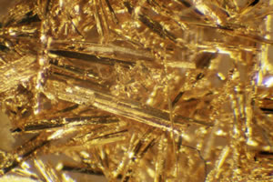

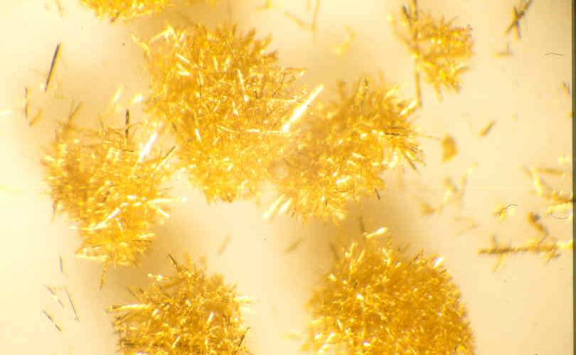

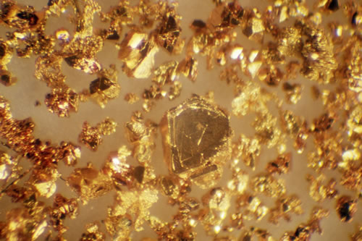

"Treatment" of the Mercury, to make Gold.

Extract your Mercury from Cinnabar (HgS) by roasting, or get it from a Chemical Supply Company. We suggest at least 1kg of Mercury (two will be better).
We have observed that the "purified" Mercury gives very poor results because in the process of "purification" some properties are lost (the Mercury goes in the wrong isomeric configuration). (3)
The Mercury from Electric Switches is usually not purified. This is why it works better. Best of all will work the Mercury from HgS.
Once obtained your Mercury (we suggest 1 or 2 kg ) do the following.
- Divide the Mercury in stocks of 500g.
- Take a 100g sample from each of the 500g and dissolve it into a solution of 1 to 5 Nitric Acid, heating at about 80°. Normally it will dissolve completely. If not take note of what remains.
- Put the remaining 400g in a glass container (1 liter Kerr Jars are good).
- Prepare a solution of 1/2 liter white wine vinegar and 1/2 liter of Acetic Acid.
- Put 1/2 liter of the mixture into the Jar, so that the Mercury will be completely covered.
- Shake the Jar by hand for a few minutes until the Mercury is reduced to tiny beads, so that the surface in contact with the liquid is a maximum.
- Do the shaking one or two times a day.
- After about two weeks some kind of sludge comes out from the Mercury and "covers" it.
If you have two Jars: a) you can keep one clean shaking and substituting the solution with a new 1/2 liter. Save the 1/2 liter solution in another Kerr Jar. In one day the sludge will go to the bottom and you can recover and use again the clean mixture. b) just shake the solution in the second Jar one or two times a day. Look if there is any difference in the final results.
- After about two months (with Mercury from HgS) you can make the first test:
take 100g of the "treated Mercury" and dissolve it in 1 to 5 Nitric Acid (100cc Nitric Acid + 500cc water) at about 80°. You should find the kind of Gold shown in the photographs.
- You can repeat the dissolution every 15 days three more times (for each Kerr
Jar). Pay attention to change the lids of the Kerr Jars at least every 15 days. The
Mixture of vinegar and Acetic Acid is very corrosive: it will "eat" the lids of the Kerr Jars.
- After having dissolved the Mercury pour the solution and clean the Gold (keep it
in the beaker) with a mixture 1 to 2 Nitric Acid (100cc Nitric Acid + 200cc distilled water). Pour the 1 to 2 Nitric Acid and wash the Gold with water.
Pour the water and dry the Gold in the beaker on a hot plate.
- Look with a microscope and analyze your Gold.
When analyzed with SEM (Electron Microscope) it will show only Gold; but when dissolved in Acqua Regia for ICP it will show: 10% Mercury, 90% Gold, owing to its "origin" from Mercury. The source of Mercury is important owing to the different isomeric configurations which can occur in the Mercury. You can make the comparison with different types of Mercury.

Conclusion.

This experiment, in our opinion, is of great didactic importance. The experiment can be easily reproduced, at low expenses, in the laboratory of any University.
It seems not showing seasonal effects and can be started and concluded in a few months.
It shows clearly that:
- The "Principle" of Lavoisier is experimentally groundless.
- Alchemy is an Experimental Science.

We strongly suggest it to the students of Chemistry.

The source of Mercury is important: better results are obtained taking the Mercury directly from Cinnabar. (10)

References.

- A. L. Lavoisier, Traite Elementaire de Chimie,(Italian Edition),Vol. IV,
Venice, 1792.
- G. Salmon, Biblioteque des Philosophes Chimiques, Paris, 1672 .
- R. A. Monti, "Low Energy Nuclear Reactions: The Revival of Alchemy", Proceedings of the International Conference Space and Time, St. Petersburg, Russia, 2001, p.178.
- Geber, Summa Perfectionis, Ed. Tredaniel, Paris, 1992,Vol. II, p.17.
- I. Filalete, "Principles", In: J. Sadoul, The Treasure of the Alchemists (Italian Edition), Ed. Mediterranee, Roma, 1972, p.44.
- I. Filalete, Open Entrance to the closed Palace of the King (Italian Edition), Phoenix, Genova, 1987, p.11.
- R. A. Monti, "Nuclear Transmutation Processes of Lead, Silver, Thorium and Uranium", ICCF-7 Proceedings, ENECO, Vancouver, 1998, p.264.
- L. Theriault, Private communication to R.A. Monti.
- See: G. Rupescissa, On the Preparation of the true Philosopher Stone (Italian Edition), Ed. Atanor, Roma, p.41; G. Testi, Dictionary of Alchemy and Antiquary Chemistry (Italian Edition), Ed. Mediterranee, Roma, 1980, p.73.
- F. Nardin, Private communication to R. A. Monti.

