Roberto A. Monti
Researcher IASF-CNR
Research Director
Monti America Corporation
E-mail: monti@bo.iasf.cnr.it

Gerardina A. Cesarano Monti

Research Assistant
Monti America Corporation
E-mail: gerardinacesarano@hotmail.com

The real Einstein

Abstract

There is a definite coherence and continuity of the non - null results of the interferometric experiments, which cause the Theory of Relativity unlikely to be sound.
Optical Gyroscopes disprove everyday Special Relativity.
The entire Theory of Relativity, both Special and General and its cosmological implications, the Big Bang and the Expanding Universe are highly speculative.
Relativity has proved to be the greatest scientific swindle in the history of Modern Science.
Résumé

Il existe une cohérence et une continuité certaine dans les résultats non nuls obtenus dans le cadre des expériences interférométriques qui fragilisent la Théorie de la Relativité.
Les expériences réalisées à l’aide de gyroscopes optiques désapprouvent chaque jour la Théorie de la Relativité Restreinte.
La Théorie de la Relativité toute entière, Restreinte et Général, et ses implications cosmologiques comme le Big Bang et l’expansion de l’Univers sont hautement spéculatives.
La Théorie de la Relativité s’avère être la plus grande escroquerie scientifique de l’histoire de la Science Moderne.

Key words.

Theory of Relativity, Electromagnetic (one way) measurements of the Speed of Light, Kinematic measurements of the Speed of Light, Interferometric experiments, Electric conductivity of the Ether, Optical Gyroscopes, Cosmology, Background Radiation, Extragalactic redshifts.
1. Introduction.

According to L. Essen, Einstein's paper of 1905 is characterized by strange features as the brevity of the introduction…and the omission of any reference to the work of H. A. Lorentz and H. Poincare. (1)
In our opinion Essen is simply omitting to consider the elementary experimental evidence: that A. Einstein was a mediocre student, the worst in his class, with the only possibility, once graduated, to become an employee of the Patent Office in Bern.
Einstein came to know Michelson's experiment in his student's years, having read Lorentz's book of 1895 (2): Soon I came to the conclusion that our idea about the motion of the Earth with respect to the Ether is incorrect, if we admit the Michelson null result as a fact. (3)
As a German student he had, clearly, no occasion to read the original paper (in English) of Michelson and Morley: otherwise he should have known that the experimental result was beneath expectations, but not null.
The relative velocity of the Earth and the Ether is probably less than one sixth the Earth orbital velocity (5 km/s) and certainly less than one fourth (7.5km/s)…the experiment shall be repeated. (4)
Einstein came too soon to a wrong idea as a consequence of wrong information.
Moreover, as an employee of the Patent office in Bern, he had no occasion to have direct knowledge of Experimental Physics, especially Electromagnetic Metrology: he was simply not acquainted with such things as references and bibliography.
For this reason, in his Special Relativity paper, he did not mention Michelson's name (1): he was simply admitting the Michelson null result as a fact. (3)
For the same reason, he did not know Michelson's paper of 1904: Relative motion of Earth and Ether (5), which explains the principle of the Michelson-Sagnac Effect: the principle of the Optical Gyroscope. (6), (7)
2. H. A. Lorentz.

H. A. Lorentz is an example of 'Theoretical Physicist' not acquainted with Experimental Physics.
His theoretical treatment of Michelson Morley experiment does not consider the physical reality of the experiment.
As a matter of fact, in Lorentz's representation of Michelson Morley experiment, four fundamental mistakes are made:
- Lorentz seems unaware of the difference between the kinematic speed of light:
c_{M} = 2L / ΔT = λν and the electromagnetic (or one way) speed of light:
c₀ = (ε₀ μ₀)^{-1/2} = λ₀ ν₀ . (8), (9) These two, different, physical quantities are never distinguished. One only letter is used for both of them: c, the speed of light.
- Lorentz seems unable to write the continuous relation between c₀ and c_{M} ,which is: c_{M} = c₀ (1- β²) / (1- β² Sin²θ )^{1/2} . (9) The cases: θ = 0 ; θ = π /2 are considered separately. As a consequence, in every Relativity textbook we can find the two paradoxes: c= c(1- β²), for θ = 0 ; c= c(1- β²)^{1/2}, for θ = π /2 .
- Lorentz seems unable to understand that the reference frame whereby the
Electromagnetic speed of light c₀ results experimentally in being equal to the Kinematic speed of light c_{M} (c_{M} = c₀ if v = 0), is precisely the Space absolutely at rest endowed with special properties, or Ether. (9)
4) The project of the experimental apparatus to detect the relative motion of the
Earth and the Luminiferous Ether (4) has a fundamental flaw: the effect to
be shown does not depend on the length of the Optical Path, but on the surface
enclosed by the Optical Path, as shown by Michelson in 1904. (5)

3. Einstein's Theory of Relativity.

Einstein took for granted the null result of Michelson Morley experiment (3) and devised a Theory to explain this null result: the Theory of Relativity.
The fundamental statement of the Theory of Relativity is the following:
Let us establish, according to experimental evidence, that the quantity: c = 2L / ΔT is a Universal Constant, the speed of light in empty space. (10)
Einstein does not say according to which experimental evidence his c, which is c_{M} , is a Universal Constant.
Moreover: The introduction of a luminiferous Ether will prove to be superfluous…as will the introduction of a Space absolutely at rest endowed with special properties. (10) Again Einstein states that the space absolutely at rest… will prove to be superfluous.
But he gives no proof of this statement.
As a consequence of these statements the three special properties of the Ether which appear in the Electromagnetic wave equation (11), (12):
ε₀ μ₀ (δ² F /δt²) +σ₀ μ₀ (δF /δt) = ΔF [1] ; where:
ε₀ = Electric Permittivity of the Ether (F/m)
μ₀ = Magnetic Permeability of the Ether (H/m)
σ₀ = Electric Conductivity of the Ether (Ω m)⁻¹
are neglected as superfluous: they simply disappear. (10)
Einstein's statement is obviously groundless, considering the way in which Maxwell established the Electromagnetic Theory of Light: It is manifest that the velocity of light (c_{M} ) and the ratio of the Units (c₀) are quantities of the same order of magnitude. Neither of them can be said to be determined as yet with such a degree of accuracy as to enable us to assert that one is greater or less than the other.
It is to be hoped that, by further experiment, the relation between the magnitudes of the two quantities may be more accurately determined . In the meantime our theory, which asserts that these two quantities are equal, and assigns a physical reason for this equality, is certainly not contradicted by the comparison of these results such as they are. (11)
That is: c_{M} = 2L / ΔT and c₀ = (ε₀ μ₀)^{-1/2} are two quantities methodologically distinct.
They are the result of two independent measurements. And if these measurements result to be (nearly) equal, Light and Electromagnetic Waves are the same thing.
Einstein, certainly not a skilled Metrologist, dealing with Lorentz's treatment of the Michelson Morley experiment, is not able to understand that he is not faced with the paradox: c = c(1- β²) ; β = v/c , which requires an 'extraordinary' explanation (Relativity): he is facing the relation between two distinct physical quantities:
c_{M} = c₀ (1- β²) ; β = v/c₀ .
Unfortunately even a skilled Metrologist like Essen (and all the others) is not able to find the fundamental error in the Theory of Relativity: he seems completely unaware of the difference between c₀ and c_{M} .
The method of determination of the velocity (of light) had already been described. A pulse of light is sent from one point to the other and back again and the velocity found from the time taken for the double journey. The value obtained in this way in classical Theory is: c (1 - v²/c²). The assumption made therefore is that the velocity of light will be c instead of c(1 - v²/c²). It is only the second order term that it is assumed not to be present. (1)
Michelson was aware, since 1902, of the difference between c₀ and c_{M} : Such a difference might almost certainly be predicted, and would probably throw much light on the structure and mode of action of dielectrics. (13)
But, to our knowledge, he never again mentioned the question and his prediction, that There is little doubt that in the near future both these determinations will be made with almost the same high order of accuracy, (13) was not fulfilled.
Rosa and Dorsey made an electromagnetic measurement of the Speed of Light from 1905 to 1907: it was the last. (8), (14)

4. The Michelson Morley experiment 'before 1905'.

It is now time to consider the 1887 paper by Michelson and Morley, which Einstein never analyzed before 1905.
In 1887 the experiment was supposed to measure the Earth's orbital velocity, which was already known from astronomical measurements and confirmed by the measurements of the Kinematic Speed of Light (c_{M}, 1849) and the Electromagnetic measurement of the Speed of Light (c₀, 1856): both terrestrial measurements. (11), (13), (15)
The result (of Michelson Morley experiment) did not have the anticipated magnitude, corresponding to the known velocity of about 30 km/s: in fig.1... the dotted curve represents one eight of the theoretical displacement. (4)
The experimental result is clearly not up to expectation. There is no explanation about where the sinusoidal form of the theoretical displacement comes from.
It is stated that the experiment… will be repeated. (4)
But notwithstanding many printed statements to the contrary…Michelson and Morley made only one series of observations, in July 1887, and never repeated the Ether drift experiment at any other time. (9), (16)
5. The Michelson Morley experiment 'after 1905'.

Morley and Miller repeated the Michelson Morley experiment from 1902 to 1905, with a result similar to the one of 1887: The observations…showed a very definite positive effect slightly larger than that previously obtained, but still too small to be reconciled with the expectation: v = 8.7 ± 0.6 km/sec . (16), (17)
The tests of the Theory of Relativity, made at the solar eclipse of 1919, were widely accepted as confirming the theory. Since the Theory of Relativity postulates an exact null effect from the Ether drift experiment which had never been obtained in fact, the writer (Miller) felt impelled to repeat the experiment in order to secure a definitive result. (16)
That is: Miller understands that the experimental verification of the Theory of Relativity offers a reason for new experiments of the Michelson Morley type, even if they cannot measure directly the absolute velocity of the Earth. In fact in 1921 he obtains the funds for the experiment, to test the Theory of Relativity.
Unfortunately Miller was clearly unaware of the Michelson Sagnac Effect.
Certainly he does not understand that he has the possibility to detect the full effect of the orbital velocity of the Earth by changing the geometry of the Optical Path in the interferometer. As a matter of fact he repeats another Drift Experiment of the Michelson Morley type: with the Optical Path enclosing an insufficient area. (7)
Anyway, with a two arm interferometer it is possible to make a comparison between the Kinematic Speed of Light in different directions, without making measurements of c_{M} . Any daily or seasonal effect will destroy the Theory of Relativity: it is enough to justify a new test.
Like Miller, Einstein also understands the meaning of periodical effects in a Universal Constant.
In a letter to Millikan (June 1921) he states the following: I believe that I have really found the relationship between Gravitation and Electricity, assuming that the Miller experiments are based on a fundamental error. Otherwise, the whole Relativity Theory collapses like a house of cards. (18)
But: 1) Einstein has found no relation between Gravitation and Electricity.
2) Miller experiments have no fundamental error: These observations all show a positive periodic displacement of the interference fringes, as of an Ether drift, of the same magnitude, about 10 ± 0.33 km/s, as had been obtained in previous trials…The effects were shown to be real and systematic, beyond any further question. (16)
On April 2, 1921 Einstein arrived for the first time in the United States for a two months visit…while he was there, words reached Princeton that Miller had found a nonzero Ether drift during preliminary experiments, performed (on April 8-21) at Mount Wilson observatory. Upon hearing this rumor Einstein commented: "Subtle is the Lord, but malicious He is not". Never the less on May 25, 1921, shortly before his departure from the United States, Einstein paid a visit to Miller in Cleveland, where they talked matters over. (19)
Consequently Einstein was fully aware of Miller results.
Having to choose between experimental evidence and his theory Einstein chooses his own theory.
On April 28, 1925, Miller read a paper before the National Academy of Science in Washington D.C. in which he reported that an Ether drift had definitely been established…Einstein got flooded with telegrams and letters asking him to comment.(19) He kept silent, but in a letter to his friend Besso (December 23, 1925), he writes: I have not for a moment taken (Miller results) seriously. (19)
That is: 'If my Theory is contradicted by experimental evidence, then experimental evidence must be wrong'.
The real Einstein shows himself.
Miller's work was a major obstacle to the Einstein's Theory of Relativity…
Shankland blamed Miller for having blocked the awarding of a Nobel Prize to Einstein for his Relativity Theory. (18)
Miller experimental results from 1921 to 1925 proved the correctness of Miller's opinion about Relativity because the whole Relativity collapses like a house of cards as a consequence of the fact that c_{M} proves not to be a Universal Constant, being subject to daily and seasonal effects.
But, probably, too confident in his own experimental results, Miller did not consider the experimental result by Michelson and Gale, published in the same year (1925). (20)
Coherence and continuity of the non - null results of the interferometric experiments.

6. The Sagnac experiment.

In 1904 Michelson had a new idea to test the effects of the smaller rotational (instead of the orbital) velocity of the Earth on the Kinematic Speed of Light (5), but he was unable to fund the experiment.
Michelson idea was taken and developed by Sagnac in 1913. (21)
Sagnac understood that the fundamental idea in Michelson 1904 experiment was that an interferometer device with a beam path enclosing a finite area would give a clearly observable fringe shift.
From this point of view it is easy to understand that the Michelson Morley type experiment is nearly the worst possible solution.
Both the ideal Lorentz representation of the experiment (fig.2) and the real experiment (fig.3) show that the beam path encloses very small areas.
But adding one mirror to the ideal Michelson Morley experiment we have Sagnac experiment (fig.4).
Consider the difference: Δt_{F} - Δt_{R}, where: Δt_{F} = L / (c₀ - v) ; Δt_{R} = L /(c₀ + v) (9).
Neglecting only terms in β³ and higher order, we have: ΔT = Δt_{F} - Δt_{R} = 2Lβ /c₀ .
The corresponding phase shift is: Δ_{L} = c₀ ΔT / λ = 2L β /λ.
In the case of fig.5, for example, we have: Δ_{L} = 2(2πR) v / λ c₀ = 4ω S / c₀λ.
This relation is completely general, that is: a) it does not depend on the shape of the surface S; and: b) it does not depend on the location of the center of rotation. (22)
In 1913 Sagnac proved the formula: Δ_{L} = 4ω S / c₀λ and disproved the Theory of Relativity. Moreover, he suggested that a large Sagnac Circuit fixed to a carrier (a ship in his example) could be sensitive to slow and small deviations around a fixed velocity, so that it could work as an Optical Gyroscope (21); slow and small deviations like, for example, those in the Michelson Morley type (Miller) interferometer.
The result of Sagnac's experiment corresponded to the magnitude anticipated by the theory: it was, finally, a full effect.

7. The Michelson Gale experiment (1925).

After the result of the Solar Eclipse of 1919, Michelson could find the money for a new test of Relativity both Special and General. (7), (23)
In the Michelson Gale experiment the ship of Sagnac (21) was the Earth itself.
The Michelson Gale apparatus, owing to its dimensions, was sensitive to the Earth's rotation. (20), (9) It consisted of two coupled interferometric experiments, fixed in Clearing, Illinois (rotating with the Earth, fig.6), of which one gives a null Michelson Sagnac Effect owing to insufficient surface, and worked as a fiducial mark, whereas the second gives a positive Michelson Sagnac Effect owing to the large enough surface enclosed by the Optical Path of the two pencils of light. (fig.6)
The approximations used to obtain the formula: Δ_{L} = ( 4ω / c₀λ) (S₁ - S₂) Sin φ ,
where: φ = 41°46' is the latitude of the experiment, are questionable.
As a matter of fact, the distribution of the experimental data in Michelson Gale experiment shows large oscillations around the constant value:
Δ_{L} = ( 4ω / c₀λ) (S₁ - S₂) Sin φ = 0.23.
The Michelson Gale apparatus works exactly as an Optical Gyroscope showing, in addition to the constant effect due to the rotation of the Earth around its axis, other deviations due to other velocities (velocity of revolution, velocity relative to the Background Radiation). (9)
Michelson omitted to give his experimental data in time sequence. (see fig.7)
Anyway the data show clearly that c_{M} is not a Universal Constant, in contradiction of Special Relativity.
But taking for granted General Relativity on the basis of the test of 1919, there is a possible explanation for a full effect.
It seems that Michelson, following Silberstein, hoped that the experiment would reveal the existence of only a fraction k of the (full) effect, sensibly different from unity, which would have irremediably disproved the Relativity Theory, Special and General. (23)
It is difficult to understand why the full effect already shown by the Sagnac experiment should have been different from the full effect of the similar Michelson Gale experiment.
As a matter of fact the full effect shown by the experiment of Michelson and Gale was understood as a delusion by Michelson: The calculated value of the displacement on the assumption of a stationary Ether as well as in accordance with (General) Relativity is …. (20)
Michelson, a good experimentalist but probably not acquainted with Theoretical Physics, is not able to understand that - only according to Langevin opinion - the full effect, which contradicts Special Relativity, can be explained by General Relativity, if General Relativity is true.
But General Relativity is experimentally groundless: the positive result in favour of Relativity was simply a swindle played by Eddington (9), (24), (31).
Einstein maintained in print a studied silence regarding the damaging discoveries of Sagnac, Michelson & Gale. (25)

8. Langevin 'explanation' of Sagnac experiment.

Two years after Sagnac's experimental result Einstein produced the General Theory of Relativity. (26)
One very important, because unexpected, experimental proof of the General Theory should have been a difference between the Newtonian and Einsteinian deflection of a beam of light passing near the Sun (near a strong gravitational field).
The experimental results observed during the 1919 solar eclipse were unable to prove anything, but Eddington decided that they were convincing in favour of Einsteinian Theory and the Theory was quickly, widely and easily accepted. (24)
These results were never experimentally confirmed: (in 1965) we cannot jet be certain what to make of these observations. (27)
But in 1921, after the 'success' of the 1919 expeditions, Langevin tried to 'save' Special Relativity by means of General Relativity. (28)
According to Special Relativity (9), (10): Δt_{F} = Δt_{R} . The Optical Gyroscope works owing to the fact that: Δt_{F} ≠ Δt_{R} , that is: in contradiction with Special Relativity (Einstein ,consequently, considered the Optical Gyroscope to be theoretically impossible). (29)
Langevin then made the hypothesis that the rotation of the platform in Sagnac experiment, with a frequency of about two rotations per second, causes, within the reference frame connected with the rotating platform, exactly the space time variations that can explain the experimental result: Δ_{L} = 4ω S / c₀λ if General Relativity is true.
In a previous paper we have given the reasons why Langevin argumentation is experimentally groundless (9):
- Langevin starts his explanation saying that the Michelson Morley experiment and Sagnac experiment are not comparable. (28) But he only shows that he has not understood that the only difference consists in one mirror (3 instead of 4).
- There are no direct experimental proofs of the space time variations called for by Langevin. The relativistic explanations of the well known secular advance of Mercury's perihelion does not consider that the 1916 experimental value of the unexplained advance of 43" was corrected in 1930 to 50.9". (30)
Today we know that a new evaluation in necessary. (31) Moreover, Einstein's explanation (of the advance) was based on the hypothesis that the speed of Gravitational Interaction is equal to the Speed of Light.
This statement has no experimental evidence. On the contrary Laplace (32) and Tisserand (33) showed experimental evidence to the contrary.
Today we know that the Sun's solid inner core rotates faster than the surface, and this can explain the precessions of the planets. (34), (35)
In 1920 Dyson and Eddington (36) put forth, without any experimental proof, the hypothesis that the refraction index of Solar atmosphere had a constant value:
n<1.00000212, and neglected the results from the astrographic plates of Sobral's expedition.
Finally the experiment by Pound and Rebka (37) showed that the energy or mass of light is subject to gravitation in the same way as ordinary matter. (38)
3) Ives pointed out that the behavior of moving clocks supposed by Langevin ends
with another clock paradox that has no experimental proof. (39)
- Michelson and Gale showed in 1925 (20) that the platform of the Sagnac experiment can also work fixed to the Earth (with no additional rotations) - the same reference frame of Michelson Morley experiment.
5) In 1941 Dufour and Prunier showed that Langevin argumentation is disproved if
part of the Optical Circuit is fixed to the laboratory. (40)
6) Langevin did not pay attention to the most important statement made by Sagnac:
that a large circuit could be sensitive to slow and small deviations around a fixed
velocity (21), so that it could work as an Optical Gyroscope.
Today we know that an Optical Gyroscope can fit the palm of one's hand (41)
and is sensitive to 0.001 deg/h (42). General Relativity is simply ruled out by
such rotational velocity. Every day Optical Gyroscopes on passenger carriers, like Boeing and Airbus, disprove Special Relativity.
- In 1999 E. J. Post showed the equivalence between the Michelson Morley experiment and the Sagnac experiment. (43)
General Relativity, which is a generalization of Special Relativity (26), cannot give any validation to Special Relativity.
Langevin argumentation is experimentally groundless and Sagnac's experiment disproves Relativity. (44)

9. The Michelson, Pease and Pearson experiment (1929).

After Miller's result Michelson could not avoid a repetition of his experiment. (fig.8) (45)
Michelson gave a first announcement of his result at the Michelson Meeting of October 31- November 3, 1928: The result gave no displacement as great as one fiftieth (1/50) of that to be expected on the supposition of an effect due to a motion of the Solar System of 300 km/s (6 km/s, similar to the one of 1887). These results are differences between the displacement observed at maximum and minimum at sidereal times. These directions correspond to Dr. Stromberg's calculations of the supposed velocity of the Solar System. (46)
But later (January 1929) he corrected the previous announcement: …No displacement of the order anticipated was obtained…the results gave no displacement as great as one fifteenth (1/15) of that to be expected on the supposition of an effect due to a motion of the Solar System of 300 km/s. (45) 20 km/s: double Miller's result.
Michelson had only two possibilities: 1) to confirm, in accordance with Miller, that Michelson Morley experiment never had a null result and, consequently, Relativity collapses like a house of cards. 2) Stop the experiment and do not publish the already available experimental data.
The experiment was stopped and the experimental data, to our knowledge, were not published.
10. The Kennedy Thorndike experiment (1932).

In 1929 Kennedy and Thorndike supposed that, according to their theoretical calculation, a Michelson Morley interferometer with unequal arms (L₁ ≠ L₂) could show experimental evidence not only for the longitudinal contraction L = L₀(1- β²)^{1/2},
but also for the time dilation ΔT = ΔT₀ / (1- β²)^{1/2}.
Consequently they built an interferometer with unequal arms. (fig.9) (47)
But they had an astonishing surprise: the interferometer worked as an Optical Gyroscope, showing a daily effect due to the rotation of the Earth around some kind of fixed velocity. The daily effect was a real effect: it could be clearly observed in the photographic plates. Again they tried to save Relativity saying that the effect had not the anticipated magnitude according to Ether theories, the experiment has a result as null as the result of Michelson Morley experiment. (47)
But, as a matter of fact, the daily effect of the Kennedy Thorndike experiment definitely disproves Relativity, because a daily effect in itself means that the Kinematic Speed of Light is not constant during the day, while the anticipated theoretical magnitude according to Relativity is: no daily effects.
It is important to note the following: the experimental apparatus (of Kennedy and Thorndike) consisted of a two arms interferometer, very similar, apart the unequal arms, to the ideal Lorentz representation of the Michelson Morley experiment, and very similar to the Michelson Gale experiment: the interferometer was fixed to the Earth (rotating with the Earth). The two Optical Paths were enclosing small, different surfaces S₁, S₂ (9), these were too small to give a full Michelson Sagnac effect, but sufficient to give the observed velocity behind expectations of about 15 ± 4 km/s . (47)
Once again the experiment proved that the exact null result postulated by the Theory of Relativity had never been obtained.
Kennedy and Thorndike showed also that the Lorentz - Michelson solution for the fringe shift does not depend on the SUM L₁ + L₂ of the Optical paths.
We have shown (9, p.248) that it may depend on the difference L₂ - L₁ of the lengths of the Optical paths.
As a matter of fact Michelson, like Miller, tried for a life to maximize the SUM L₁ + L₂ up to about 50 m, with “multiple reflections”, destroying any possibility to apply Lorentz - Michelson solution to the real Optical paths (see: 9, p.247 and fig. 3).
On the contrary Kennedy and Thorndike, using unequal arms (L₂ - L₁ about 15 cm ) and a total length of about 60 cm, obtained a result 3 times bigger than Michelson - Morley result.
A repetition of the Kennedy and Thorndike experiment according to the apparatus shown in fig.10: a Michelson Gale (fixed to the Earth) Sagnac (with disjoint and unequal surfaces), should be interesting. Attention has to be paid to avoid the locking of the standing waves in the interferometer. (9)

Conclusion

As we have seen, there is a definite coherence and continuity of the non - null results of the interferometric experiments.
Shankland, after extensive consultation with Einstein, decided to subject Miller's observation to a thoroughgoing review…Einstein saw the final draft (of Shankland's prepublication manuscript) and wrote a personal letter of appreciation for having finally explained the small periodic residual from (Miller's) Mount Wilson experiments. (48)
But, faced with the experimental evidence shown by Miller and about the time of Einstein's death, Shankland decided not to embark himself on a sound recomputation of the cosmic solution data. (49)
In 1997 Maurice Allais made a sound recomputation of the cosmic solution data shown by Miller, confirming the correctness of Miller's results. (50), (51)

11. Errata Corrige (R. A. Monti).

In my student's years Arnold Sommerfeld's Lectures on Theoretical Physics (VI Volumes) was one of my preferred textbooks.
I took for granted Sommerfeld's explanation of the measurement of the velocity of light made by O. Roemer (1676). (52)
Unfortunately I did not pay attention to two fundamental mistakes made by Sommerfeld: he made no distinction between c₀ and c_{M} ; consequently his explanation for Roemer's and Bradley's experiments, which I used as a reference (9), is wrong.
The correct expressions for T_{MAX} and T_{MIN} are the following (53):
T_{MAX} = T₀ + v T_{MAX} / c₀ ; T_{MIN} = T₀ - v T_{MIN} / c₀ .
From which: T_{MAX} = T₀ / (1- β) ; T_{MIN} = T₀ / (1+ β) and:
ΔT = 2v T₀ / c₀ (1- β²) = 2v T₀ / c_{M} ⇒ v = ΔT c_{M} / 2T₀ .
The uncertainties in the measurements of c₀ and c_{M} do not allow us to distinguish between c₀ and c_{M} . Both the measurements of the speed of light (Electromagnetic and Kinematic) allow the measurement of the absolute velocity of the Earth.
It is important to underline: 1) that the electromagnetic measurements of the Speed of Light allow the measurement of the true Maxwell's constant: c₀ = (ε₀ μ₀)^{-1/2}.
2) That this measurement allow the calculation of the absolute velocity of the Earth by means of the measurement of two physical properties of the medium through which the electromagnetic waves propagate (Ether). 3) That Roemer's experiment is equivalent to the horizontal arm in Lorentz's representation of Michelson Morley experiment. 4) That in 1728 Bradley, on the basis of Roemer's hypothesis, could measure the aberration angle: α = v / c₀ = β .
Bradley's experiment is equivalent to the vertical arm in Lorentz's representation of Michelson Morley experiment.
Roemer's and Bradley's experiments show that: in Nature the Speed of Light plays physically the role of a finite velocity.
Einstein's statement: In my Theory (of Relativity) the Speed of Light plays physically the role of an infinite velocity (10) is a consequence of the trivial solution of the paradox:
c + v = c ($∞$ = $∞$). (52)
The non trivial solution, according to Einstein, should be the theorem of the addition of velocities (10) which is based on the experimentally groundless principle: c_{M} is a Universal Constant.
Einstein's Physical Theory (Relativity) has nothing to do with Physical Reality.
Errata corrige.

12. The electric conductivity of the Ether.

Einstein was not acquainted not only with the American Journal of Science, but also with the Philosophical Magazine.
Omitting to read the original papers of Michelson and Morley (4) and Michelson (5) he lost not only the occasion to pay attention to the special properties of the Ether: ε₀ and μ₀ , but also to the third special property of the Ether: σ₀ .
In 1897 John Trowbridge, whose name Einstein could have met in the last page of Michelson Morley paper (4), communicated the paper: The electrical conductivity of the Ether to the Philosophical Magazine. (54)
The electric conductivity of the Ether was considered negligible by Maxwell: Ether transmits transverse vibrations to a very large distance with a negligible dispersion of energy, because we can see the light from the Sun and the Stars. (55)
Edlund maintained the electrical conductivity of the Ether, which has been apparently disproved by various recent investigations - notably those of Prof. J. J. Thomson. The latter writer, in his treatise entitled Recent Researches in Electricity and Magnetism, also remarks (p.98) : These experiments show that after a certain exhaustion has been passed, the difficulty of getting a discharge to pass through a highly exhausted tube increases as exhaustion is increased. This result is in direct opposition to a theory which has found favor with some physicists, viz. that a vacuum is a conductor of electricity …numerous other experiments of very different kinds point to the conclusion that a vacuum is not a conductor …Again if we accept Maxwell's Electromagnetic Theory of Light, a vacuum cannot be a conductor or it would be opaque and we should not receive any light from the Sun of Stars. (54), (56)
To this statement, made by Thomson, Trowbridge replies as follows: I have studied the resistance of highly rarefied media with disruptive discharges and I am led to the conclusion that with a sufficiently powerful electrical stress, what we term a vacuum can be broken down, and that the disruptive charge during its oscillations encounters very little resistance …the Ether offers very little resistance … My experiments lead me to conclude that under very high electrical stress the Ether breaks down and becomes a good conductor. (54)
Thomson intended his Treatise as a sequel to Professor Clerk Maxwell's Treatise on Electricity and Magnetism. (56)
But Maxwell wrote correctly: because we can see the light from the Sun and the Stars the dispersion of the energy of the electromagnetic waves is negligible.
Thomson wrote instead: the vacuum cannot be a conductor… or we should not receive any light from the Sun or Stars.
Thomson's statement is clearly in contradiction with Newton's Third Principle (Action and Reaction): if the Electric Conductivity of the Ether is zero, electromagnetic waves should be an example of perpetual motion (no damping for the energy of the electromagnetic waves during their journey).
Thomson did not see this contradiction and did not add any errata corrige in his Treatise to take notice of Trowbridge's experiment.
His Treatise became (probably) a textbook in his time: as a matter of fact, to our knowledge, the question of σ₀ disappeared from the scientific literature.
Einstein (probably) knew ε₀ and μ₀ : the two special properties of the Ether, that - in his Theory - became superfluous. (10)
Maybe he had occasion to note the wave resistance of the Ether: R₀ = (μ₀ / ε₀ )^{1/2} = 377 Ω (12), but he shows to be completely unaware of the third special property of the Ether: σ₀ …until 1925.
In 1925 the experimental results of Miller and Michelson Gale, gave a terrible shock to Relativity and, in addition, something new came into play: the forgotten question of σ₀ .
From 1912 onwards Slipher made the first observations regarding systematic shifts in the spectra of the nearest galaxies.
Although the first one, Andromeda, was a blue shift, redshifts were soon to predominate in the list he had compiled by 1925. (57), (58)
Walter Nernst was, probably, the first one to take note of Slipher's observations, in the same year (1912).
Certainly since 1921 he had focused correctly the question: The most important aspect of my observations lies in the hypothesis, already dealt with in the work I carried out in 1912, which has already been proven, namely that basically the Universe is in a stationary state…since 1921 I had emphasized, in Structure of the World, p.40, that in the presence of a freely expanding Universe of unlimited age, interstellar temperature should be continually increasing on account of radiation; yet in reality we are certain that this temperature has remained extremely low.
In order to explain this I then concluded that, Luminous Ether…thought to be a conductor capable of assuming energy, a fact which may only be disputed with great difficulty, possesses the ability to absorb radiant energy even if only in extremely small quantities. One might imagine that this absorption would redistribute the irradiated energy over the long term, thus returning it to the zero point energy of luminous Ether.
It may therefore be concluded that even in the steady state the temperature of the Universe can be very low. (59)
In 1938 This concept has since met with experimental proof of considerable importance. While I was looking for experimental proof of the above hypothetical phenomenon, I came across the famous nebulae redshift and thought that it contained what I was looking for, in other words a fall in luminous quantum energy only resulting in diminished frequency, i.e. light absorption…
Let's make the following simple hypothesis for the gradual disappearance of light quantum: -d(hν) = H(hν)dt [2]…therefore: ln(ν₀ /ν) = Ht …on the basis of this simple formula, we think we have replaced the fairly unreliable theory of the exploding Universe with a much simpler concept of vast importance, which also accounts for redshifts in the most distant object…and it is highly significant that Hubble, one of the discoverers of redshifts, should consider the model of the expanding Universe to be unreliable…continuing Hubble's research with a more powerful telescope…we could on the other hand arrive at an answer to a very important question, namely according to which law the frequency of light quanta is modified.
Hubble made the hypothesis of a linear relation: t = 1.84 × 10⁹(ν₀ -ν) /ν L.Y.
whereas my approach goes like this: t = 1.84 × 10⁹ ln [(ν₀ - ν)/ν] L.Y.
In his successive works Hubble still declared the interpretation of redshift as being a Doppler Effect to be untrue. He based this on the fact that the decrease in nebulae luminosity over distance did not proceed as a Doppler Effect did, but much more slowly, thus corresponding to my new interpretation.
From an astronomic viewpoint, equation [2] poses precise limits on the possibility of penetrating ever greater territories with the aid of the telescope…at a distance of 1.8 thousand million light years, the energy irradiation by a luminous source is reduced by 1/3 and so on. At ever increasing distances individual sources of light can no longer be distinguished…just as in the case with Olber's paradox, a solution to the
so - called gravitational paradox can be found in equation [2]…in place of the law of gravity: K = f(m m' / r²) would be: K = f(m m' / r²) exp (- rH/c)…
it is important to emphasize that we are not dealing with an arbitrary modification to the law of gravity, as (this modification) has been borne out by experimental findings (redshifts, etc)…
We should hypothesize, as Regener did, that the source of this radiation is the entire Universe, as per my hypothesis of 1912 before this had been discovered, and following the ideas behind all of my astrophysical observations…
Regener's important work that I have just quoted contains the fact that a body in the Universe absorbing cosmic radiation should heat up to 2.8°K…
All the individual parts of cosmic radiation undergo upon the basis of equation [2], a redshift… of the energy available in the Universe…most of it is required to keep cosmic radiation constant…this would yet again stress the fundamental importance offered by the study of cosmic radiation to the fields of Physics and Astrophysics…
My guiding conviction has been the study of the hypothesis which claims that the Universe is in a stationary state…in 1912 this hypothesis had already led me to conclude that space must be full of cosmic radiation...further study of my ideas will render some parts of cosmic radiation more comprehensible...As I had already forecast in 1921, redshift once more forms the basis of my theory...whereby it does not constitute a Doppler Effect…this final reaffirmation of the point I wish to make can be proven, quite independently of any of my studies, by Hubble's astronomical measurements, which also exclude the hypothesis of exploding space, a theory which has never been included among any of my observations…For the moment my redshift equation leads to some physical generalizations which can be deduced from observations that have not yet been completed. However, they should be borne in mind…the astrophysical observations published in my works are an attempt to create a coherent, yet physically simple concept that broadly answers all the essential questions even in quantitative terms…for the moment they do not clash with any other kinds of experiment…if any basic objections are to be made in the field of astronomical research, this is how we are to discover what the future holds in store. (59)

13. Einstein's unhappy idea.

The danger constituted by Hubble's experimental data and Nernst's hypothesis of 1921 was finally understood by Einstein, who changed in 1931 his unhappy idea of 1917 about a Stationary Universe, in favour of the Expanding Universe advanced by Friedman in 1922. (60)
Faced with the experimental evidence of Galactic redshift, only two possibilities existed: 1) to explain the redshifts as a consequence of the existence of an Ether endowed with the special property electric conductivity: σ₀ .
But this explanation would irremediably destroy Relativity.
2)To explain the redshifts as a Doppler Effect, due to the expansion of the Universe. This explanation, in Einstein's opinion, could save Relativity.
Einstein abandoned the unhappy idea. Once more he proved to be unaware of elementary experimental physics: the Doppler Effect for sound waves exists because the speed of sound depends on some specific physical properties of the medium (Air).
By analogy the Doppler Effect for light depends on the fact that the Speed of Light is a constant depending only on some physical properties of the Ether: ε₀ and μ₀ .
The real constant of the Doppler Effect for light is:
c₀ = (ε₀ μ₀)^{-1/2} =λ₀ν₀ , not c_{M} =2L/ΔT = λν.
The existence of a Doppler Effect for light, in itself, means that: a medium (Ether) exists, endowed with physical properties: ε₀ and μ₀ which are essential, not superfluous.
In 1938 Ives and Stillwell wanted to use the newly discovered Doppler Effect in canal rays for An experimental study of the Rate of a Moving Atomic Clock. (61)
Unfortunately, Ives proved to be a good experimental physicist but a bad theorist .
His poor Graphical exposition of the Michelson Morley experiment proves that he never understood the physical meaning of the Michelson Sagnac effect. (25), (62)
In addition Ives proves to be unaware of the distinction between c_{M} and c₀ , so that he is unable to understand the meaning of his own experiment.
A first mistake is made by Ives accepting the idea of a null effect characteristic of the experiments of Michelson Morley and Kennedy and Thorndike. (61)
A second mistake is made accepting the definition Transverse Doppler Effect for the effect he wanted to study. A simple glance to the experiment shows that: there is nothing transverse in the Transverse Doppler Effect. The quantity to be measured is the arithmetic mean of two longitudinal Doppler Effects in opposite directions (9):
The second difficulty…can be avoided by observing not at right angles, but in two directions, with and against the motion of the particles; the observations being made simultaneously by the use of a mirror in the tube.
Under these conditions the displaced Doppler lines are observed corresponding to motion toward and away from the observer, and the effect to be observed is a shift in the center of gravity of the displaced line with respect to the undisplaced line.
As shown in a previous paper of this series the shift of the center of gravity is expressed by the equation: λ = λ₀ (1-V²/ c²)^{1/2}, where V is the observed or measured velocity of the positive particles…the present experiment establishes this rate (of change of a moving Atomic Clock) as according to the relation: ν= ν₀ (1-V²/ c²)^{1/2} where ν₀ (is) the frequency of the clock when stationary in the Ether, ν its frequency when in motion. (61)
Combining the two expressions for λ and ν we have: λν = λ₀ ν₀ (1- β²).
Distinguishing between c_{M} and c₀ Ives could have proved that the kinematic velocity of light on the Earth: c_{ME} = λ_{E} ν_{E} is very near to the Electromagnetic Velocity:
λ_{E} ν_{E} ≅ λ₀ ν₀ = c₀ = (ε₀ μ₀)^{-1/2} . (9)
Consequently he could have definitely proved that: c_{M} = λ ν ≠ c₀ ; c_{M} = λ₀ ν₀ (1- β²) = c₀ (1- β²) which is the right solution of the Einsteinian paradox: c = c (1- β²).
On the contrary taking for granted the null results of Michelson Morley and Kennedy and Thorndike experiments (which are definitely non null ) he is in fact supporting Relativity. Speaking to a reporter (New York Times, 27 April 1938, p.25), Einstein lauded the Ives Stillwell experiment as the most direct proof that had been brought forth in support of Relativity. (25)
As a matter of fact Ives misunderstandings, in taking for granted the null results of the experiments and not distinguishing between c₀ and c_{M} , constituted a support not for the Larmor Lorentz theory (61), but for Relativity. Moreover the quantity measured: Δ λ = λ_{B} - λ₀ ≅ (1/2) λ₀ β² ; λ_{B} = (λ₁ + λ₂ ) /2 = λ / (1 - β²) (9) has nothing to do with time: λ_{B} is only the arithmetic mean between the redshift and the blueshift of the light coming from the same clock .
Unfortunately, terrified by the proof of a Transverse Doppler Effect (25) Ives did not pay attention to the fact that the existence of a Doppler Effect for light is, in itself, a contradiction to Relativity.
Owing to Ives misunderstandings Einstein triumphs again (New York Times, 27 April 1938, p.22) (25), and the Doppler Effect continued to be a Relativistic explanation for the redshift.

14. Solution of the complete wave equation and evaluation of σ₀

Hubble and Nernst understood that the redshift of the Nebulae was not a Doppler Effect.
Hubble made reference to an unknown physical effect or hitherto unrecognized principle of Nature. (58)
Nernst made reference to an Ether…thought to be a conductor capable of assuming energy. (58), (59)
Hubble and Nernst seem, both, unacquainted with the solution of the complete wave equation: ε₀ μ₀ (δ² F /δt²) +σ₀ μ₀ (δF /δt) = ΔF. [1]
It is known that, if σ₀ is so small that σ₀² can be neglected, then equation [1] admits solutions of the type: φ = e^{-δr} g (r - c₀t) [3], where δ = σ₀ / 2 ε₀ c₀ = R₀ σ₀ / 2 , r is the distance between the electromagnetic source and the observer, and R₀ = (μ₀ / ε₀)^{1/2} ≅ 376.74 Ω = wave resistance of the Ether. (9), (63)
We have therefore:
E = exp(- R₀ σ₀ r/ 2) E₀ (r - c₀t) ;
[4]
H = exp(-R₀ σ₀ r/ 2) H₀ (r - c₀t) .

The solutions [4] describe, in a completely general way, the damped oscillations of the electric and magnetic fields of an electromagnetic wave in the Ether.
As is known: 1) the damped oscillations are not periodic, and 2) the pseudoperiod of the damped oscillations depends upon the amplitude. However, the way in which the frequency varies in time is not deducible a priori. Further information, which only experiment can yield, is necessary in order to deduce the frequency damping laws.
This information is provided by the laws of the photoelectrical effect, which show that the energy of an electromagnetic wave is directly proportional to its frequency.
This allows us to relate the energy density of the electromagnetic fields of an electromagnetic wave to its frequency ν under any hypothesis about its composition (whether or not it is considered composed by an ensemble of photons of energy h ν).
Let W₀ = K ν₀ be the initial energy of an EM wave (of a single photon) and
W₁ = K ν₁ the residual energy after a path r . We have :

W₁/W₀ = exp(- R₀ σ₀ r) = ν₁/ν₀ ; ν₁ = ν₀ exp(- R₀ σ₀ r) ;

λ₁ = λ₀ exp(R₀ σ₀ r) ;

z = Δλ/λ₀ = (λ₁ - λ₀)/ λ₀ = [exp (R₀ σ₀ r) - 1]

⇒ z + 1 = exp (R₀ σ₀ r) ⇒ r = (1/ R₀ σ₀) ln (z + 1) . [5]

Now, the Galactic redshifts could, obviously, be attributed to the damping of the electromagnetic waves emitted from the various Galaxies in random motion within a stationary Universe in which a velocity of the gravitational interaction v_{g} >> c₀ , according to Laplace (32), allows locally coordinated motions of clusters and superclusters of Galaxies. And measurement of the redshifts and Galactic distances allows us to determine the quantity σ₀ . From these measurements we get (9), (64):

σ₀ = (2.85 ± 0.15) x 10⁻²⁹ (Ω m)⁻¹ ,
[6]
( R₀ σ₀ / 2)² ≅ 3 x 10⁻⁵³ .

Equation [5] links distance r and redshift z of the radiation sent forth by Galaxies.
Comparison between (Hubble) Relativistic linear law and the logarithmic law which comes out from Maxwell's electromagnetic wave equation (11), (64) shows that, in any case, the logarithmic law fits experimental data much better than the linear law (58), (65), (66), (67), (68); moreover, it has no problems with the age of the Universe.
The comparison has to be made calculating the absolute flux F_{b} - or the absolute magnitude M, defined as the magnitude the source should have if placed at 10 pc (69) - of any extragalactic source, from its apparent bolometric flux f_{b} (apparent magnitude m) (69) by the relations

f_{b} = F_{b}/[4πr²(1 + z)],

M = m + 5 - 5 log r ; r = (1/R₀ σ₀) ln (1 + z),

and comparing the results consequent to these relations with the results from the standard model of cosmology. (70)
For z > 1/2 , for example (see figs. 11 and 12), the difference will be unmistakable.
All the extragalactic sources will show an extraordinary absolute flux F_{b} (an extraordinary absolute magnitude M) if not placed at the right distance
r = (1/R₀ σ₀) ln (1 + z), which is much smaller than Hubble's distance in any of its versions according to Relativistic Cosmologies. (64)
The energy effect hν₀ / hν = 1 + z is considered due to the existence of the electric conductivity of the Ether σ₀ , which decreases the energy of photons without affecting their rate of arrival (Hubble and Tolman, 1935). (65), (70), (71)
The existence of this energy effect shows that, in addition to ε₀ and μ₀ , a third special property of the Ether exists: the electric conductivity σ₀ .
Note, moreover, that the existence of the term σ₀ μ₀ (δF /δt) causes the question of Lorentz invariance of the Electromagnetic wave equation to vanish. (64)
Lorentz transformations were a consequence of the attempt to explain the null result of Michelson Morley experiment. That is: to explain an experimental result which never occurred in physical reality.
These transformations and their consequences are obviously experimentally groundless.
In the case of the Expanding Universe, for example, z assumed the valence of an indicator of recession velocity according to the law (attributed to Hubble):v = cz =Hr. (58) This groundless statement became the origin of a Relativistic paradox as soon as experimental values: z > 1 appeared (see fig.13). The paradox was solved by means of Lorentz transformations.
Applying Lorentz transformations the recession velocity became:
v = [(1 + z²) - 1] / [(1 + z² )+ 1].
That is: v is always < c and Relativity is safe.
In reality there is no paradox: z is an indicator of distance, not of recession velocity, according to the relation: r = (1/R₀ σ₀) ln (1 + z) and can assume any value z > 1. Relativity proves to be once more experimentally groundless.
Lorentz transformations, in physical reality, are simply a nonsense.
15. Conclusion.

Einstein came too soon to a wrong idea as a consequence of wrong information.
From 1887 to 1932 we can see a definite coherence and continuity of the non null experimental results of interferometric experiments, which disprove Special Relativity.
In 1913 Sagnac disproved Special Relativity and suggested that his circuit could work as an Optical Gyroscope. (21)
The mechanical vibrations of Sagnac's apparatus could allow the unlocking of the standing waves. Otherwise Sagnac's experiment would certainly have been considered further proof of Special Relativity.
In the 1960's the problem of the locking was discovered and solved technically because it was already known that a Sagnac Circuit had to work (a null result could not be accepted). (41)
The second Optical Gyroscope (after Michelson and Gale) was built in 1963 by Macek and Davis. Today a ring laser Gyroscope can fit the palm of one's hand and is sensitive to 0.001deg/h .(42)
Everyday Optical Gyroscopes on passengers carriers, like Boeing and Airbus, disprove Special Relativity.
In 1937 Nernst pointed out that the Galactic redshift does not constitute a Doppler effect. Nernst's Cosmology completely ignored, as irrelevant, the entire theory of Relativity, both Special and General. Its cosmological implications, the Big Bang and the Expanding Universe were pure fantasy so he had obviously never considered them of any importance. (59)
But owing to Ives misunderstandings in 1938 the Doppler Effect could continue to be a Relativistic explanation for Galactic redshifts. (61)
In 1941 Miller died. But in 1955, at the end of his life, the real Einstein was still trying to cover up Miller's experimental results, using Shankland's compliance, to avoid the collapse of Relativity like a house of cards. (48)
In 1942 Nernst passed away, and the real Einstein tried to bury the meaning of his scientific work saying that After 1930- when Nernst wrote his paper against Relativity and the Expanding Universe- he (Nernst) was overwhelmed by egocentric weakness. (66)
Nernst was consequently forgotten, and when in 1964 Penzias and Wilson rediscovered the background radiation at 2.7°K, Gamow played a new misinformation trying to convince everybody that he had predicted correctly, and before everyone, the right temperature of the Cosmic Background Radiation on the basis of the Big Bang hypothesis. (72)
On April 4, 1955, Einstein wrote a preface to the Italian book: Fifty years of Relativity, in which he admits that: We are very far from having a conceptual basis of physics on which we can rely. (73)
He was right: because Relativity had proved to be the greatest swindle in the history of Modern Science. Einstein died on April 18, 1955.
References

- L. Essen, The Special Theory of Relativity. A Critical Analysis, Clarendon Press,
Oxford, 1971.
- L. Kostro, B. Lange, Proceedings of the International Conference: Galileo Back in
Italy II, Andromeda, Bologna, 1999, p.338.
- A. Einstein, Speech at Kyoto University, December 22, 1922. NTM Shriftenreiche
fur Geschichte der Naturvissenshaften. Technik und Medizin. Leipzig, 20, 1983,
p.25-28.
- A. A. Michelson, E. W. Morley, Am. J. Sci. 334, 333 (1887).
- A. A. Michelson, Relative Motion of Earth and Ether, Phil. Mag. S.6, Vol.8, n.48, Dec.1904, p.716.
- F. Zernike, Physica 13, 279 (1947).
- R. A. Monti, The Michelson Morley, Sagnac and Michelson Gale experiments, Proceedings of the VIII National Congress on the History of Physics, (Napoli, 1987), Milano, 1988, p.307.
- R. A. Monti, Some Aspects of the History of Electromagnetic Measurements of the Speed of Light, Proceedings of the VIII National Congress on the History of Physics, (Napoli, 1987) Milano, 1988, p.353.
- R. A. Monti, Theory of Relativity: A Critical Analysis, Physics Essays, Vol.9, n.2, June, 1996, pp.238-260.
- A. Einstein, Zur Elektrodynamik Bewegter Korper, Annalen der Physik, 17, 1905, pp.891-921. Italian Edition in: Cinquant'anni di Relatività. Ed. Giuntine Sansoni, Firenze, 1955, pp.479-504.
- J. C. Maxwell, A Treatise on Electricity and Magnetism, Dover, 1954, Vol.II,p.436.
- A. Sommerfeld, Electrodynamik (Italian edition), Sansoni, 1961, p.36.
- A. A. Michelson, The Velocity of Light, Phil. Mag. S.6. Vol.3, n.15, March, 1902, p.330.
- E. B. Rosa, N. E. Dorsey, Bulletin of Bureau of Standards 1907, 3, p.433 - 605.
- G. S. Landsberg, Optics, (Italian edition) Mir, 1979, Vol. II, pp.9-19.
- D. C. Miller, The Ether Drift Experiment and the Determination of the Absolute Motion of the Earth, Rev. Mod. Phys. 5, 203 (1933).
- E. W. Morley, D. C. Miller, Philos. Mag. S.6, Vol. 9, n.53, 1905, p.680.
- J. De Meo, Dayton Miller's Ether Drift Experiments: A Fresh Look. http://www.orgonelab.org . A. Einstein, Letter to Robert Millikan. June, 1921(in Clark, 1971, p.328 ).
- A. Pais, Subtle is the Lord, Oxford University Press, 1982, p.183.
- A. A. Michelson, H. G. Gale, Ap. J. LXI, n.3, April, 1925, p.140.
- M. G. Sagnac, Comptes Rendus, 27 Octobre 1913, p.708. Comptes Rendus. 22 Dicembre 1913, p.1410. J. De Phys. 5 Ser. T. IV, p.177, March, 1914.
- E. J. Post, Sagnac Effect, Rev. Mod. Phys. Vol.39, n.2, April, 1967,pp.475-493.
- L. Silberstein, J. O. S. A. 5, 291, 1921.
- P. Marmet, Einstein Theory of Relativity versus Classical Mechanics. Newton Physics Books, Canada, 1997, pp.189-196.
- D. Turner, The Einstein Myth and the Ives Papers, Devin-Adair, Greenwich, Connecticut, 1979, p.87.
- A. Einstein, Ann. Phys. 49 (4), 769 (1916). Italian Edition in: 50 anni di Relatività. Giuntine Sansoni, Firenze, 1955, p.509.
- R. Adler, M. Bazin, M. Schiffer, Introduction to General Relativity, Mc Graw Hill 1965, p.193.
- P. Langevin, Comptes Rendus, 173, 821, November, 1921.
- A. Einstein, Relativity - The Special and the General Theory, Methuen, 1920, p.66. See also: T. Theocharis, Translation and Rotation Sensors, Proceedings of the International Conference Galileo Back in Italy II, Andromeda, Bologna 2000, pp.441-446.
- H. R. Morgan, J. O. S. A. 20, 225 (April, 1930).
- I. I. Shapiro, Centenario di Einstein, Giunti Barbera, Firenze, 1979, p.221.
- P. S. de Laplace, Works, Paris 1845, Vol. IV, Book X, Chap. VII, p.364.
- F. Tisserand, Mechanique Celeste, Gauthier Villars, Paris, 1896. Vol. IV, p.494.
- P. Burgatti, Acc. Lincei. Atti 19, 199 (4 Febbraio 1934); see also: Sky and Telescope, 584 (June 1989).
- P. A. Sturrock, Physics of the Sun (Reidel 1986). Vol. I, p.I.
- F. W. Dayson, A. S. Eddington and C. Davidson, R. Soc. Philos. Trans. 220, 291(27 April, 1920).
- R. V. Pound, C. A. Rebka, Phys. Rev. Letter 4, 337 (1960).
- R. T. Weidner, Am. J. Phys. 35, 443 (1967).
- H. E. Ives, J. O. S. A. 28, 296 (1938).
- A. Dufour, F. Prunier, J. Phys. Radium. T. III (9), 153 (1942).
- D. Z. Anderson, Optical Gyroscopes, Scientific American (254) 86 (April,1986).
- W. W. Chow, J. Gea Banacloche, L. M. Pedrotti, The Ring Laser Gyro, Rev. Mod. Phys. Vol. 57, n.1, January, 1985, p.61.
- E. J. Post, A joint description of the Michelson Morley and Sagnac experiments. Proceedings of the International Conference Galileo Back in Italy II, Bologna 1999, Andromeda, Bologna 2000, p. 62.
- A. G. Kelly, Sagnac Effect Contradicts Special Relativity, Infinite Energy , Issue 39, 2001, p.24.
- A. A. Michelson, F. G. Pease, F. Pearson, Nature 123 (3090), 88 (January, 1929).
- A. A. Michelson, F. G. Pease, F. Pearson ,J.O.S.A.18, 181 (1929).
- R. J. Kennedy, E. M. Thorndike, Phys. Rev. Vol.42, November, 1932, p.400.
- L. Swenson, The Ethereal Ether. A History of the Michelson Morley Miller Ether Drift Experiments. U. Texas Press, Austin, 1972, p.243.
- R. S. Shankland, S. W. Mc Kuskey, F. C. Leone and G. Kuerti, A New Analysis of the Interferometric Observations of Dayton C. Miller, Rev. Mod. Phys. 27, 167 (April, 1955).
- M. Allais, Michelson, Morley, Miller: the cover-up, 21th Century, Vol.11, n.1, Spring, 1998, p.26.
- R. A. Monti, Three Major Misinformations in Einstein's Theory of Relativity, Proceedings of the International Conference: Actual Problems of Natural Sciences at the Dawn of our Century. August 21-25, 2000. St. Petersburg, Russia 2001, p.13.
- A. Sommerfeld, Lectures on Theoretical Physics, Vol. IV, Optics, Academic
Press, 1964, p.60.
- R. A. Monti, The Measurement of the Absolute Velocity of the Earth,
Proceedings of the LXXXVII National Congress of the Italian Physical Society,
Milano, September, 2001, p.195. )
- J. Trowbridge, The Electrical Conductivity of the Ether, Phil. Mag. S5, 43 (264),
378 (1897).
- J. C. Maxwell, On Action at a Distance: Ether. Scientific Papers (1890). Italian
Edition in: A. Einstein, Relatività, Boringhieri, Torino, 1967, pp.251-280.
- J. J. Thomson, Recent Researches in Electricity and Magnetism, Clarendon Press,
Oxford, 1893.
- E. Hubble, The Realm of the Nebulae, Yale University Press, 1936, p.102.
- R. A. Monti, Albert Einstein and Walter Nernst: Comparative Cosmology,
Proceedings of the VIII National Congress on the History of Physics, (Napoli,
1987), Milano, 1988, p.331.
- W. Nernst, ZS.F. Phys. Bd 106, (1938), p.633.
- M. Mamone Capria, The Construction of the Scientific Imagine of the World, Città del Sole, 1999, p.265.
- H. E. Ives, G. R. Stilwell, J. Opt. Soc. Am. 27, 389 (1937); 28, 215(1938).
- H. E. Ives, J. Opt. Soc. Am. 27, 177(1937).
- C. A. Coulson, Waves, Oliver and Boyd, 1965, p.18.
- R. A. Monti, The Electric Conductivity of Background Space, Proceedings in Quantum Physics, Gdansk, 1987. World Scientific, Singapore, 1988, p.640.
- E. Hubble, Mont. Nat. R. Astron. Soc.113 (6), 658 (1953).
- R. A. Monti, Progress in Cosmology According to W. Nernst and E. Hubble, Andromeda, Bologna, 1988.
- P. A. La Violette, Astrophysical Journal, 301, 544 (1986).
- I. E. Segal, Proc. Natl. Acad. Sci. U.S.A. 83, 7129 (1986).
- P. Bakulin. E. Kononovic, M. Moroz, General Astronomy, Mir, Moscow, 1984, p.483.
- A. Sandage, Ann. Rev. Astron. Astrophysics. 26, 561(1988).
- A. Hewitt, G. Burbidge, Astrophys. J. Suppl. Ser. 87, 451 (August, 1993).
- A. K. T. Assis, History of the 2.7 °K Temperature prior to Penzias and Wilson,
Apeiron, Vol. 2, n. 3, July 1995, p. 79.
73) A. Einstein, Preface to: Cinquant'anni di Relatività (Fifty years of Relativity).
Giuntine-Sansoni, Firenze, 1955, p. XX.
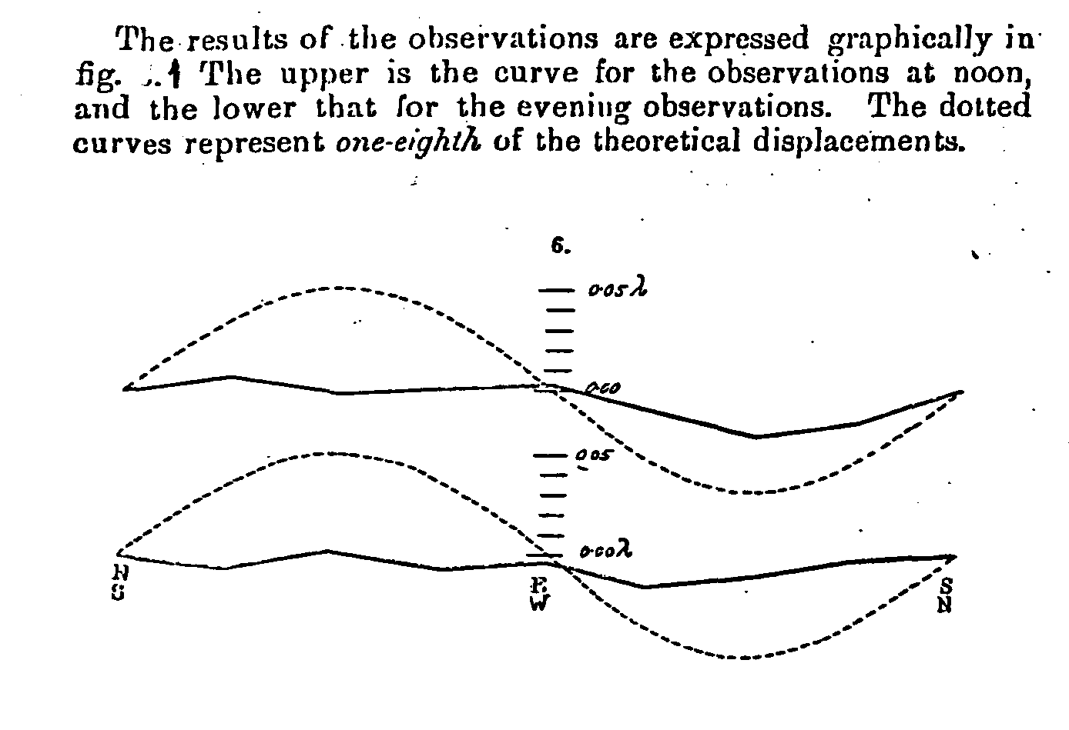
Fig. 1

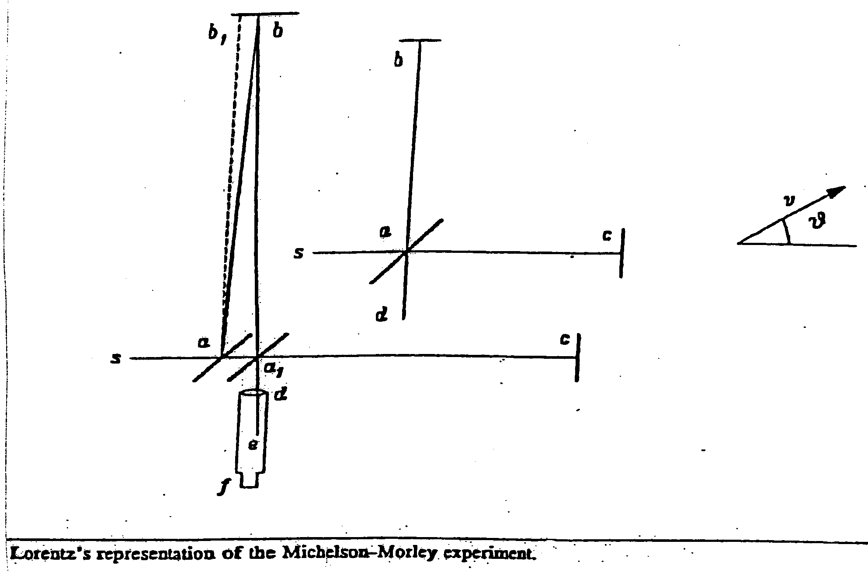
Fig. 2

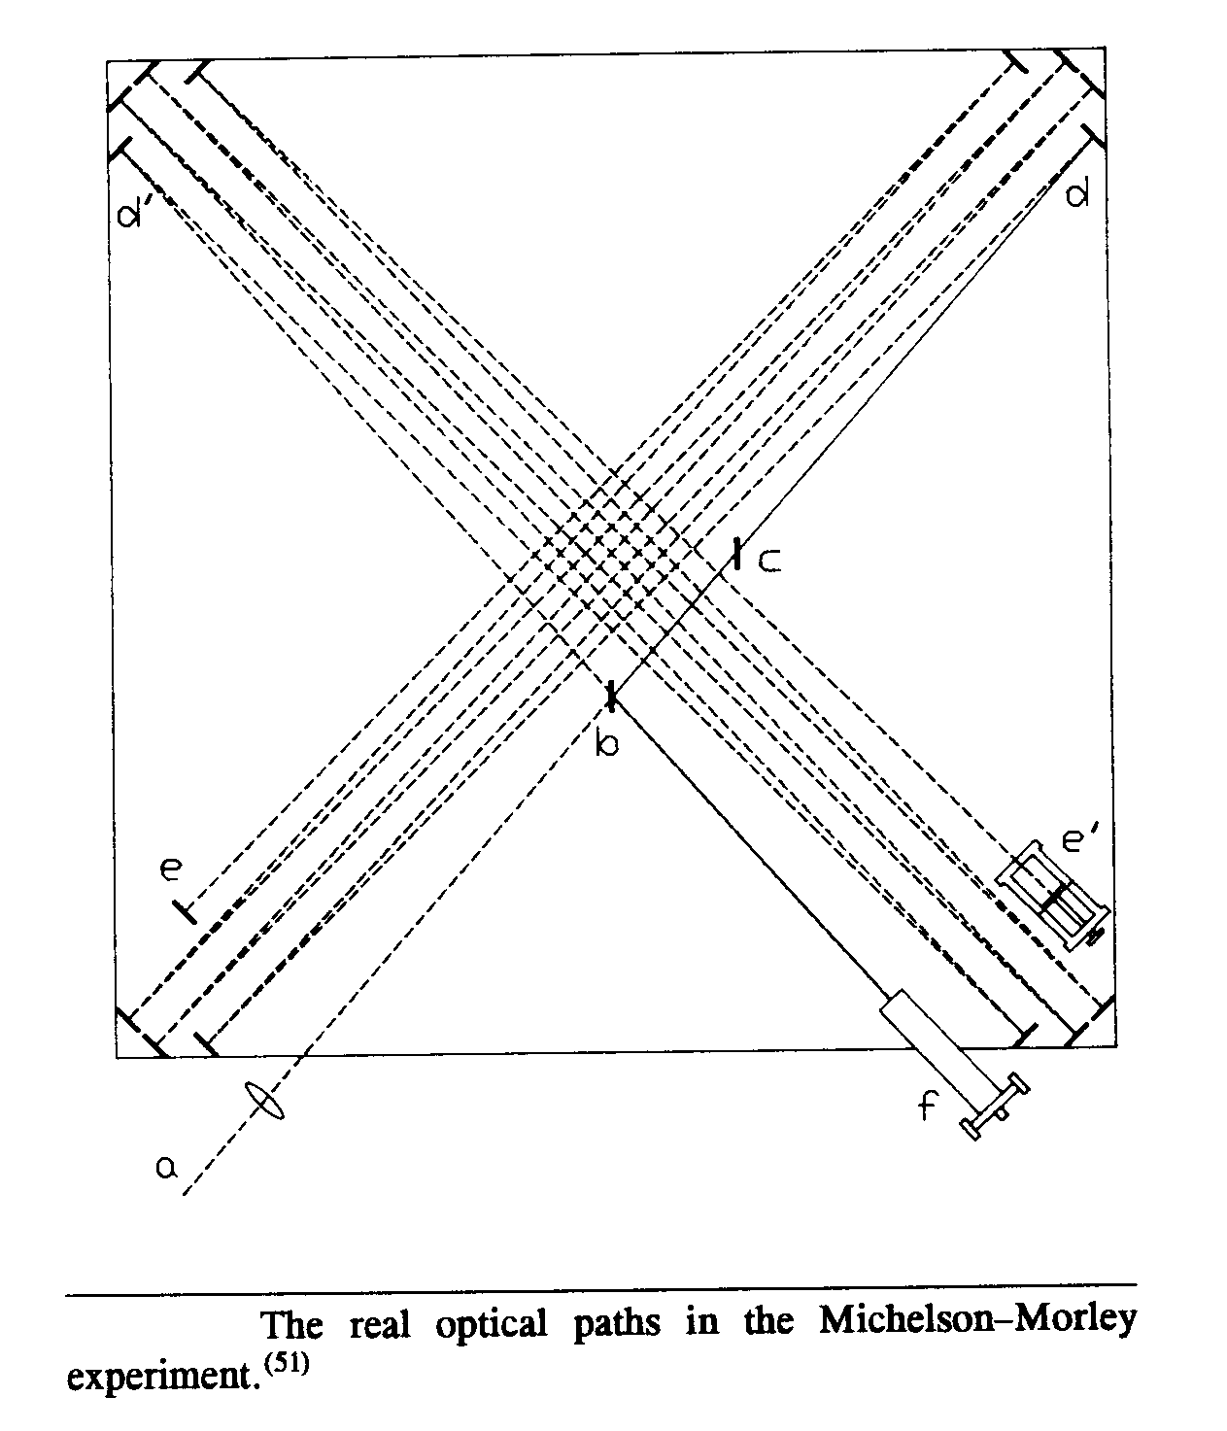
Fig. 3

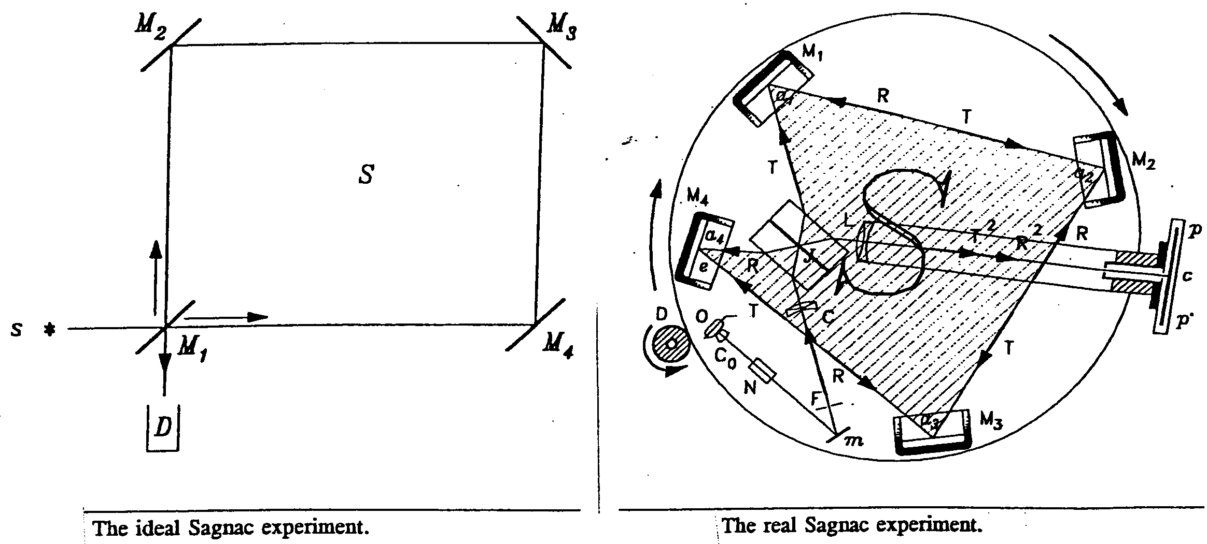
Fig. 4

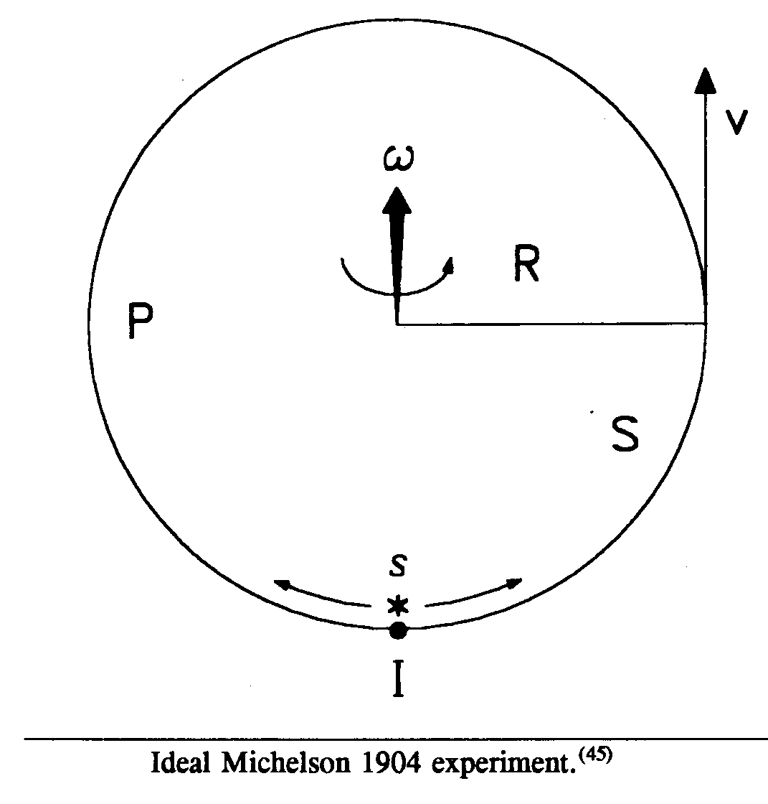
Fig 5
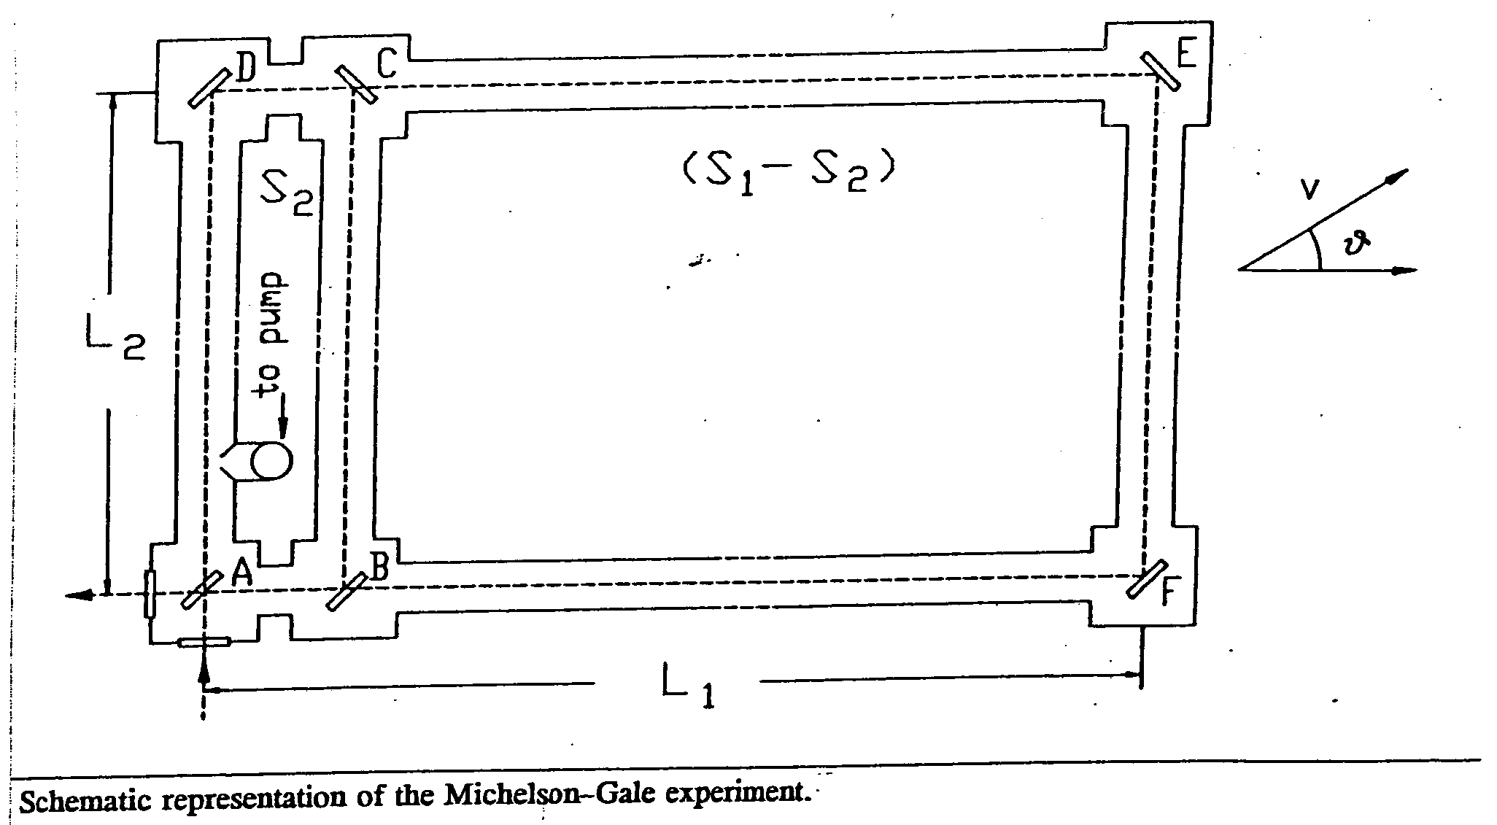
Fig. 6

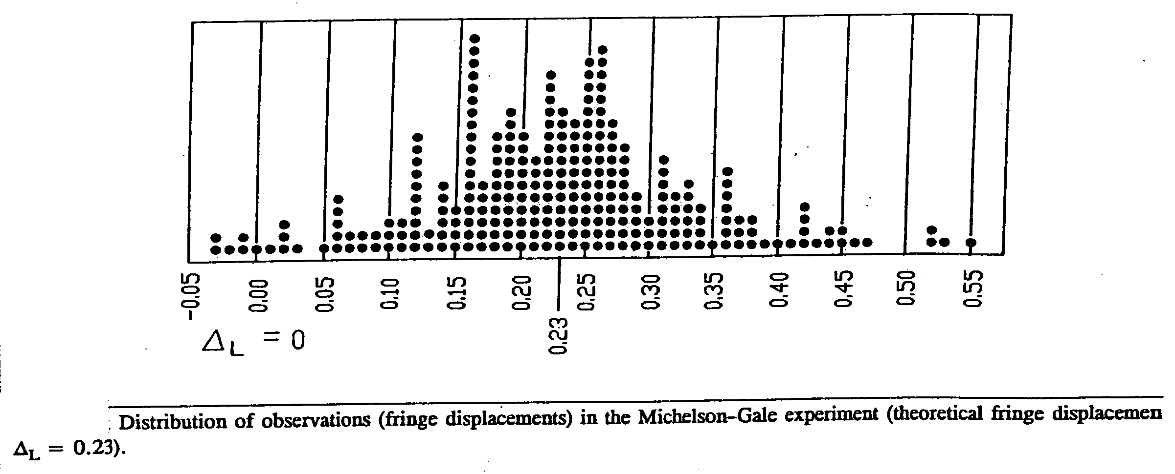
Fig. 7

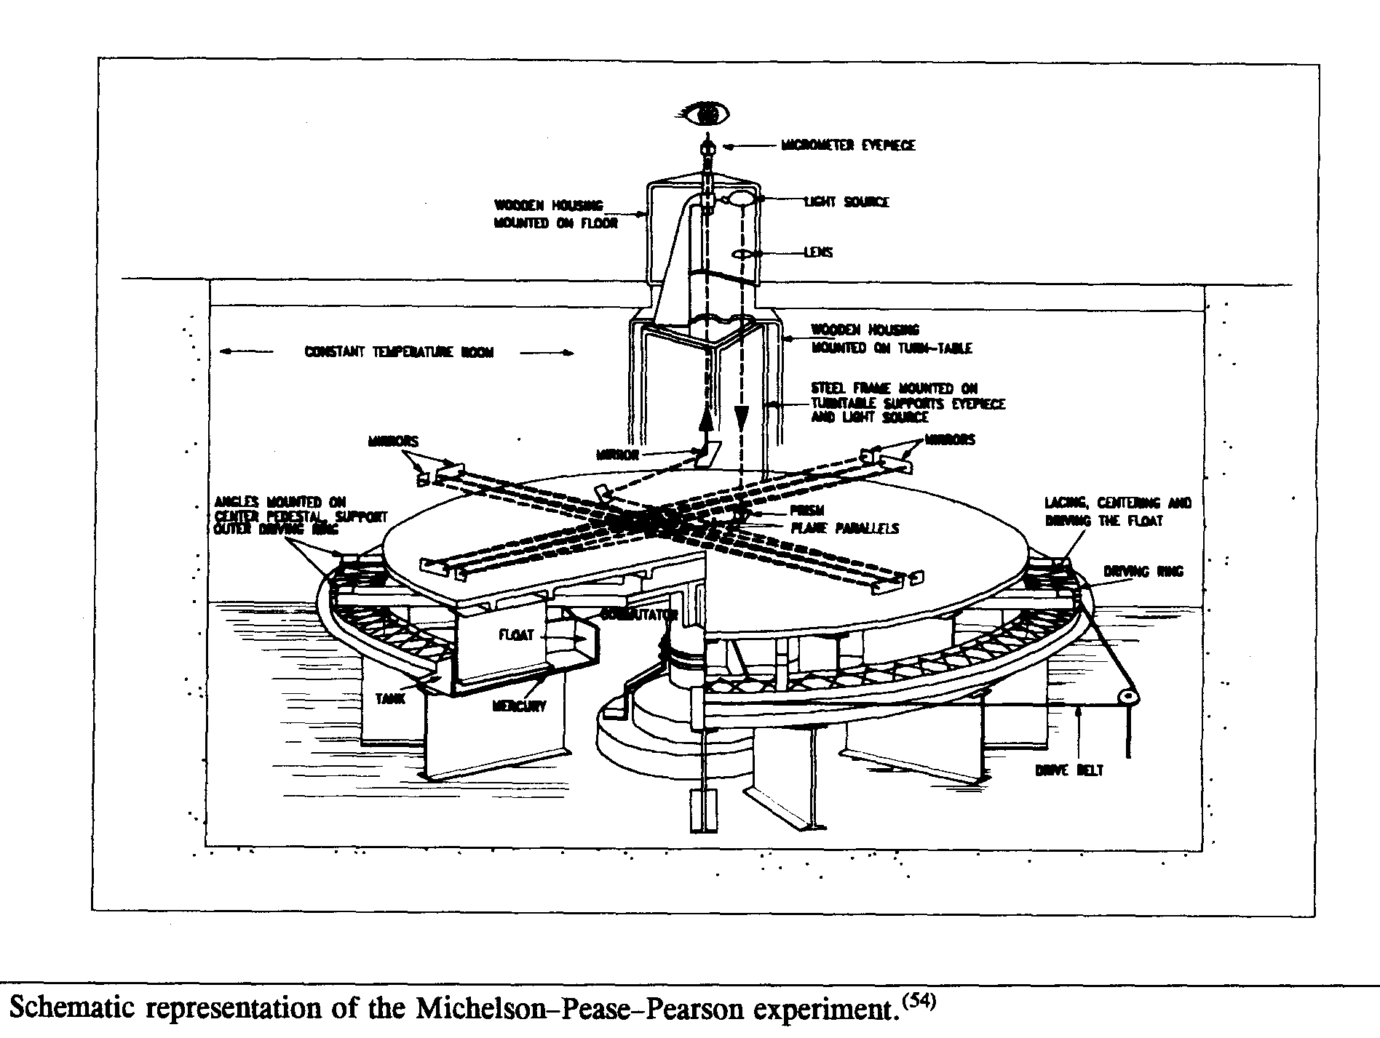
Fig. 8

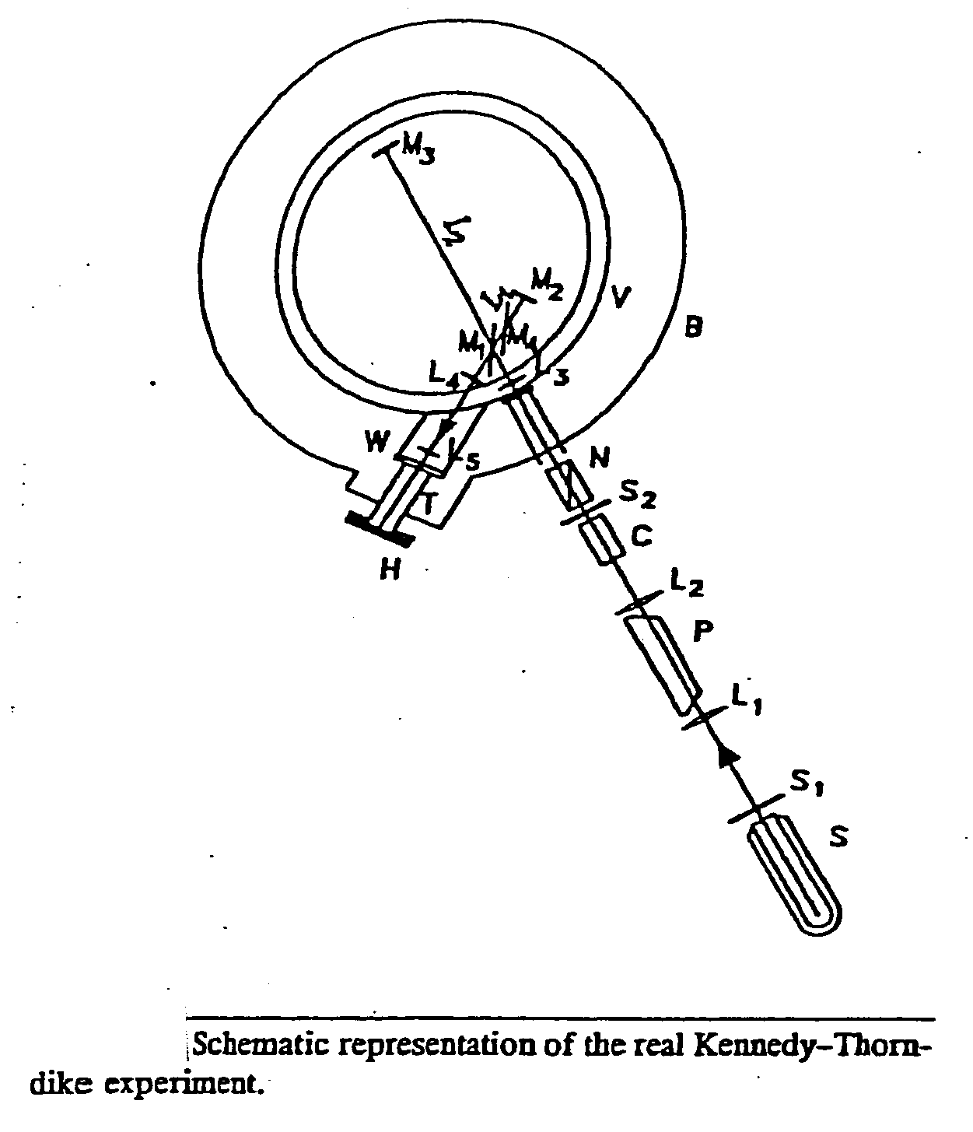
Fig. 9

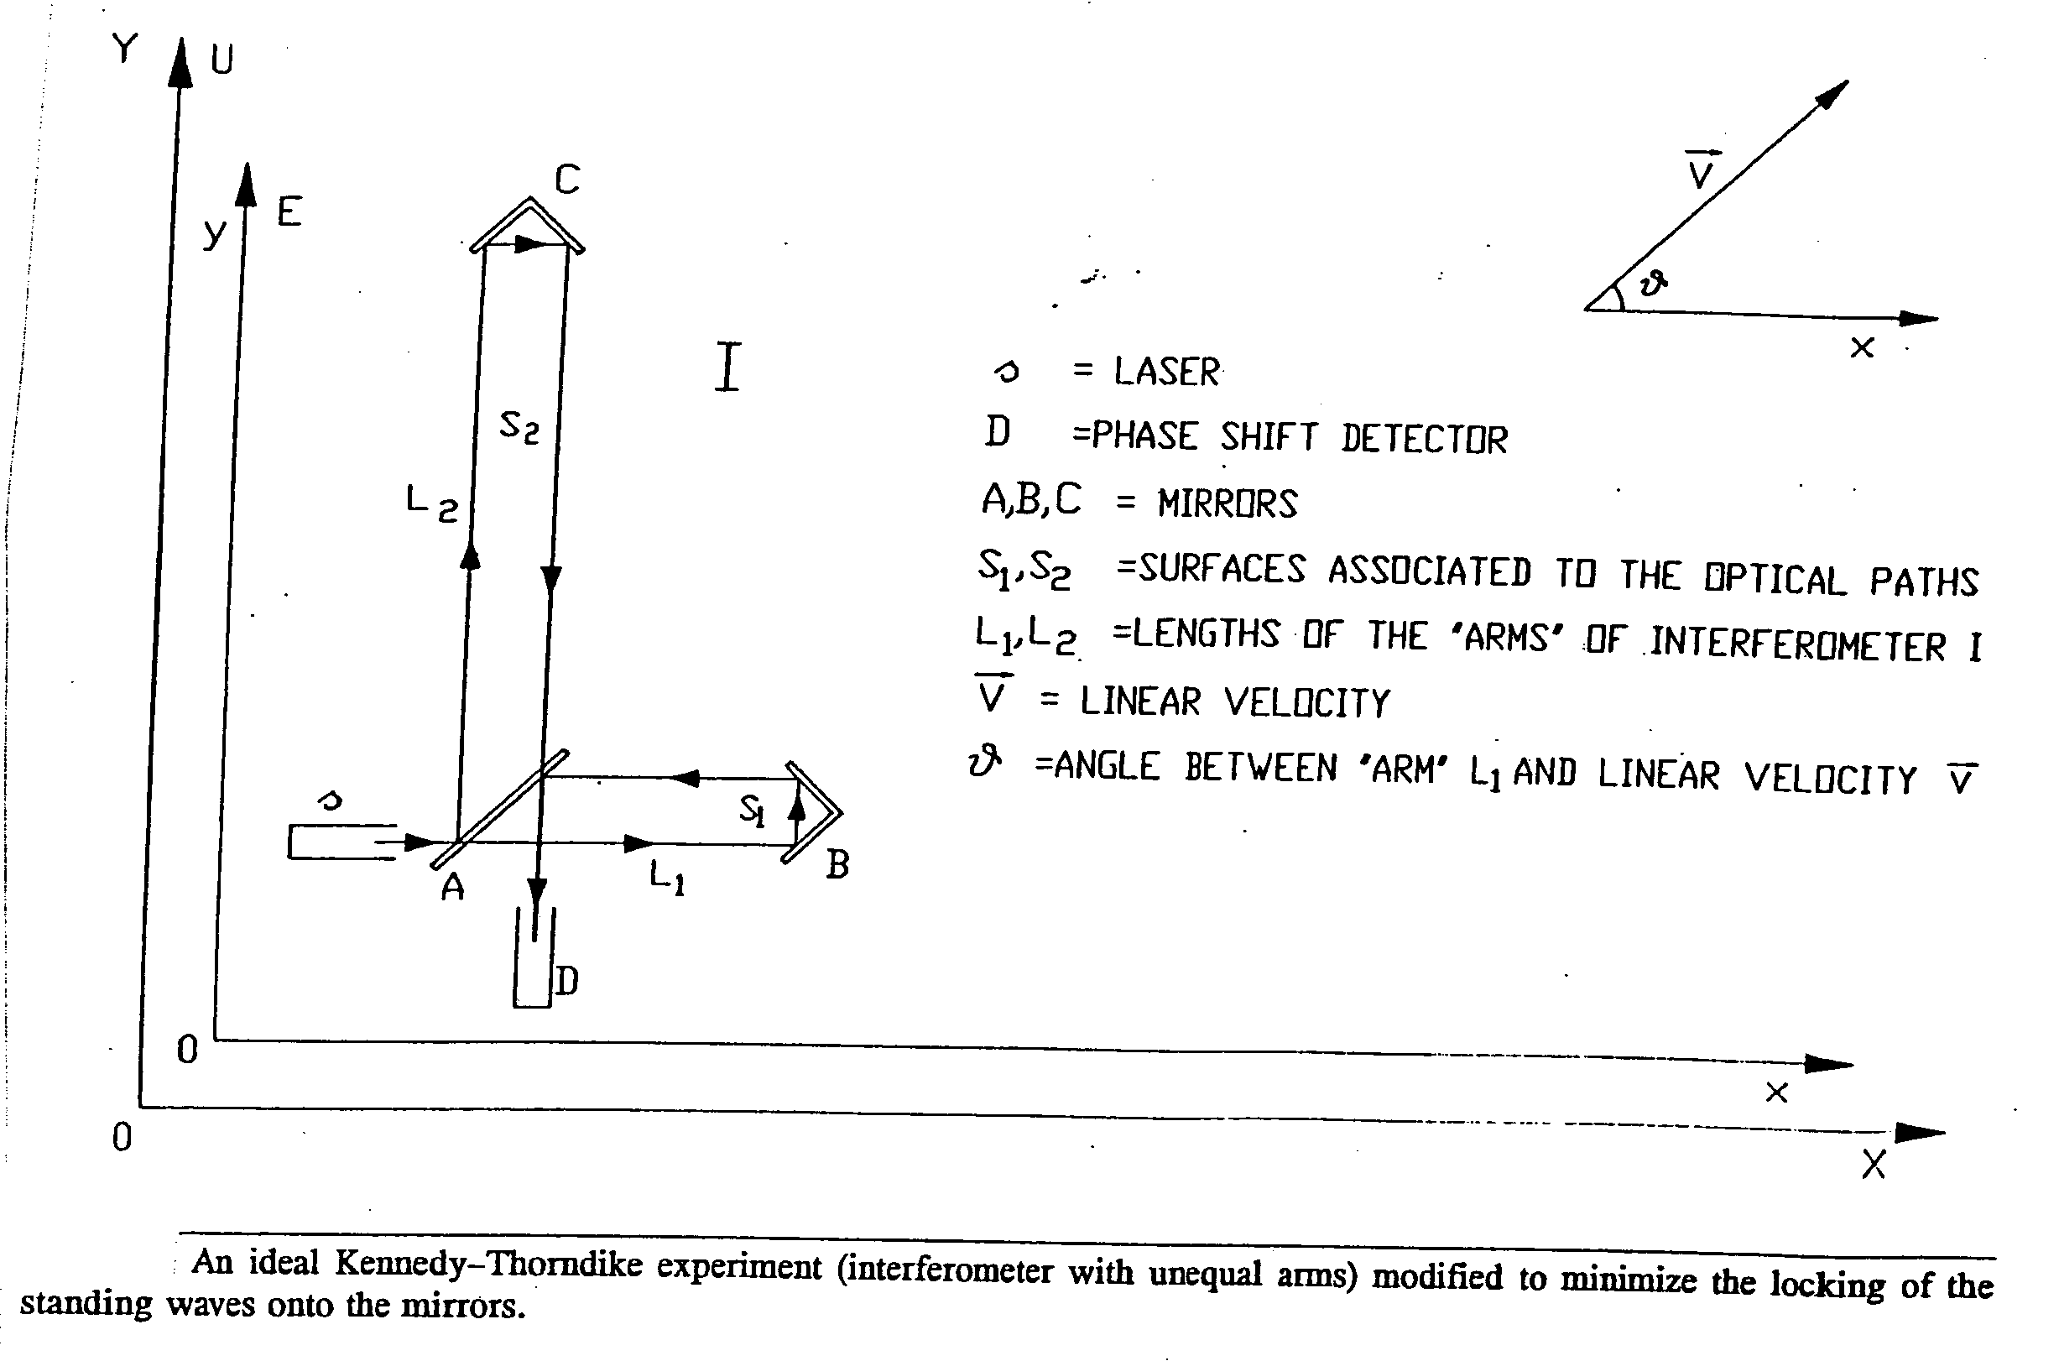
Fig. 10

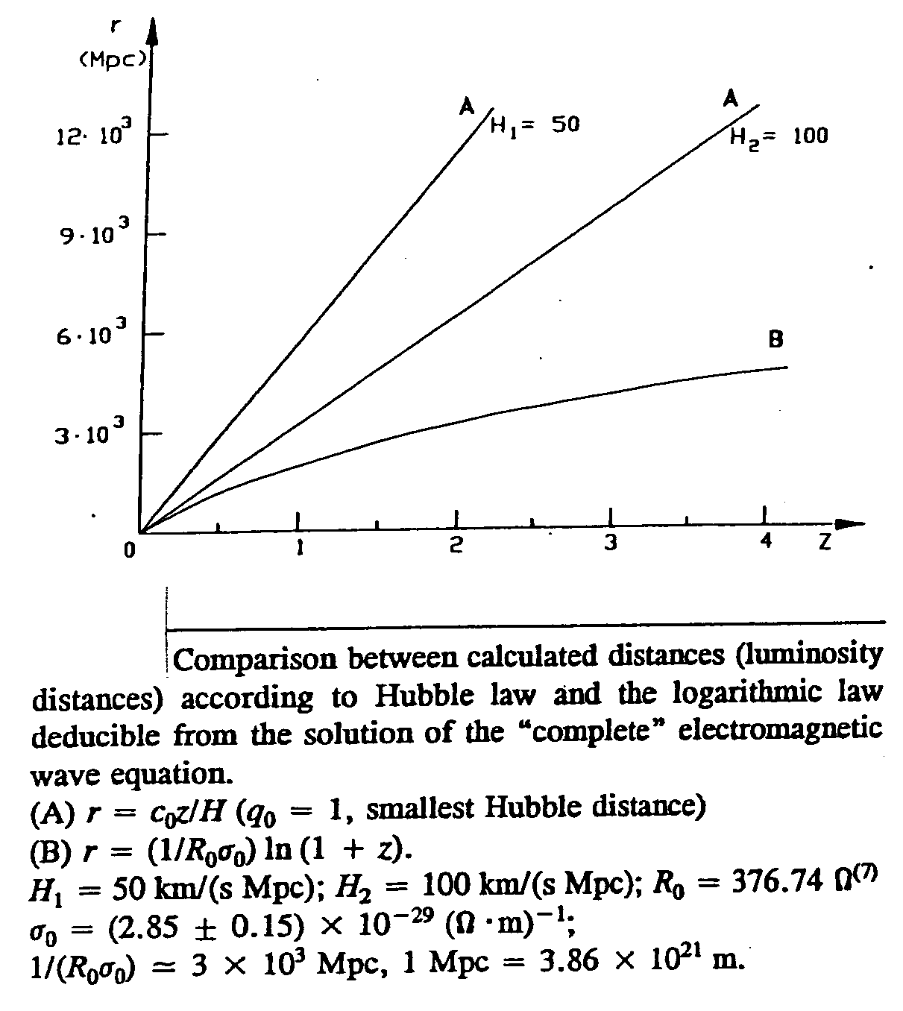
Fig. 11

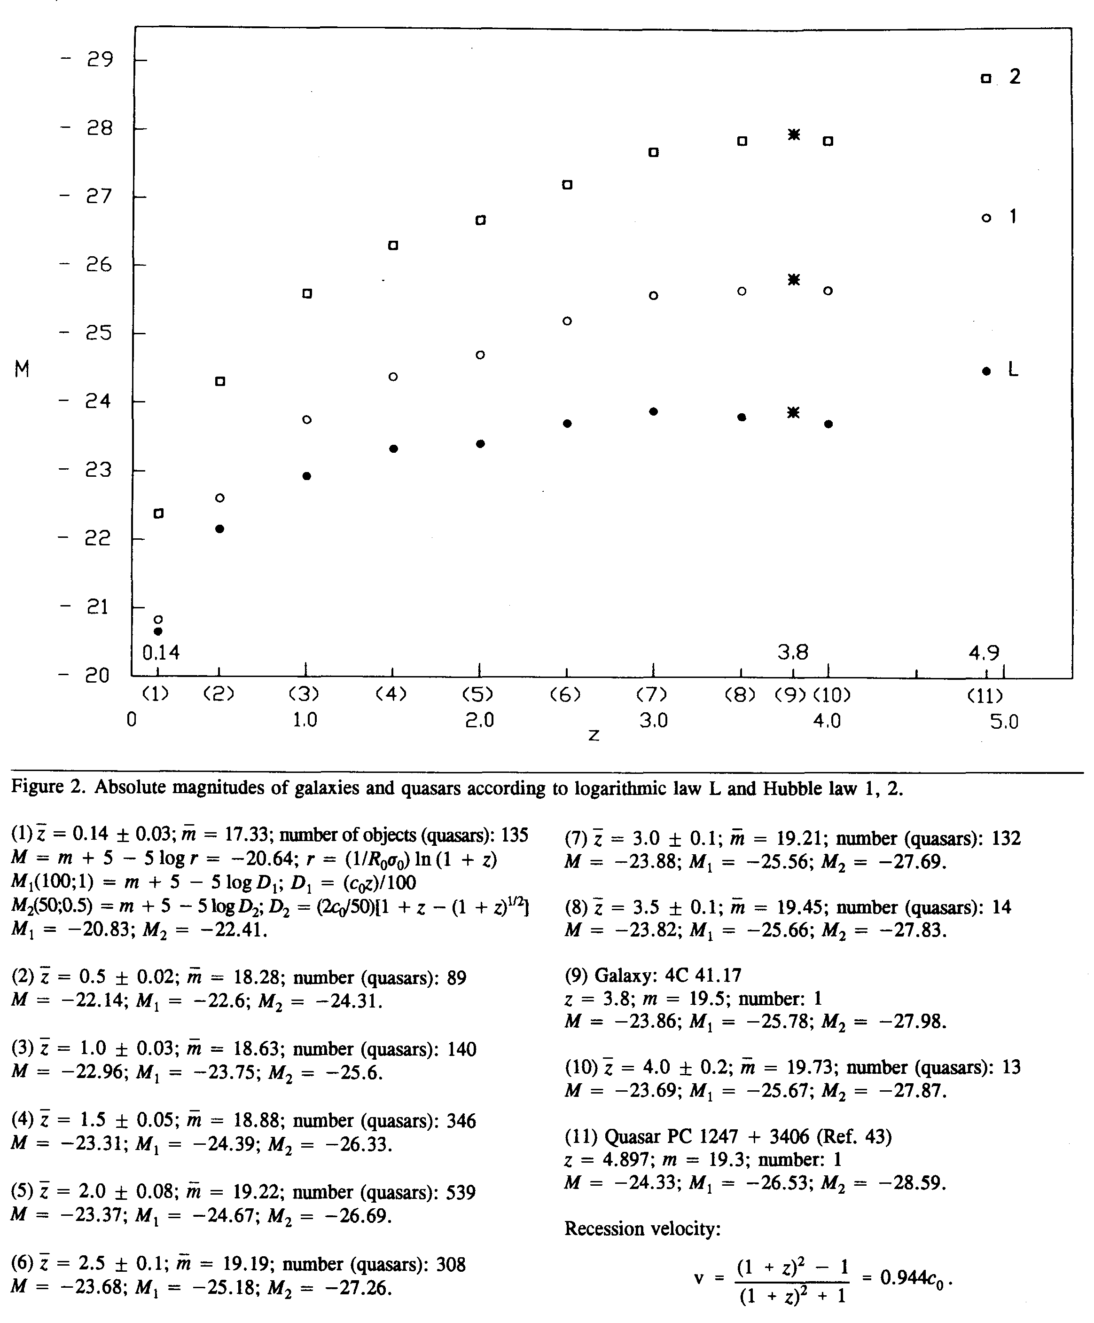
Fig. 12
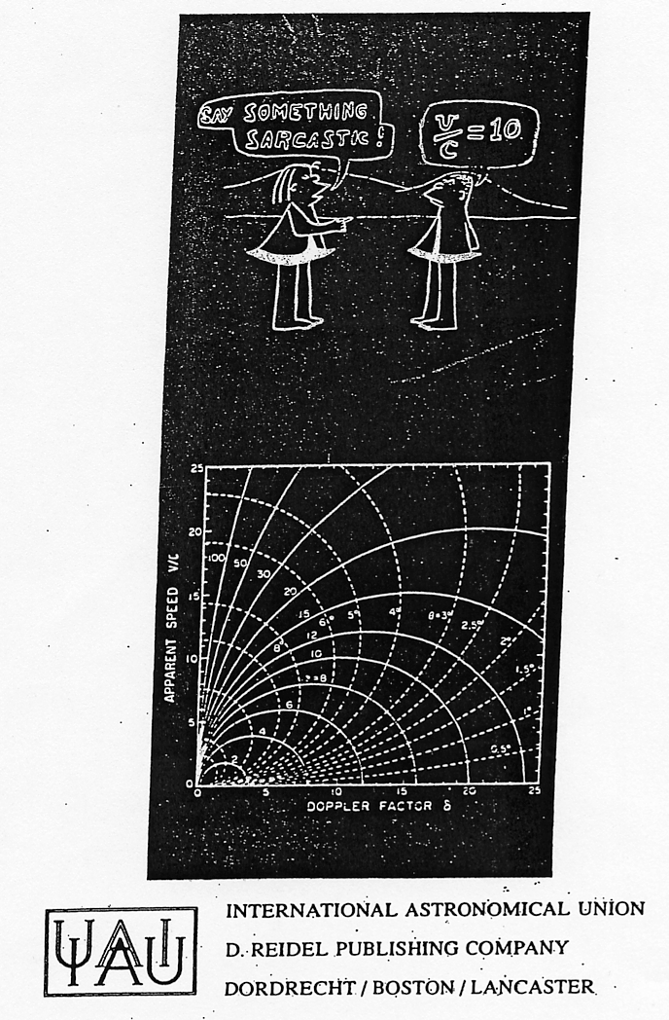
Fig. 13
List of figure captions

Figure 1. The results of the observations in Michelson Morley experiment.
Figure 2. Lorenz’s representation of the Michelson Morley experiment.
Figure 3. The real optical paths in the Michelson Morley experiment.
Figure 4. The ideal Sagnac experiment. The real Sagnac experiment.
Figure 5. Ideal Michelson 1904 experiment.
Figure 6. Schematic representation of the Michelson-Gale experiment.
Figure 7. Distribution of observations (fringe displacements) in the Michelson-Gale experiment (theoretical fringe displacement: Δ_{L} = 0.23).
Figure 8. Schematic representation of the Michelson-Pease-Pearson experiment.
Figure 9. Schematic representation of the real Kennedy-Thorndike experiment.
Figure 10. An ideal Kennedy-Thorndike experiment (interferometer with unequal arms) modified to minimize the locking of the standing waves onto the mirrors.
Figure 11. Comparison between calculated distances (luminosity distances) according to Hubble law and the logarithmic law deducible from the solution of the complete electromagnetic wave equation.
Figure 12. Absolute magnitudes of galaxies and quasars according to logarithmic law L and Hubble law 1,2.
Figure 13. Cover of the INTERNATIONAL ASTRONOMICAL UNION proceedings(1984). 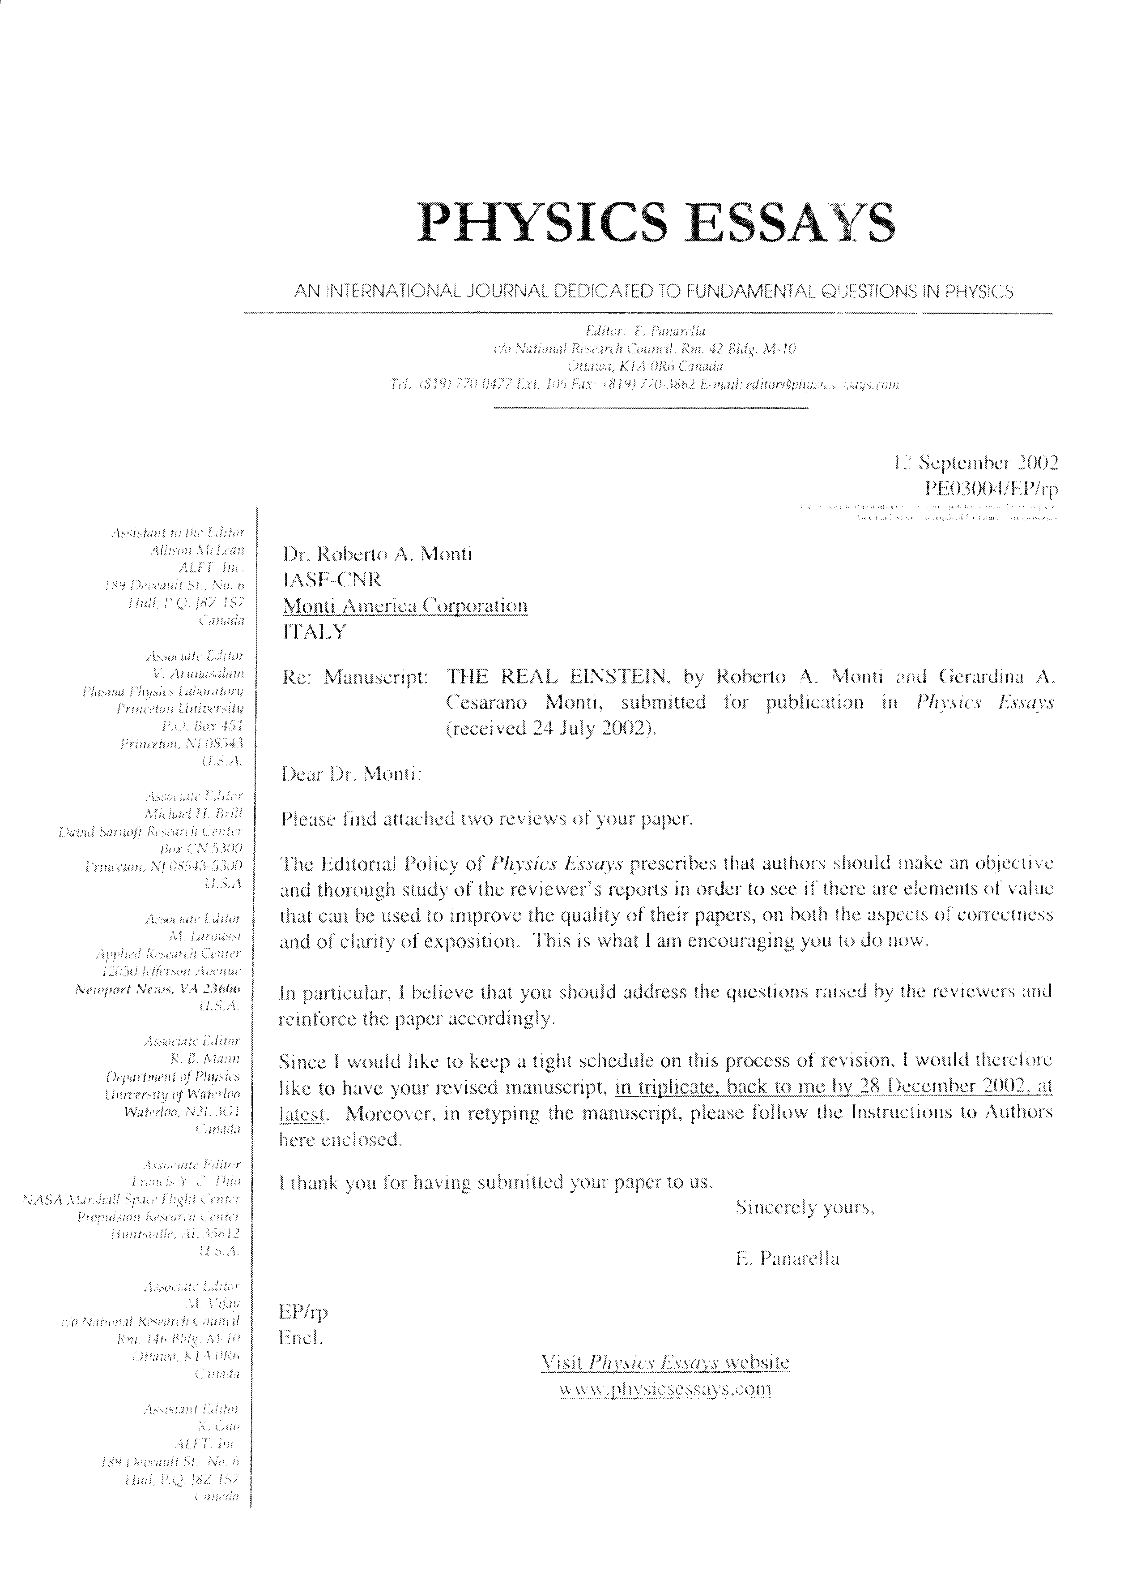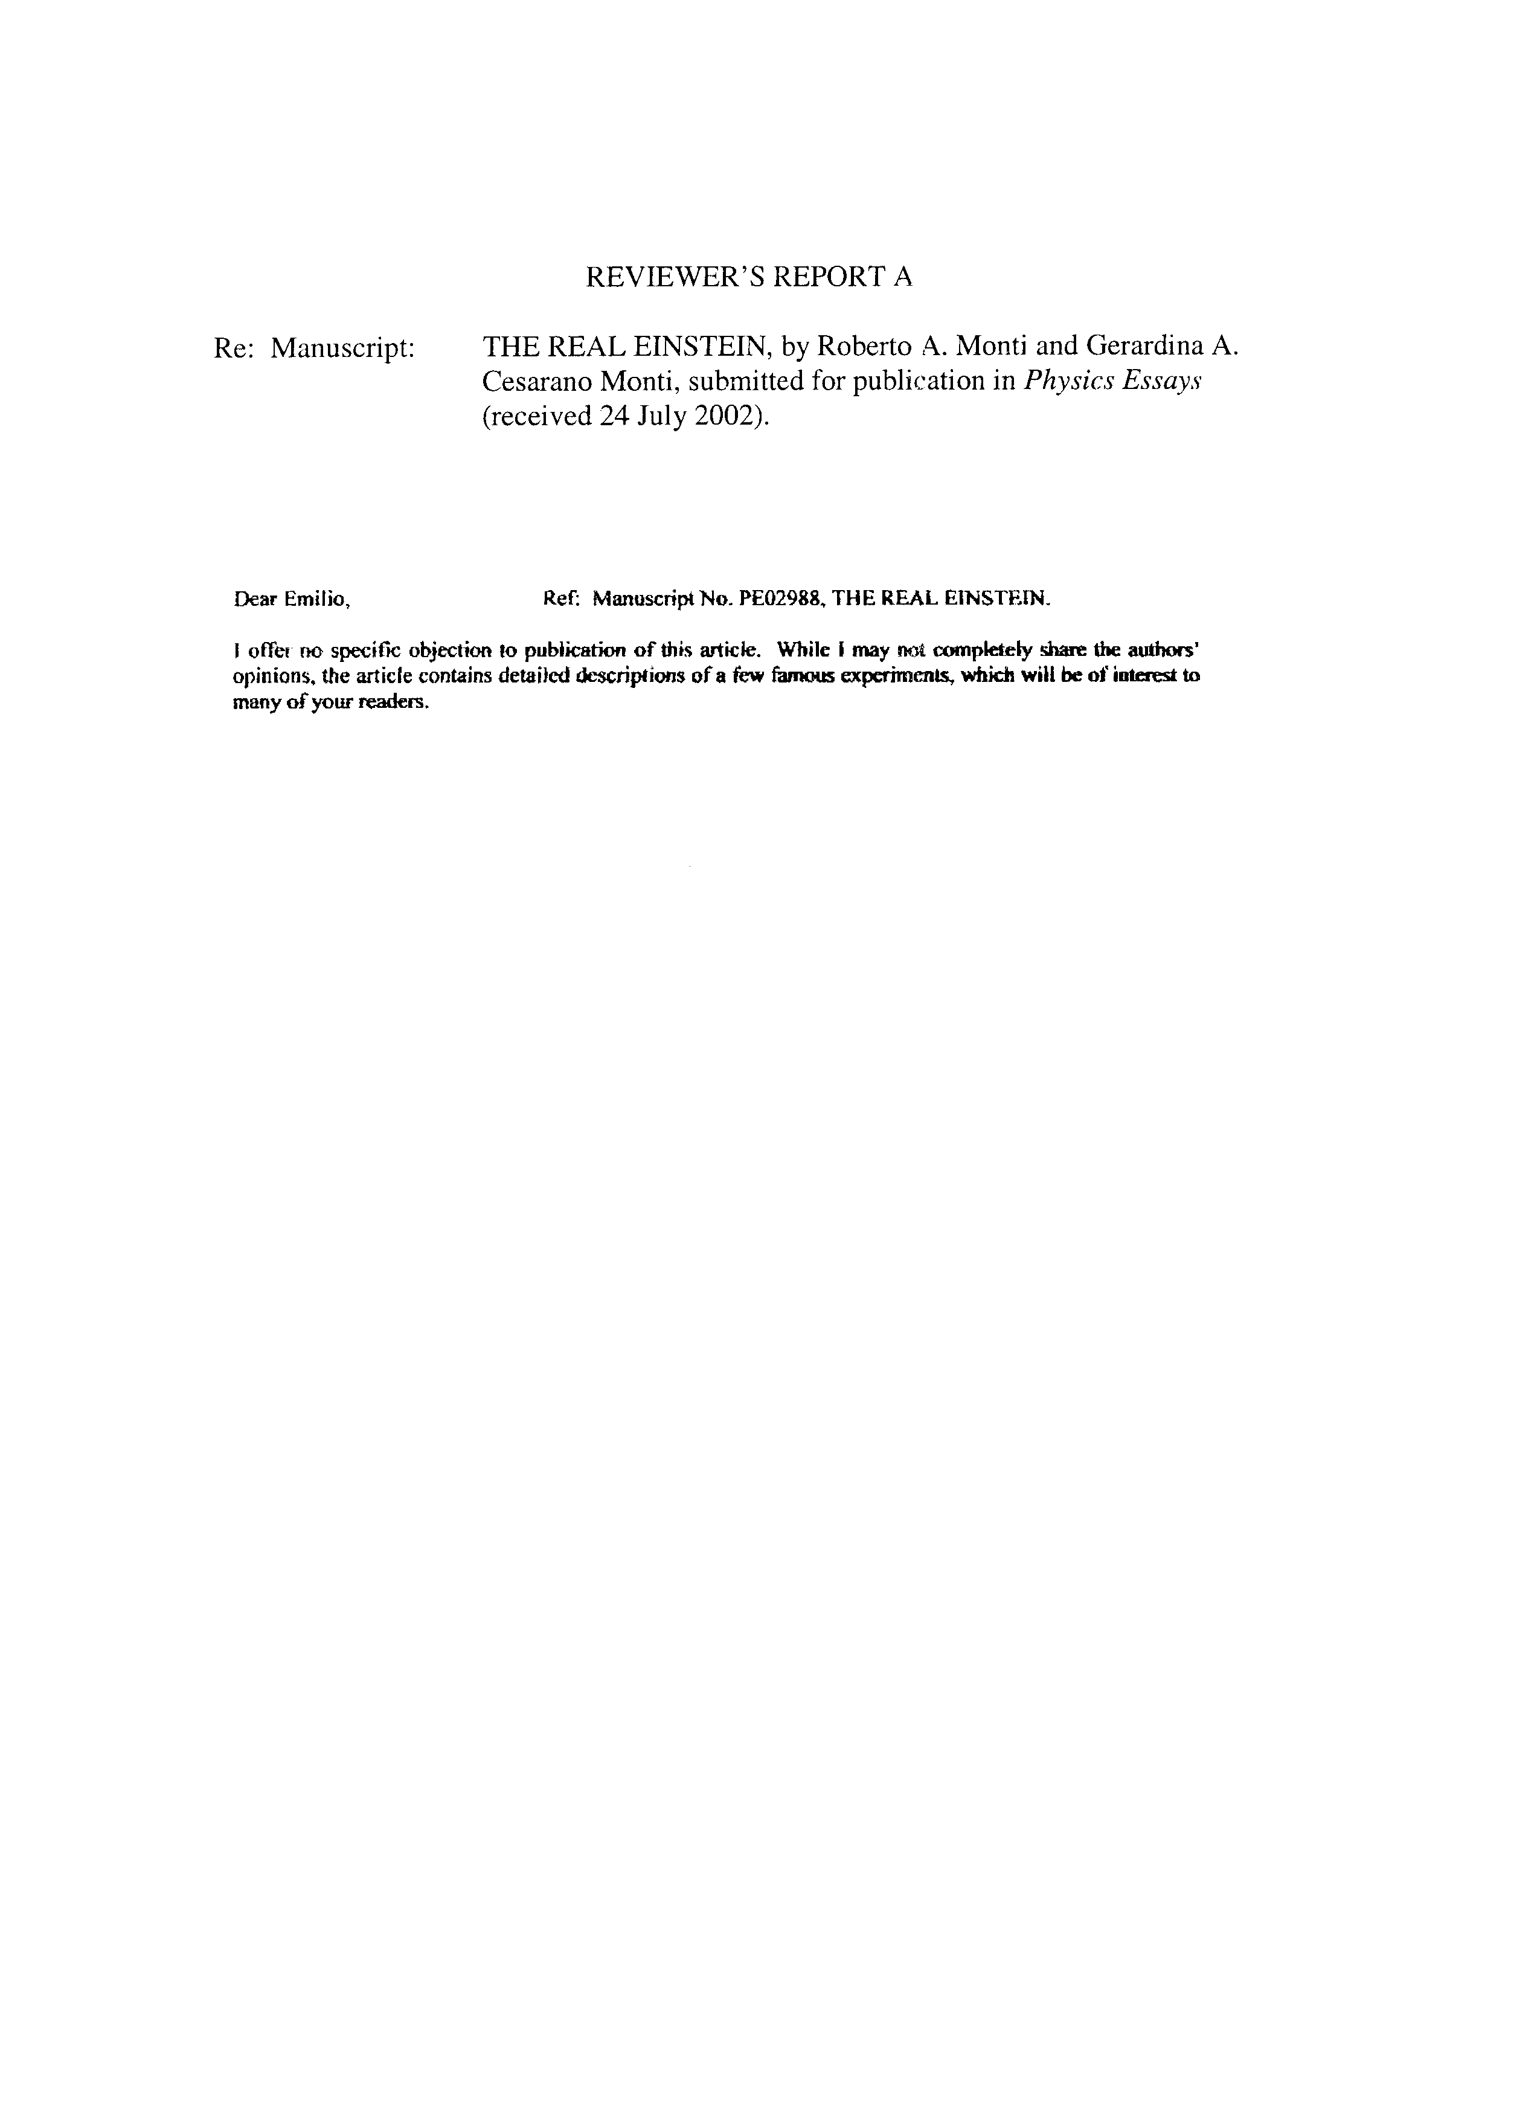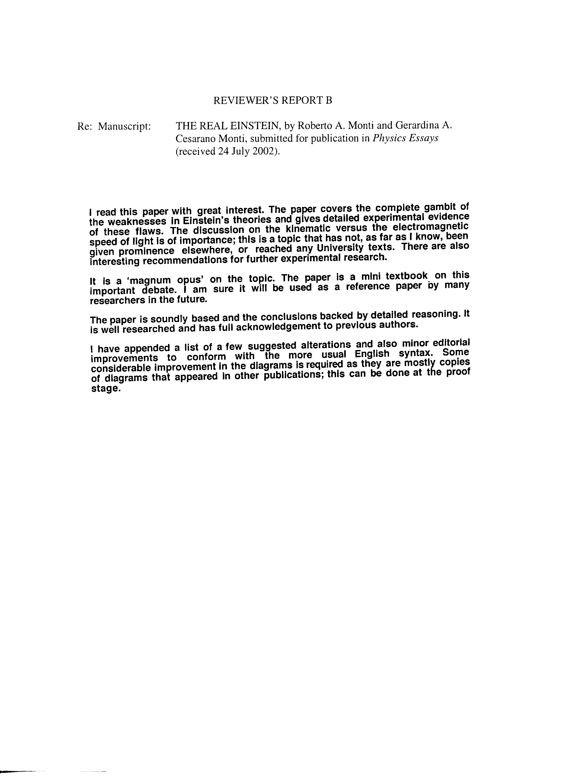
Notwithstanding these two positive Referee Reports, Emilio Panarella, Editor of Physics
Essays, rejected The Real Einstein.
This paper will be published by Hal Fox (J. N. E.).

